TASKS ON AUTO SCALING GROUPS
Title:
- Create one VPC in N. Virginia region.
Objective:
VPC is isolated private network in this we can customize our private ip and we can manage services.
Prerequisites:
- AWS Console
- CIDR
- VPC
- Region
Step by Step implementation:
Step 1: Navigate to VPC resource and click on create
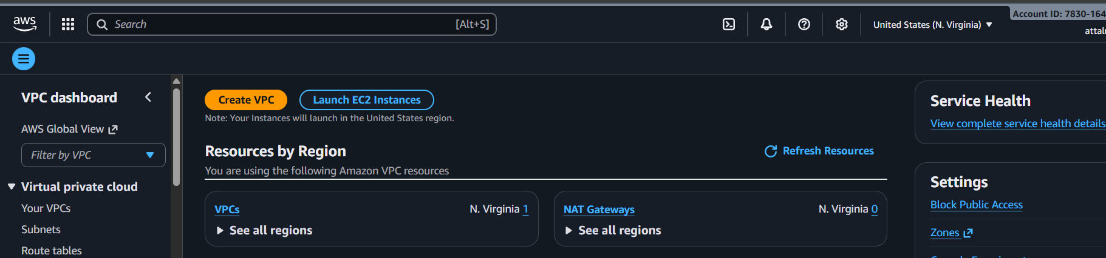
Step 2: Provide a name to vpc and CIDR range value
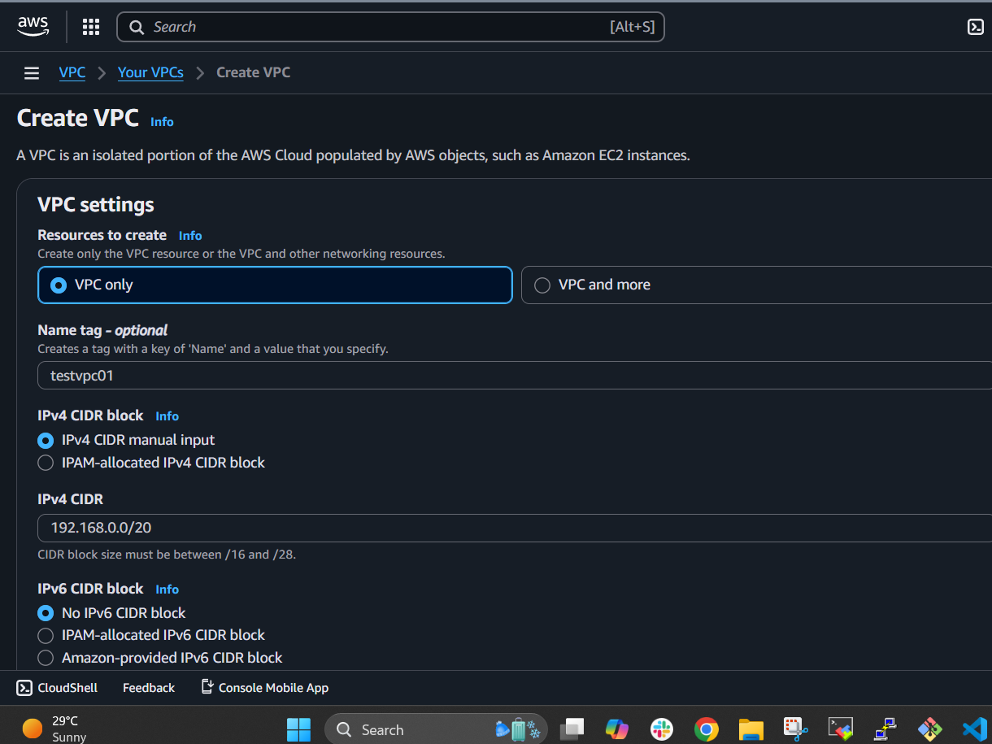
Step 3: Review the details and click on create vpc
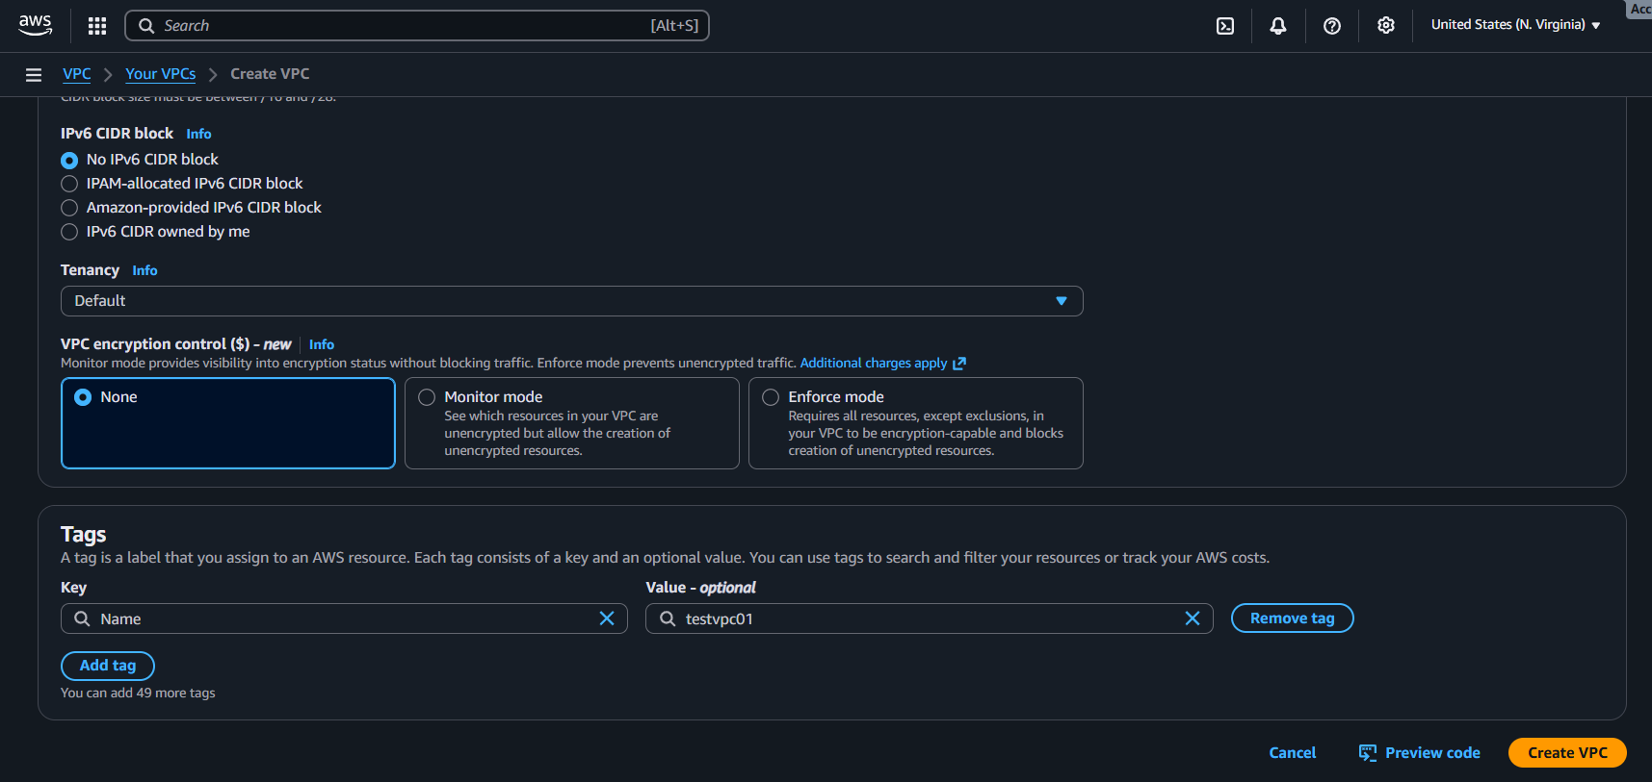Step 4: Successfully a vpc has been created
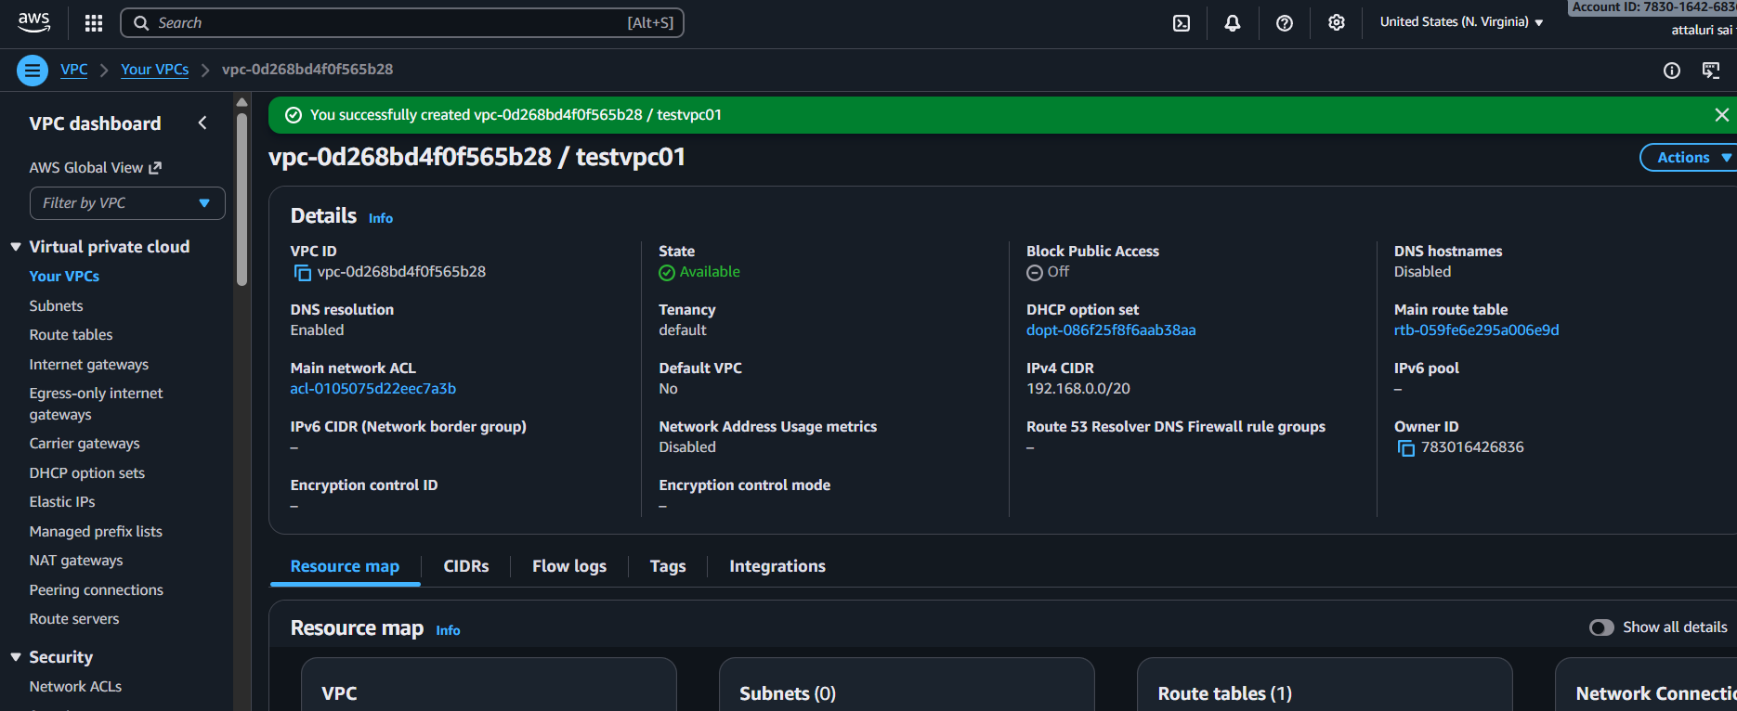
Validation Part:
Verified the CIDR range and VPC is Your vpc’s section
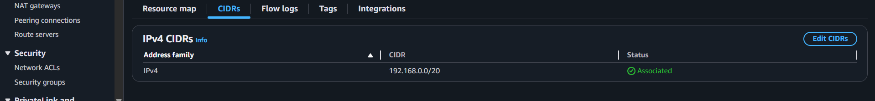
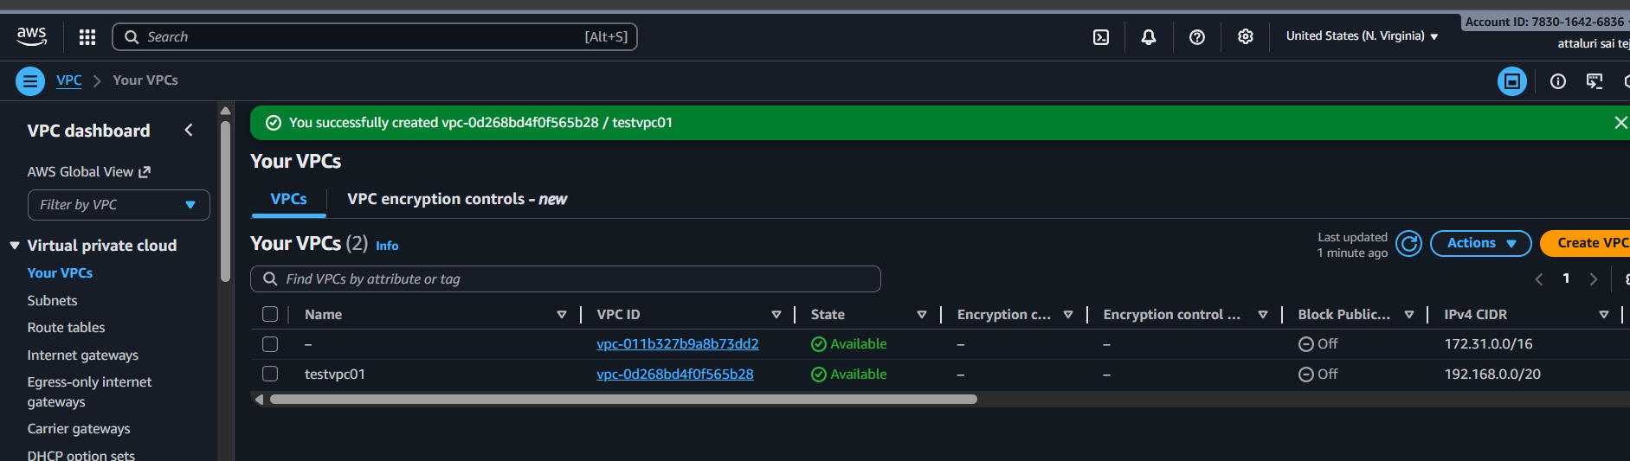
Title:
2. Create two subnets: one public subnet and one private subnet.
Objective :
Subnet live inside a VPC, a smaller portion of IP address
Through subnets we can able to launch instance and ip address will allocate to ec2 from it.
Prerequisites:
- VPC
- Subnet Masking
Step by step implementation:
Step 1: Navigate to VPC and select Subnet section and click on create subnet
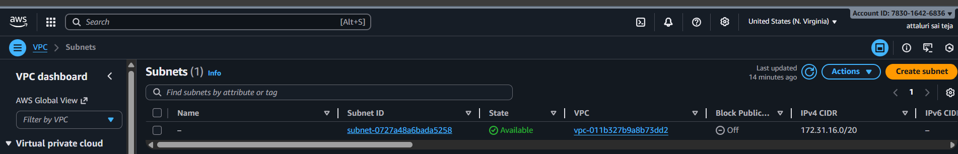
Step 2: Select a Custom VPC and continue
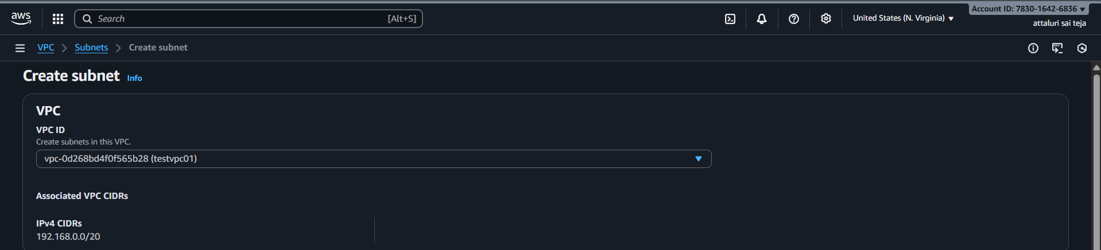

Step 3: Provide a name to subnet like private and public and provide VPC CIDR Block range without overlapping the ip address
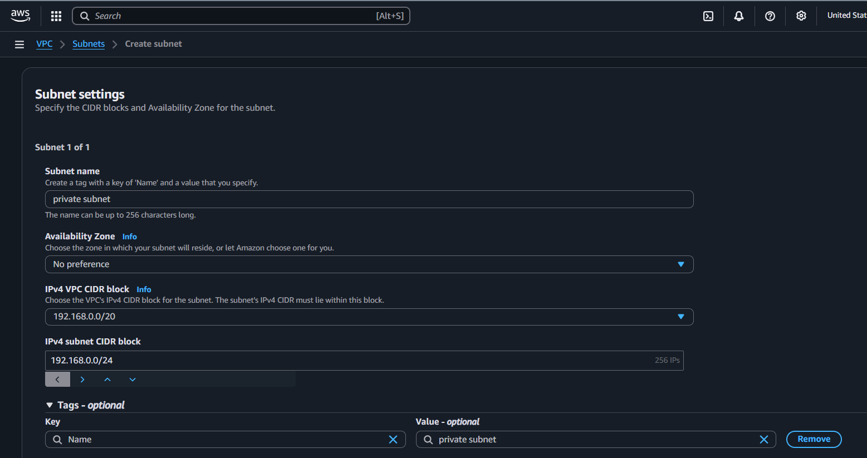
Step 4: Provide a name to subnet and also provide cidr block and click on create
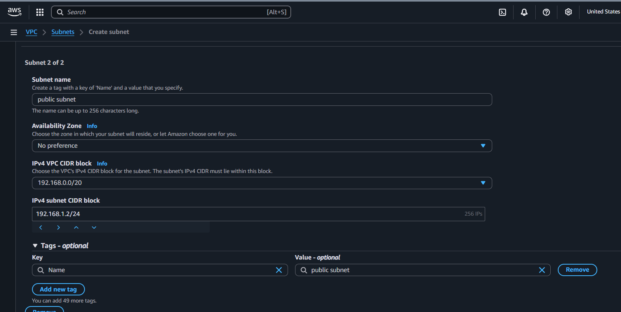

Step 5: In the Subnets tab 2 new subnets were created
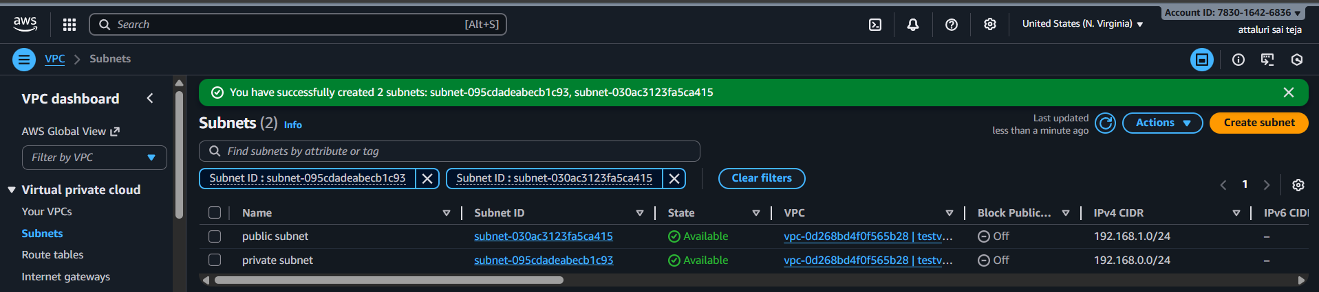
Conclusion :
Now we had created our customized subnets with our IP’s
Which will used in launching an instance.
Note:::
No two subnets CIDR block range should not be overlapped
If Subnet masking is not given properly the you will face a issue while creating subnet.

Title:
Attach an IGW to the VPC.
Objective:
IGW means Internet Gateway
It is used to Provide an Internet access to our subnets
IGW should be attached in Public Subnet Only.
Prerequisites :
- VPC
- Subnets
Step by step Implementation:
Step 1: Navigate to VPC Dashboard and Select Internet Gateways and click on Create Internet Gateway
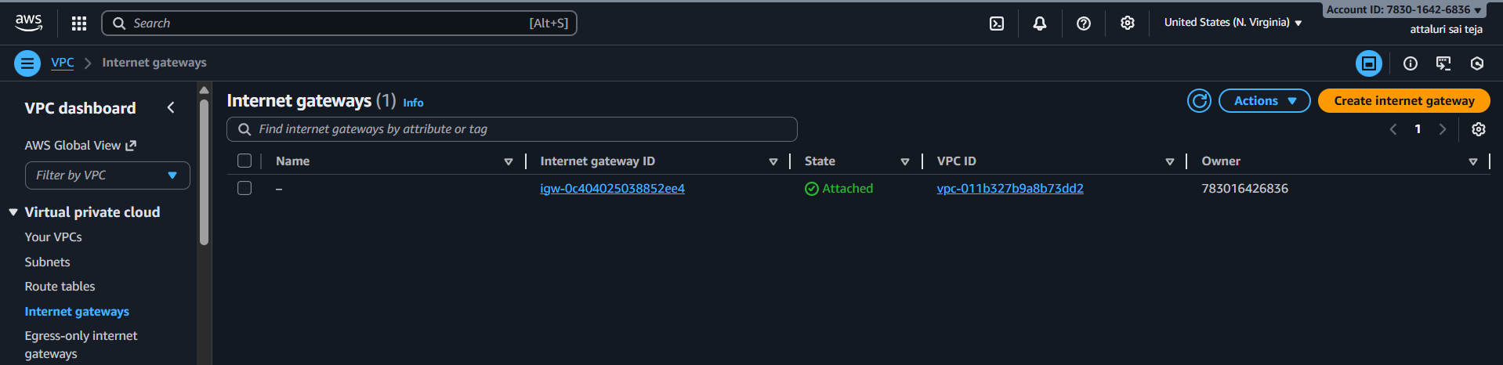
Step 2: Provide a name to IGW and continue to Create
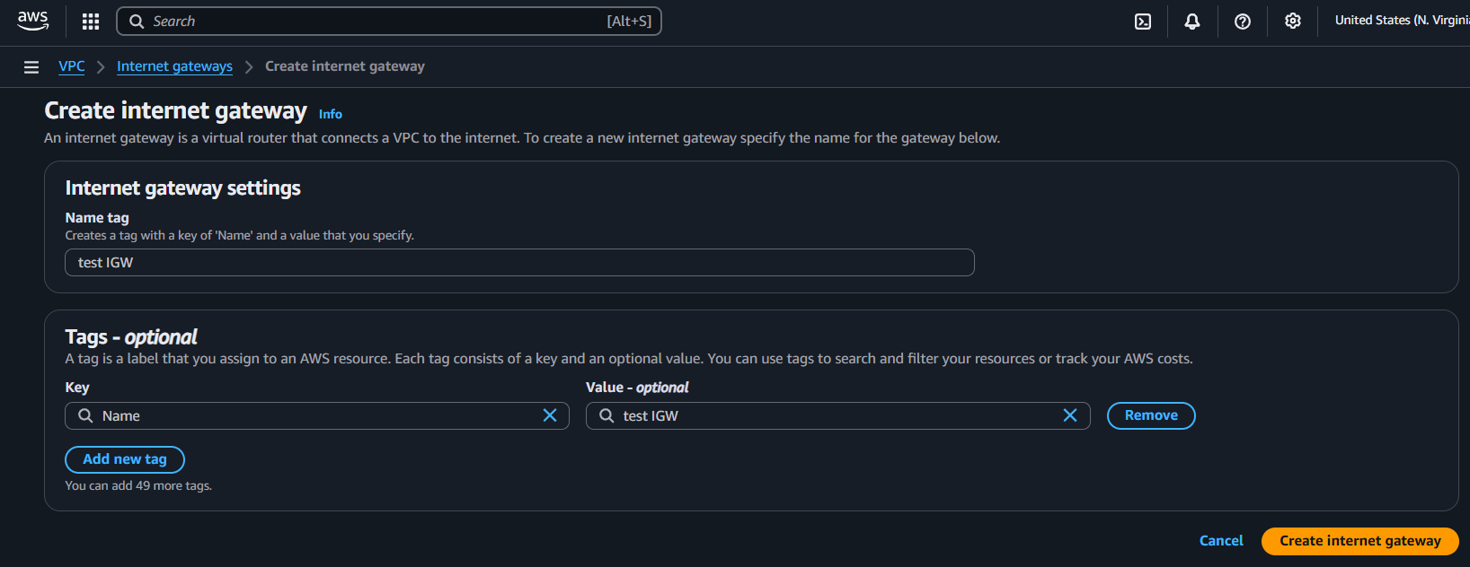

Step 3: Internet gateway has been created successfully
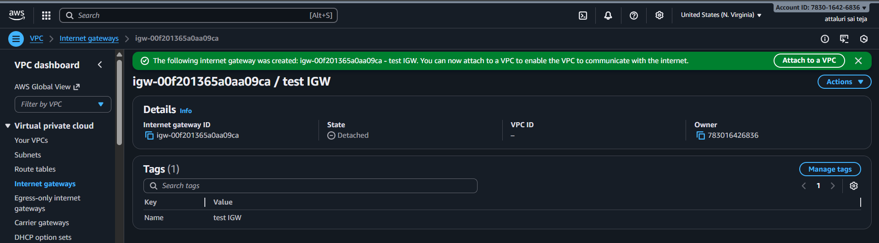
Step 4: Now You need to attach the IGW>VPC
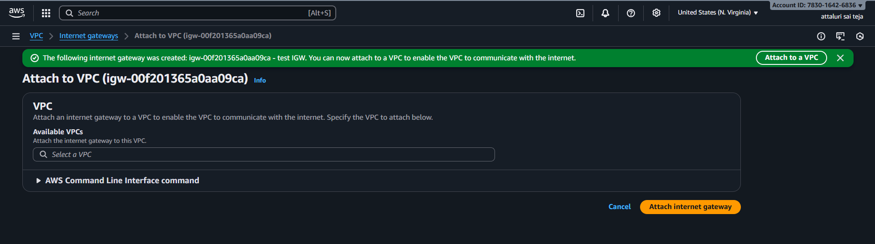
Step 5: Select the VPC which you created and Select on Attach Internet Gateway
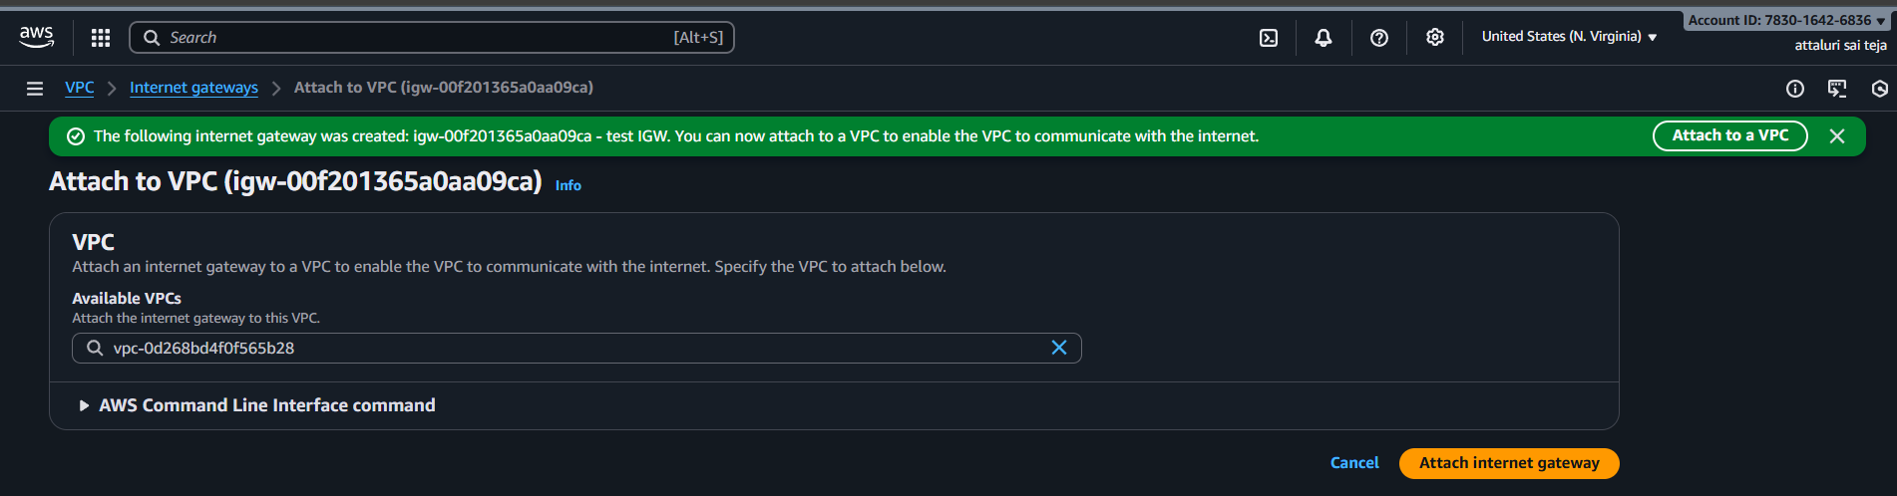
Step 6: Verified that IGW Successfully attached to VPC
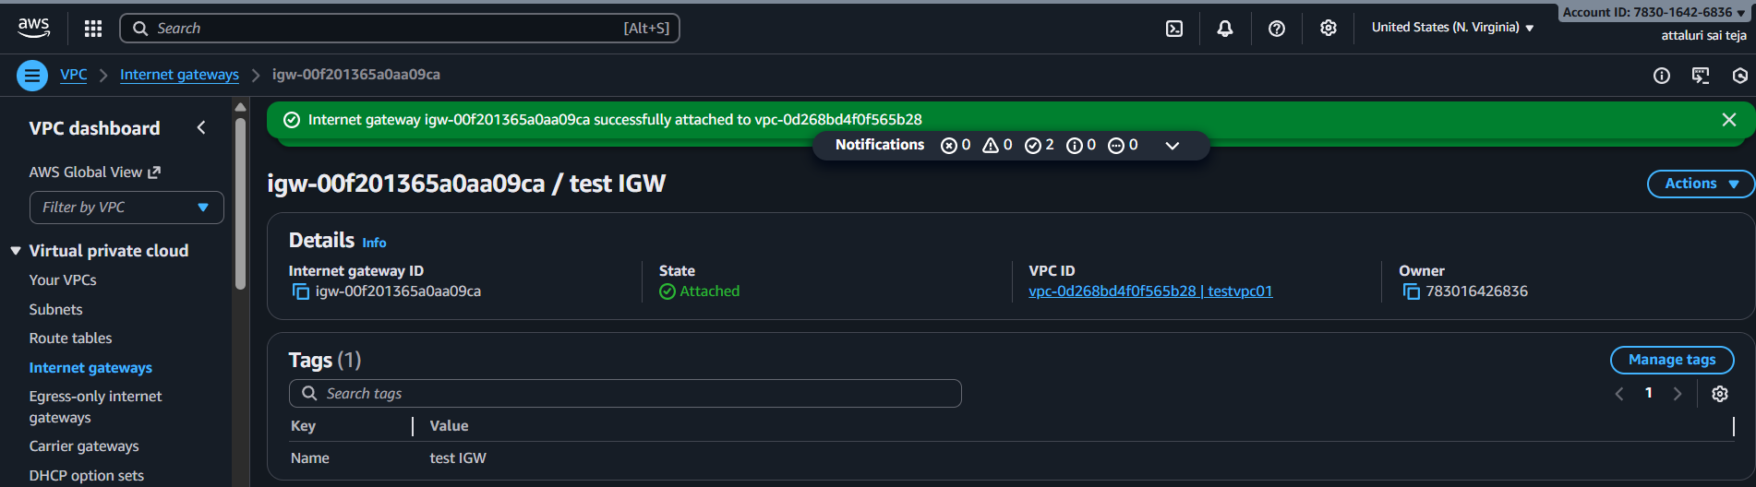
Conclusion: Now our VPC can communicate with help of IGW
Title:
Create one public route table (RT) and one private route table.
Objective:
Create one public and one private route table in the VPC to properly route resources based on their internet accessibility requirements, ensuring secure and organized network segmentation.
Prerequisites:
- VPC
- Subnet
Step by step Implementation:
Step 1: Navigate to VPC and Select Route tables tab and click on Create Route Table
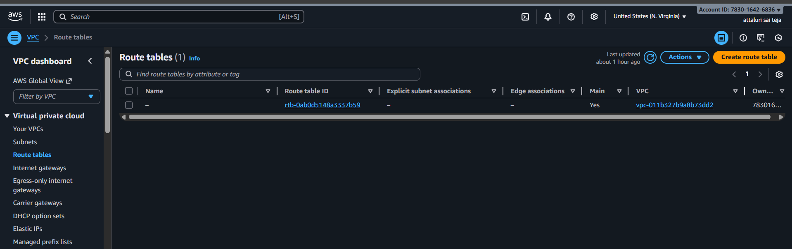
Step 2: Provide a name to recognise i.e PUBLIC or PRIVATE RT and select VPC
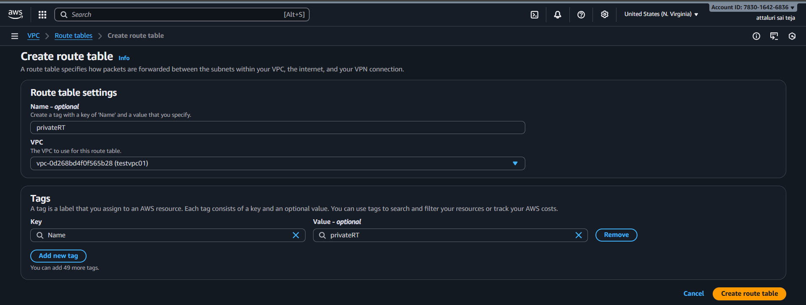

Step 3: Successfully Routes tables RT has been created
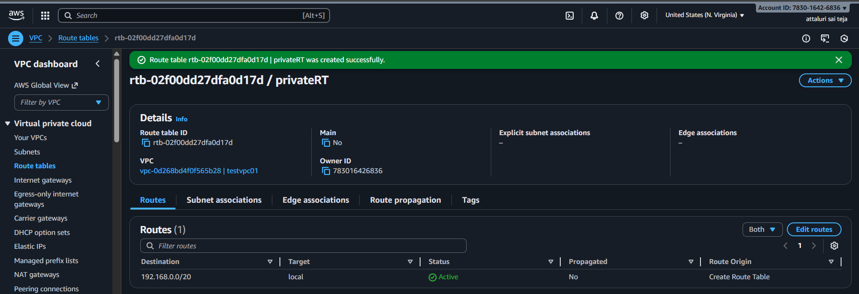
Step 4: Listed all the RT in the VPC dashboard
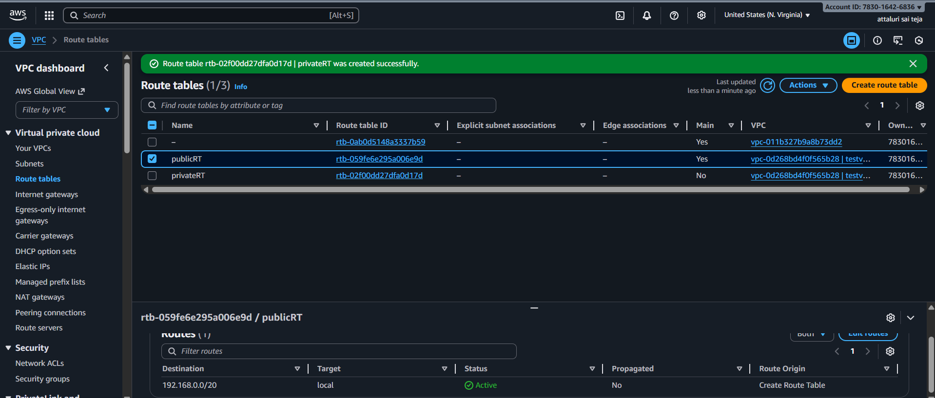
Conclusion:
The creation of public and private route tables ensures secure and efficient routing by allowing internet access only where needed while keeping internal resources protected.

Title:
Deploy a NAT gateway in the public subnet and attach the NAT gateway to the private subnet.
Objective:
Enable private subnet instances to securely access the internet by deploying a NAT Gateway in the public subnet and routing private subnet traffic through it.
Prerequisites :
- VPC
- SUBNET
- ROUTE TABLES
- IGW
- Elastic IP
Step by Step Implementation:
Step 1: Navigate to VPC in that Select NAT Gateway Option and proceed for Create NAT gateway
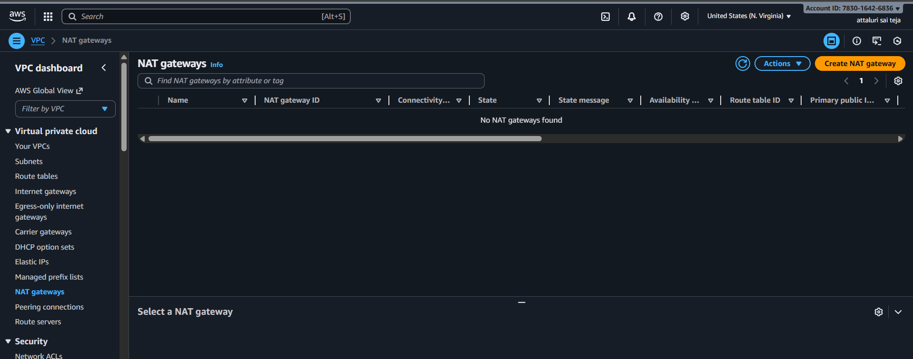

Step 2: provide a name and select availability zone has Zonal and select Subnet as Public and click on generate Elastic ip and attach it
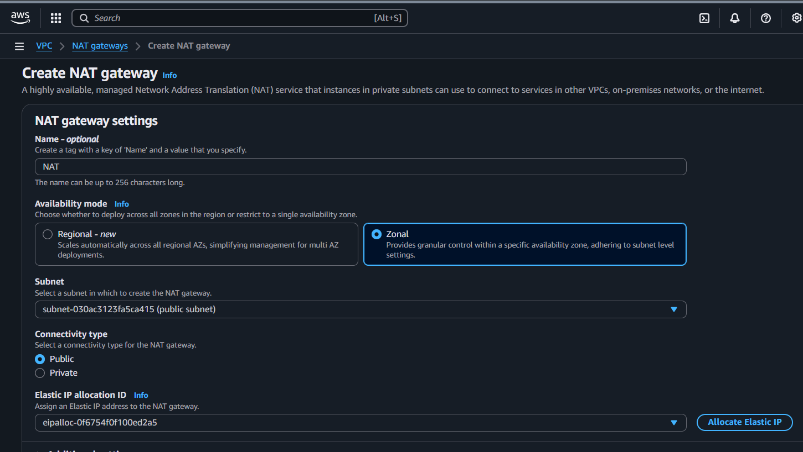
Step 3: Review the details and Proceed
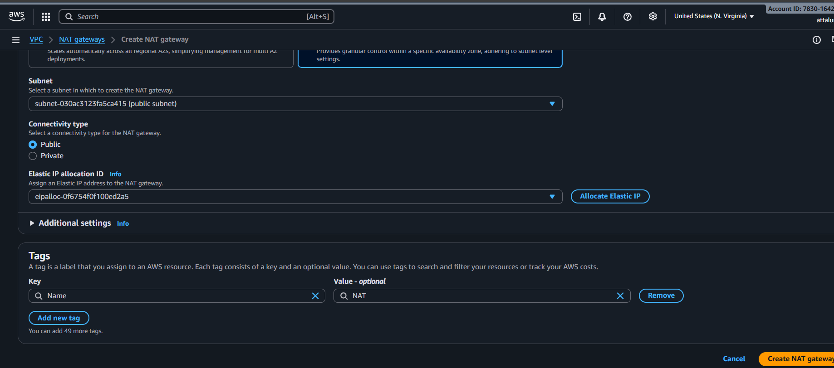

Step 4: Nat gateway has been created successfully
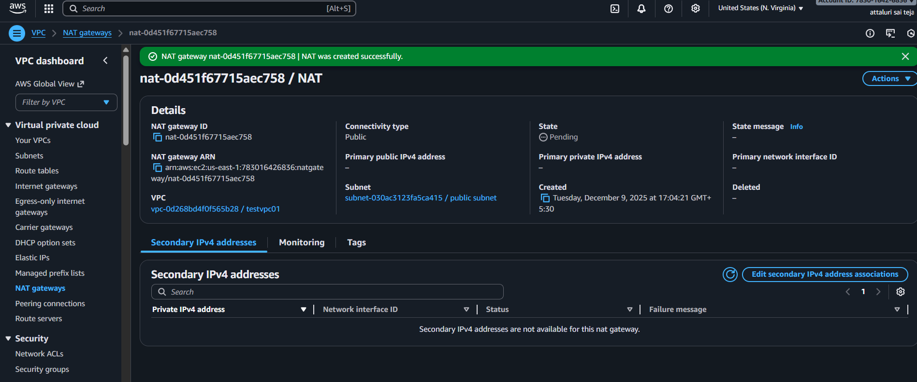
Step 5: Listed the subnets and verified route tables and attach NAT gateway in Private Subnet
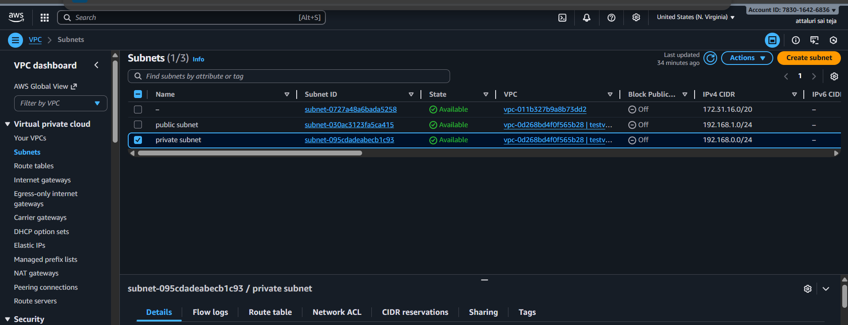
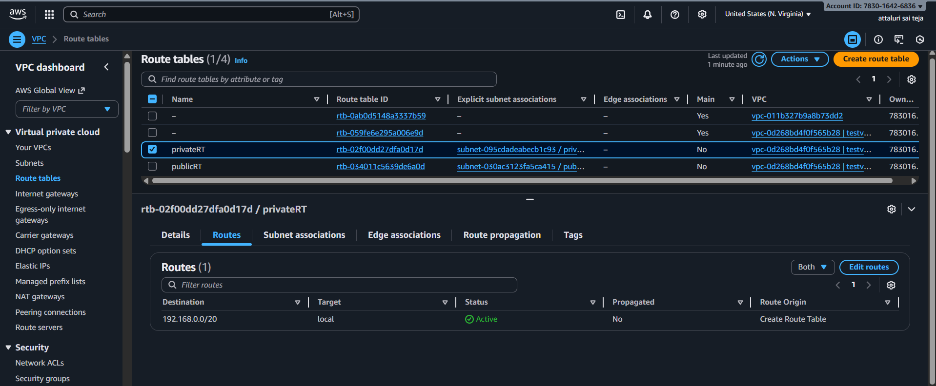
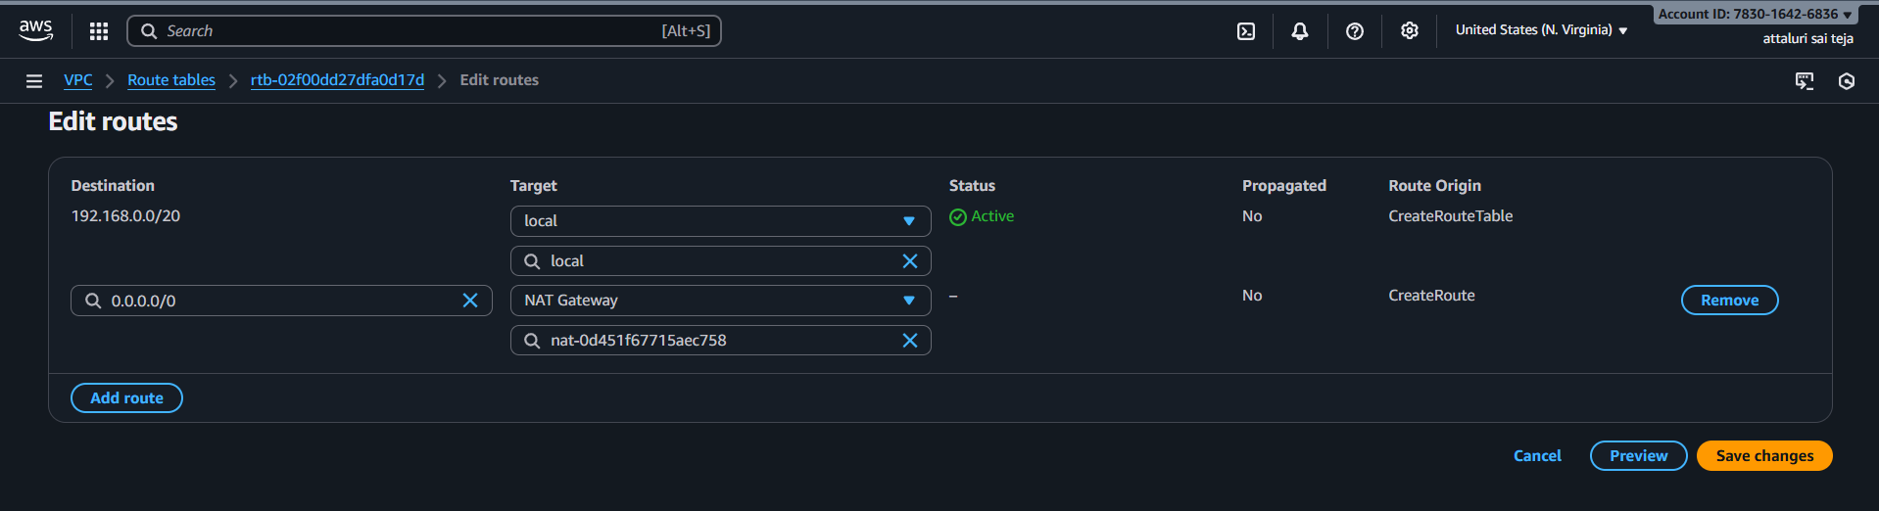
Step 6: private RT has been updated Successfully
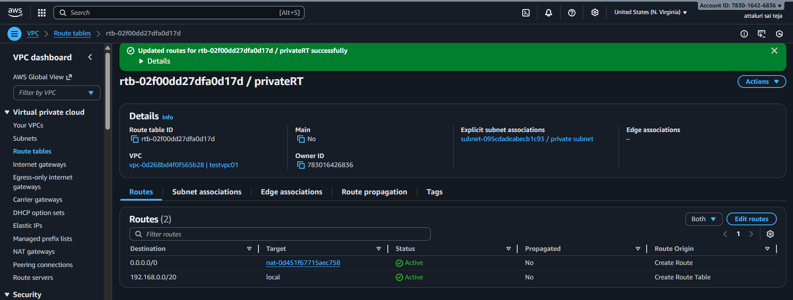
Step 7: Add the subnet associations and continue
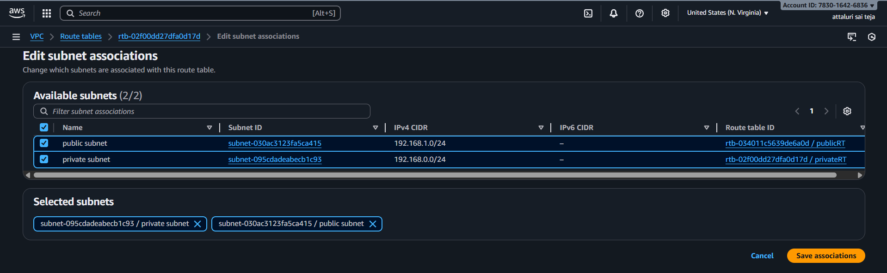
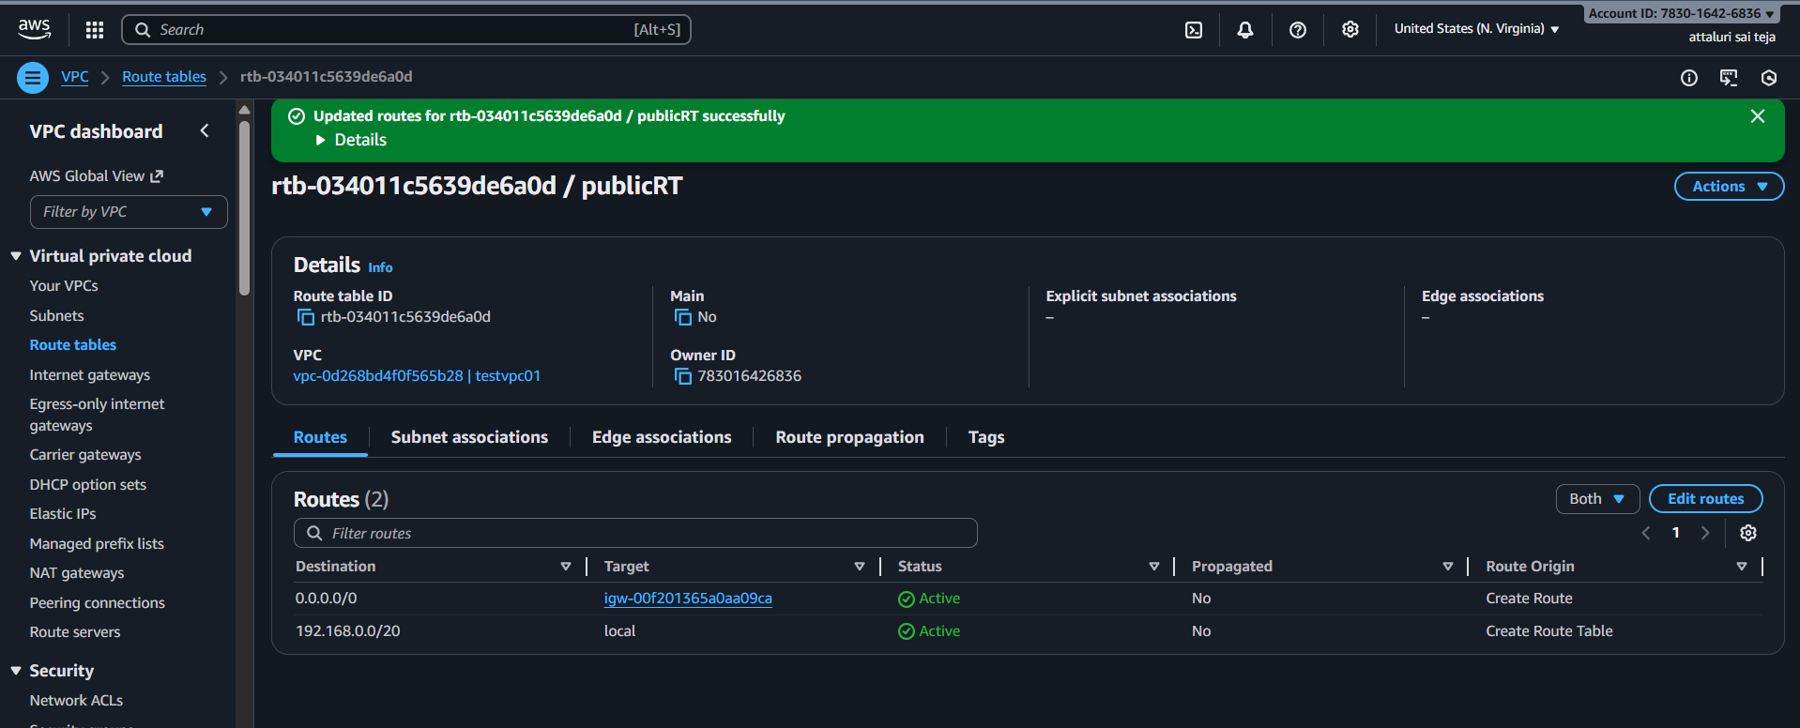
Step 8: Add the IGW into public route table and continue
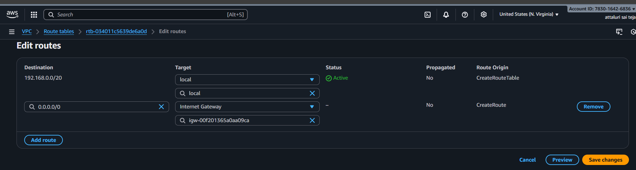
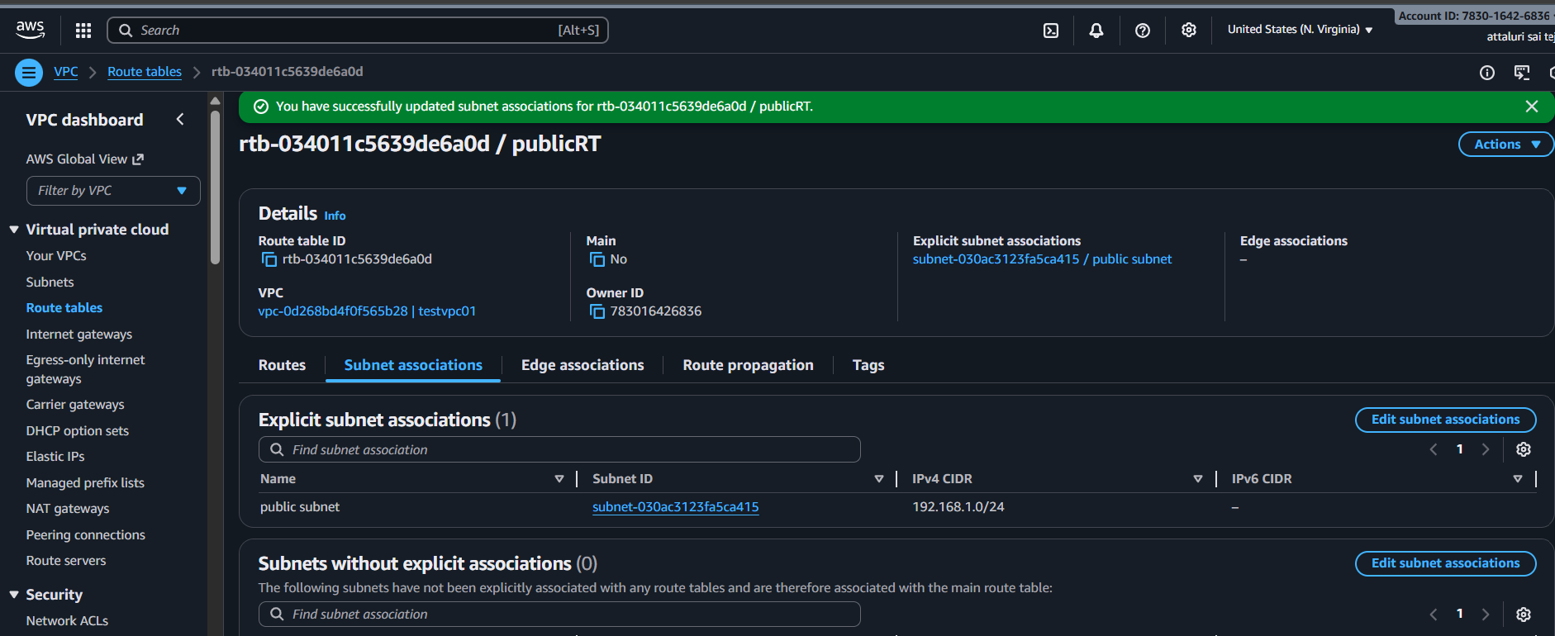
Issues Faced:
Check twice the route table and subnet associations by that you can connect to internet and you can connect from public to private ec2
Conclusion:
The NAT Gateway setup successfully provides secure outbound internet access for private subnet instances without exposing them to public traffic.

Title:
Deploy Apache server on both EC2 instances with a sample index.html file.
Objective:
Connecting between Public -private ec2 and Deploying an apache service
Prerequisites :
- 2 ec2
- Vpc
- Subnet
- SG
- Apache package
- Pem key (key pair)
Step by Step Implementation:
Step 1: Navigate to ec2 in your aws console
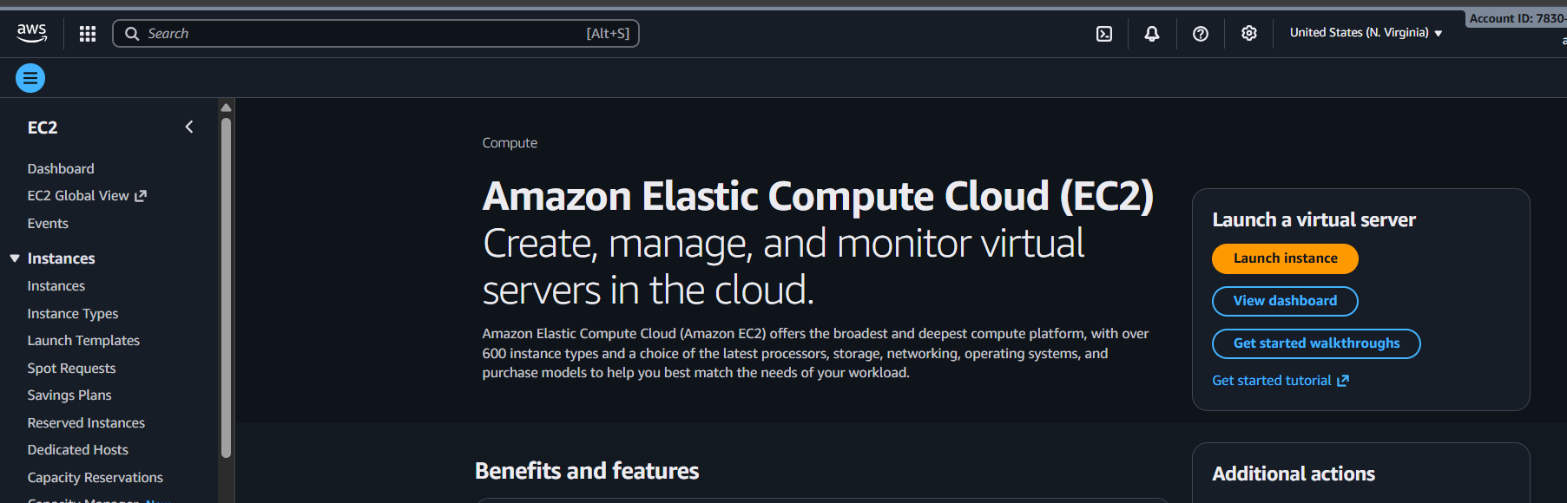
Step 2: Provide a name to ec2 to easily recognize and continue to next
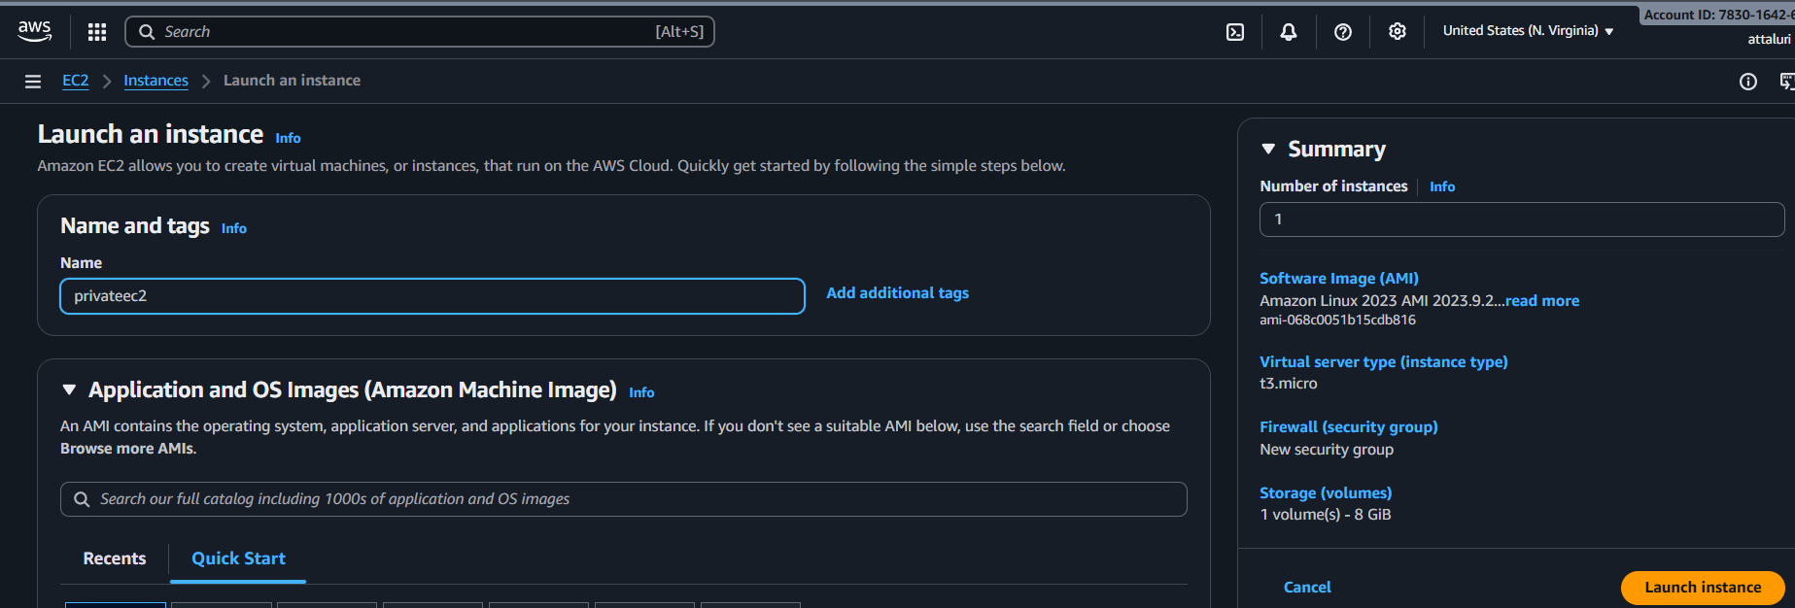

Step 3: Select VPC which we created and Select Private subnet for creating private ec2 and select existing sg and continue
Disable Public ip
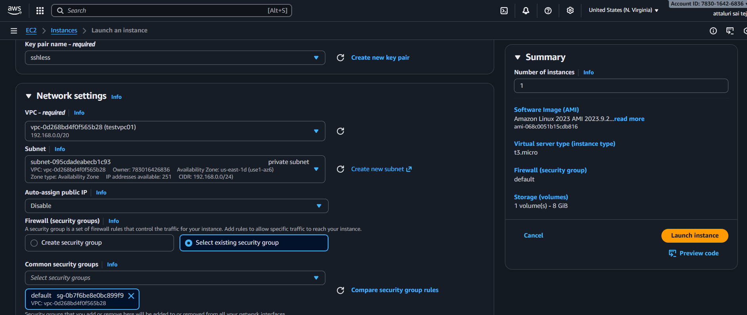
Step 4: Do the same for another ec2 by selecting public subnet
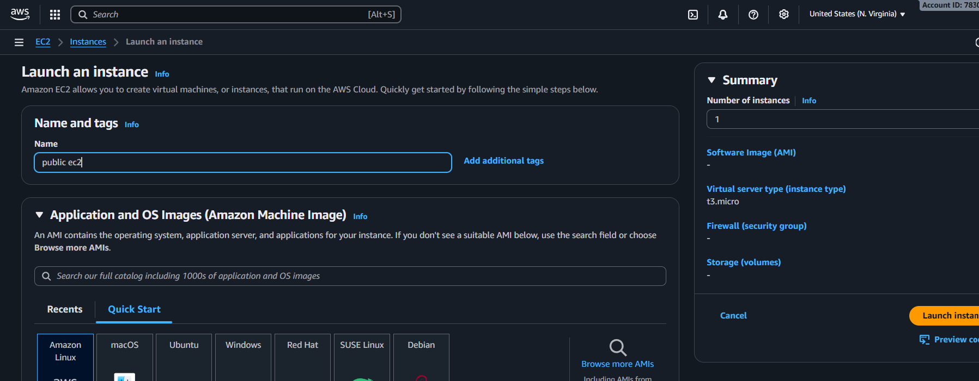
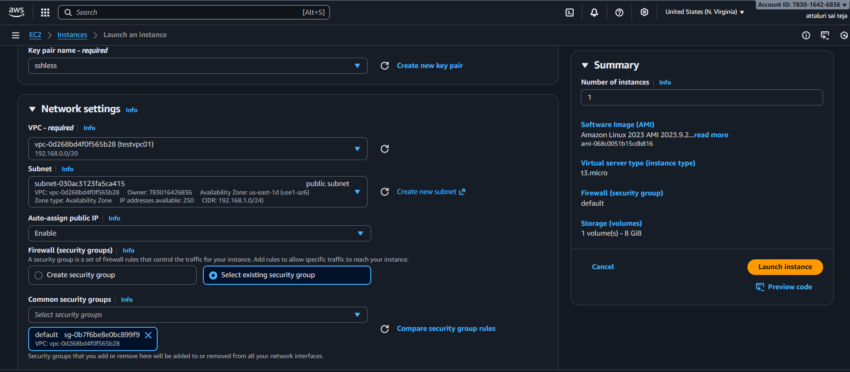
Listed the EC2 Instances
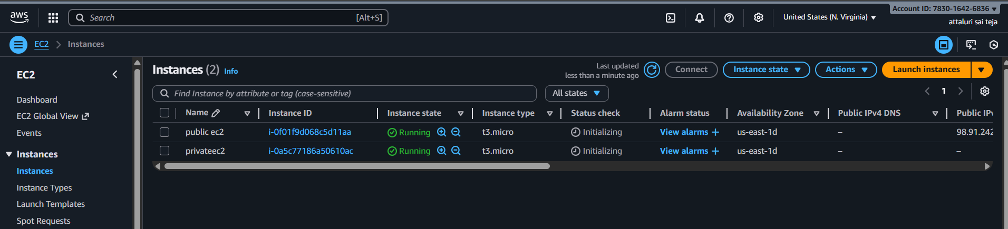
Step 5: Tried to Connect with CLI and got an error
Allow security groups ssh port and continue
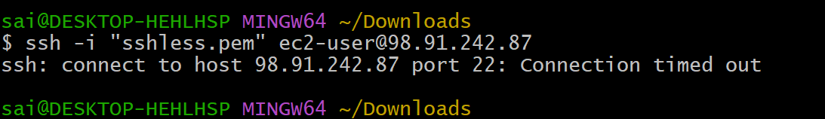
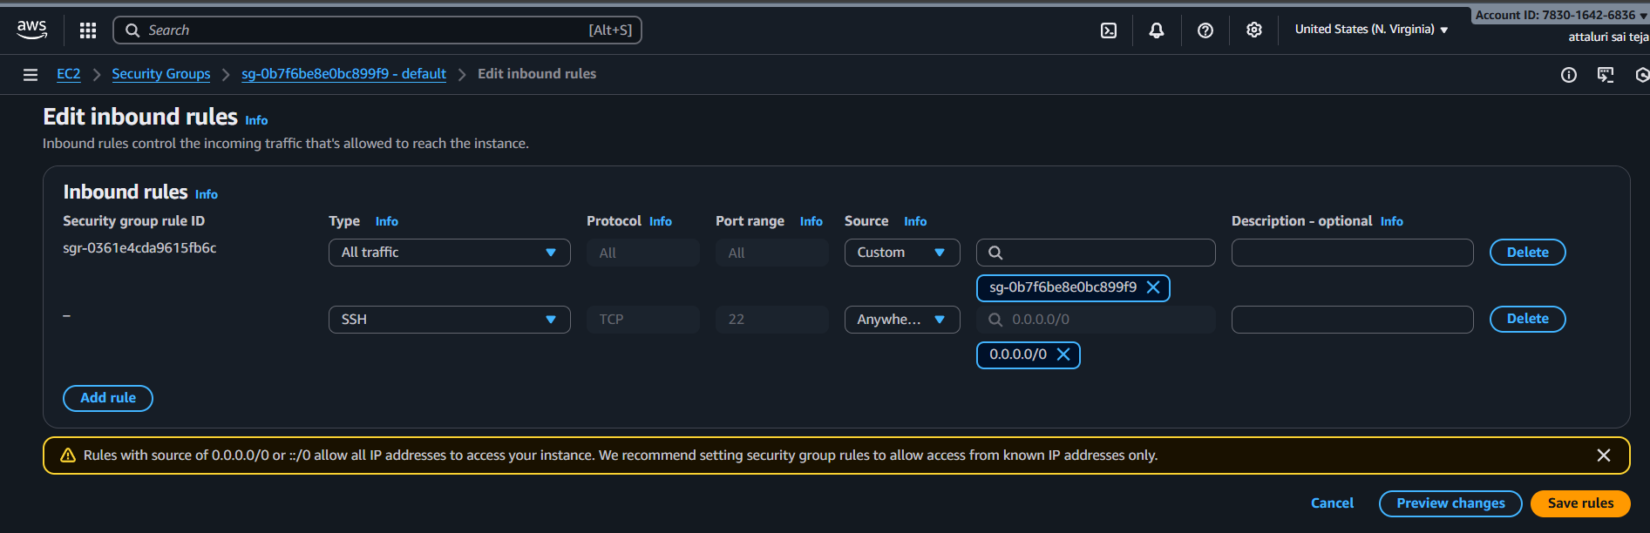
Connected with CLI
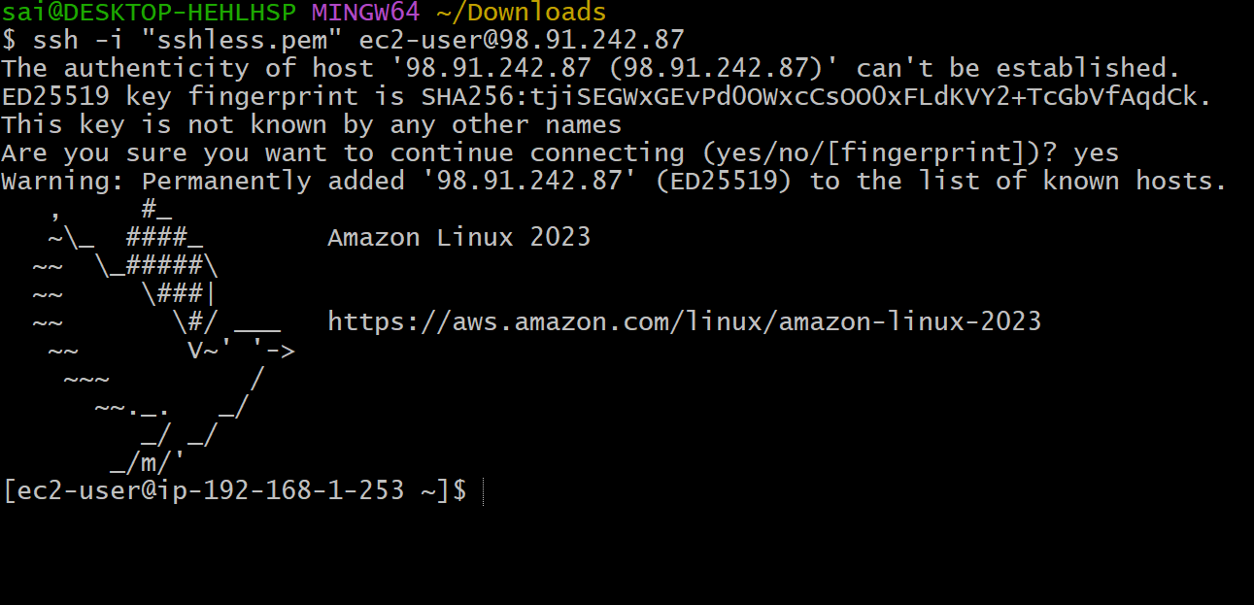
Step 6: Install Httpd and continue
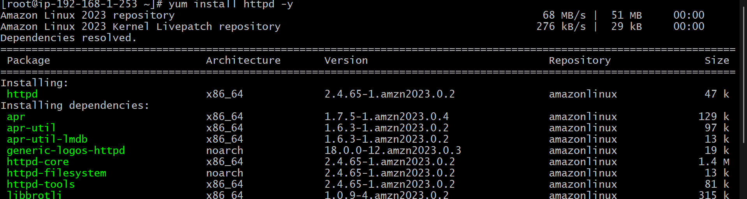
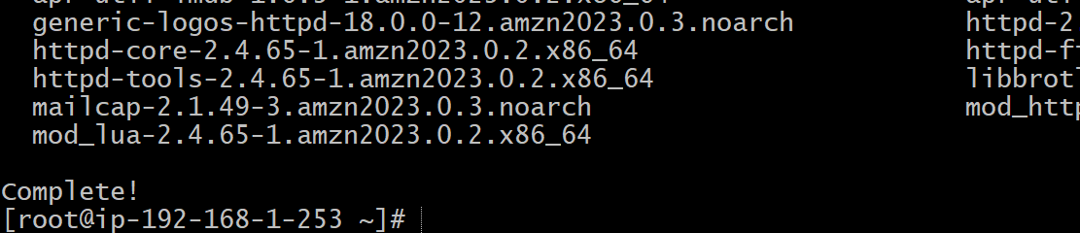
Checked the status of the service and started the service
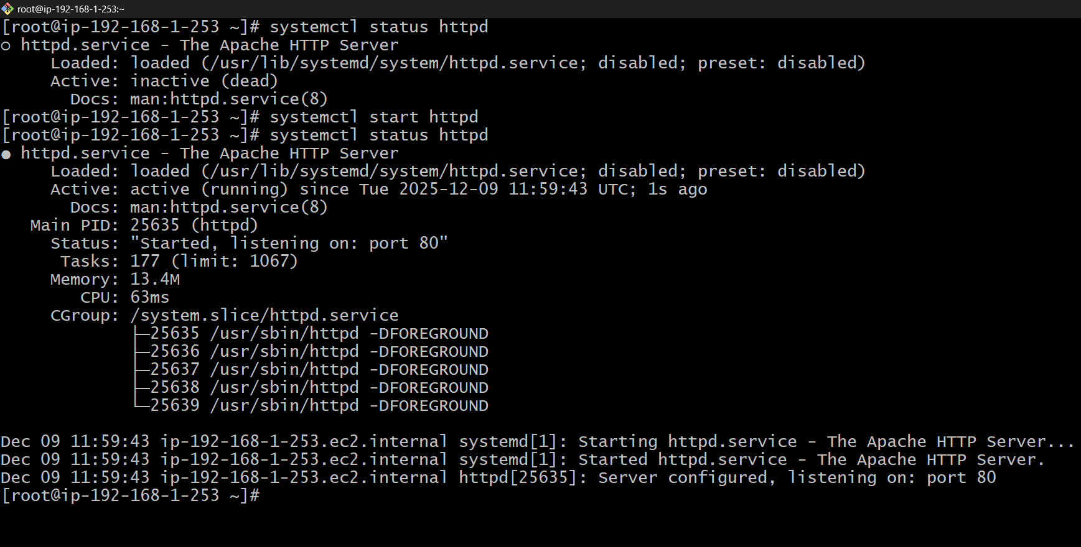
Also verified in web browser using publicip@port number


Step 7: Change the directory and create a index.html file and insert the data into it and later verified in web browser
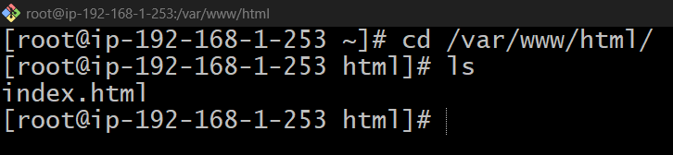
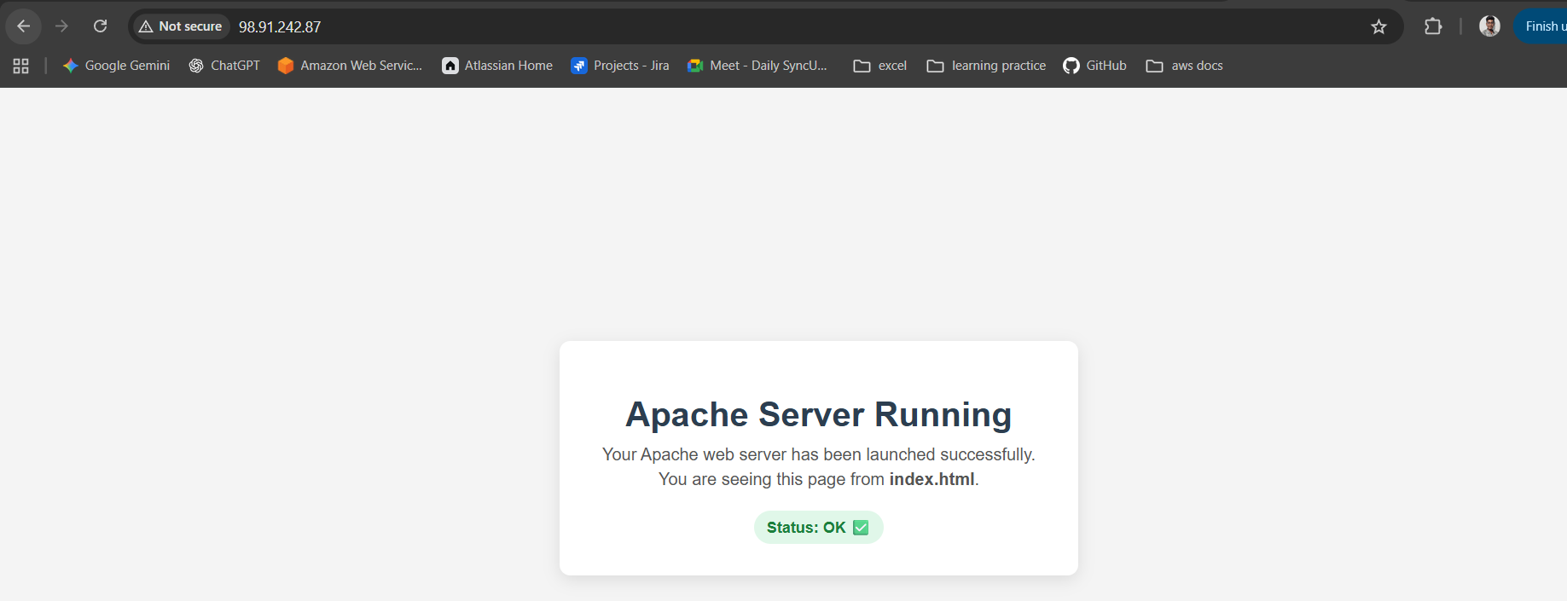
Step 8 : Trying to connect with private ip and faced an error
We need to copy the private key and need to paste in CLI so that it works
Also need to provide permisiion to that file
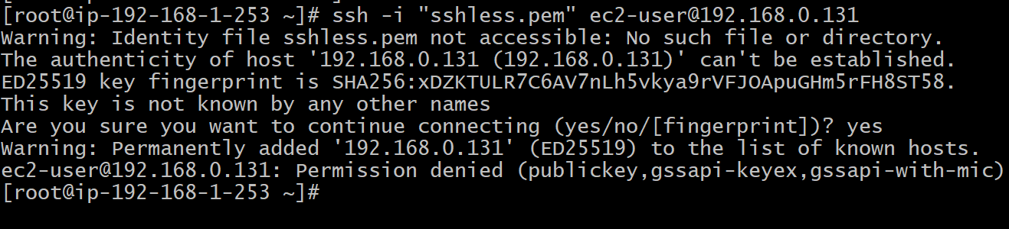
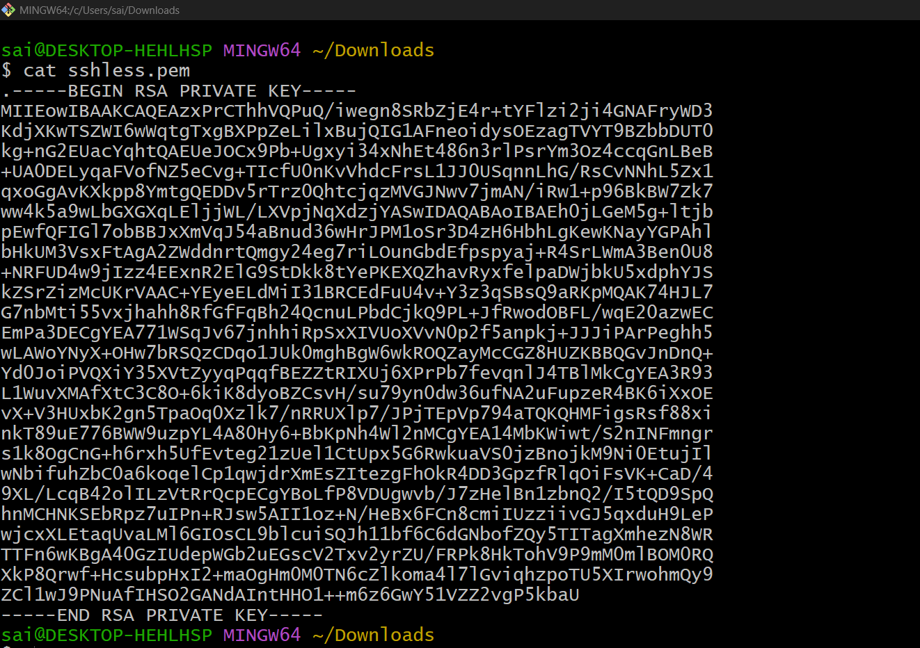
Created a file called test.pem and pasted and provided permissions and after
Successfully connected to private ec2
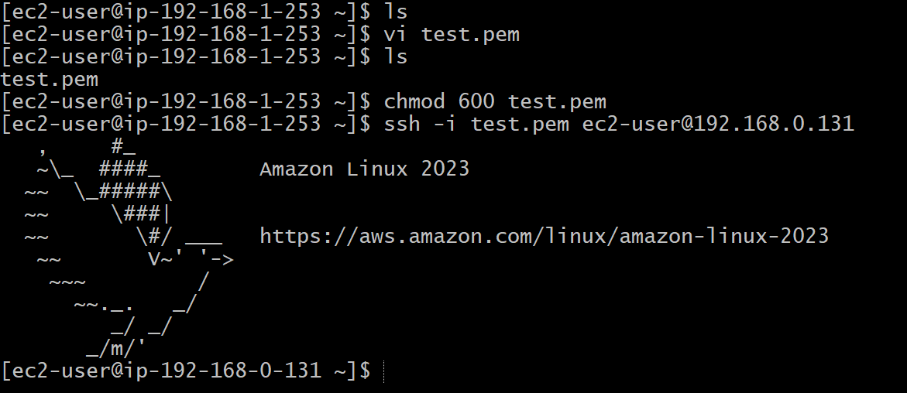

Step 8: Checking the Connectivity between servers using ping command
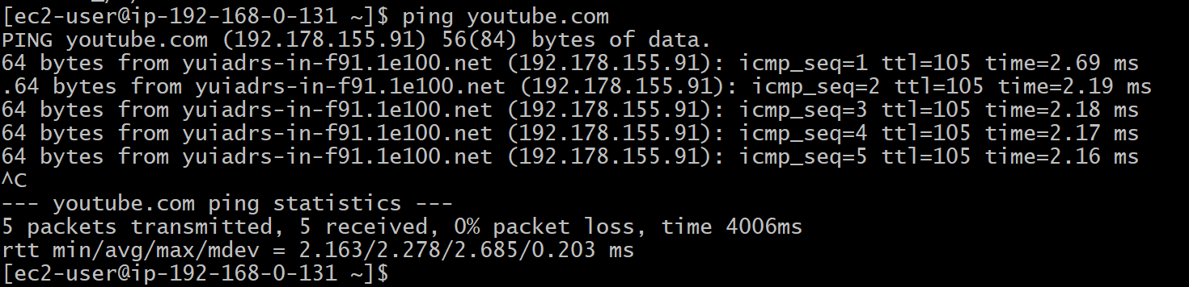
I again installed the same package in private ec2 as well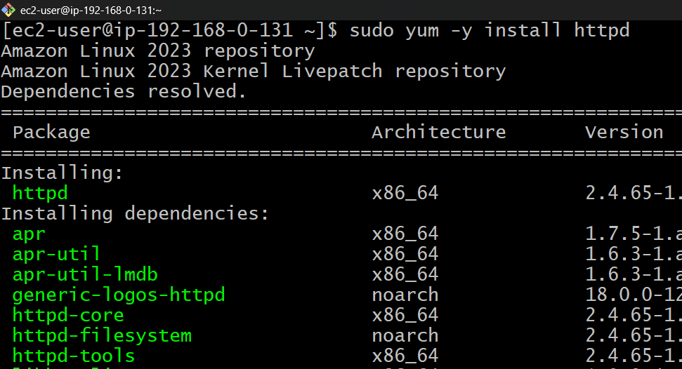
Again changed the directory and updated the index,html file and verified in CLI
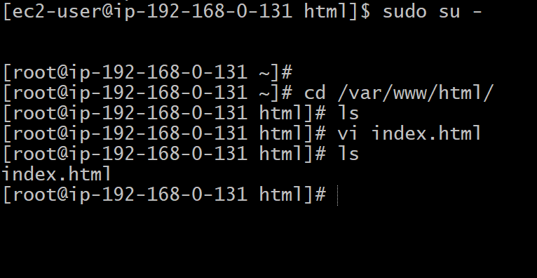
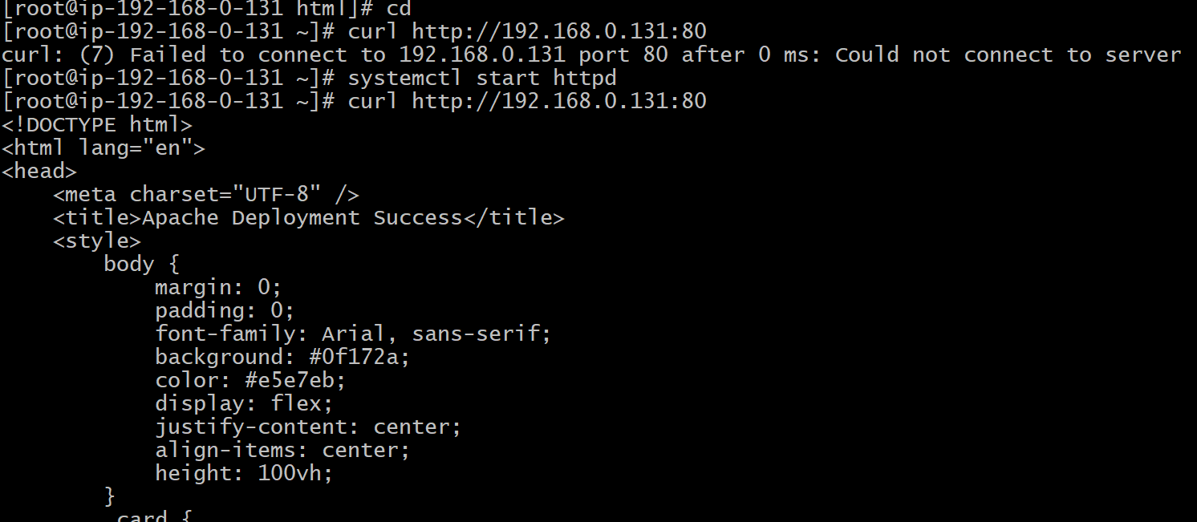
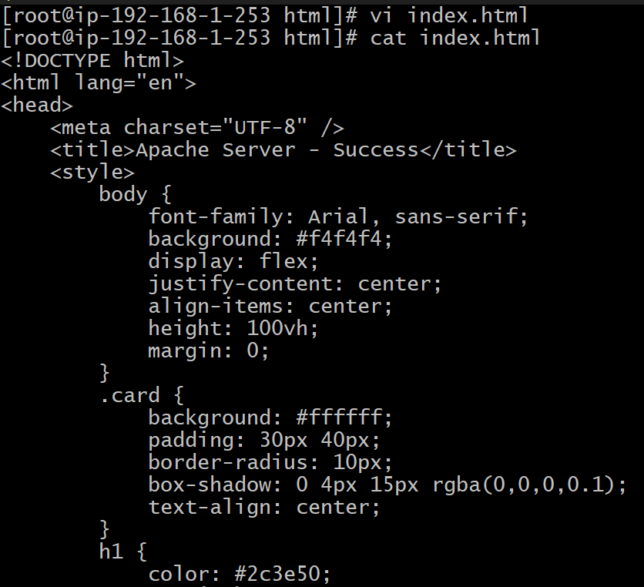

Issues Faced:
Faced the issues while connecting between ec2’s ensure the files were successfully created (.pem) .
Conclusion:
Apache was successfully deployed on both EC2 instances, and the sample index.html page is correctly served, confirming that the web servers are functioning as expected in their respective subnets.

Title:
Create one application load balancer and attach it to both EC2 instances.
Objective:
Deploy an Application Load Balancer and register both EC2 instances to evenly distribute traffic and ensure high availability of the web application.
Prerequisites :
- Load Balancer
- VPC
- EC2
- Subnets
- Target Groups
- Index.html files
- Apache Package
Step by Step Implementation:
Step 1: Navigate to VPC and Create another subnet in another zone with existing CIDR range only
And click on create
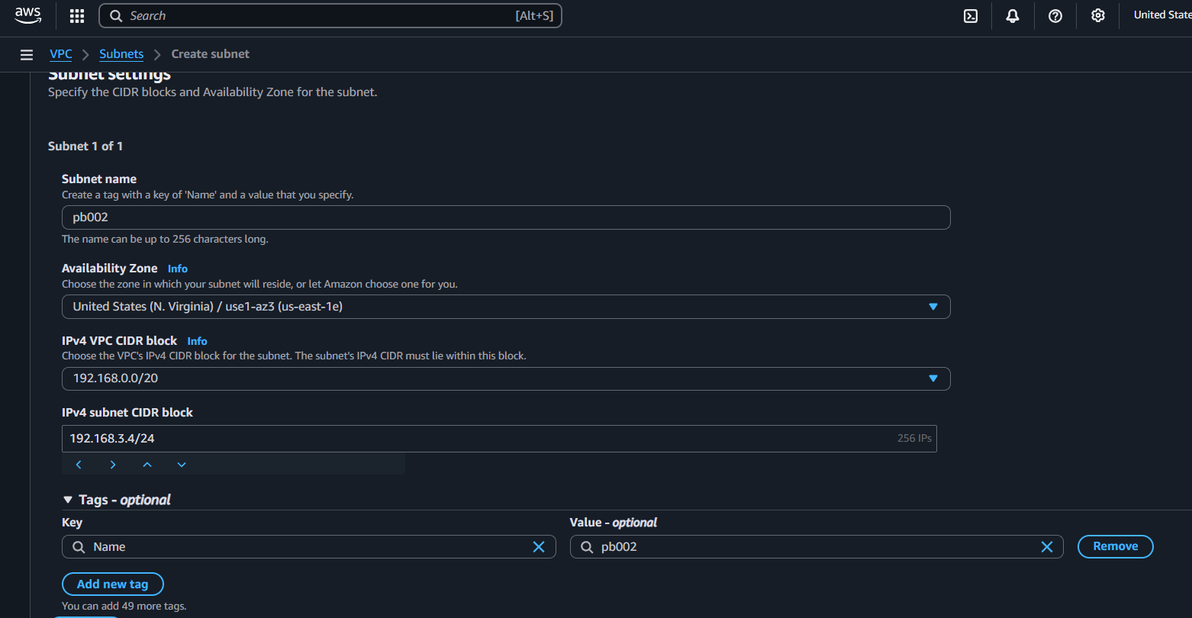
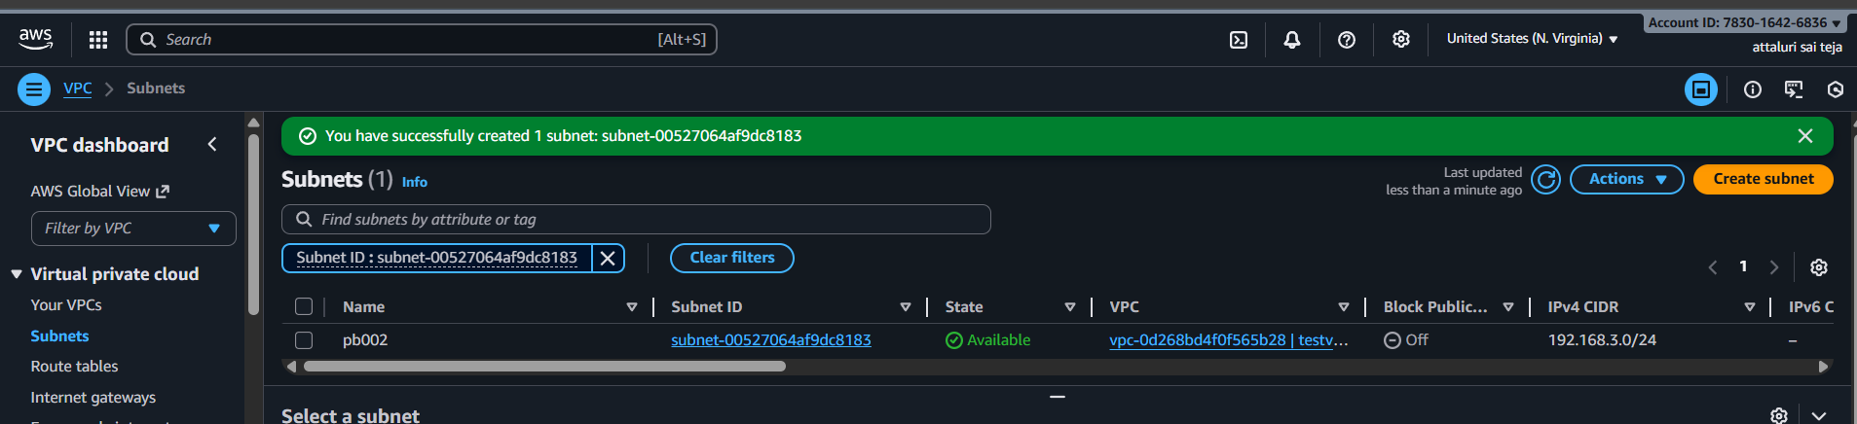
Step :2 Define route tables accordingly by giving IGW and NAT in public and private subnet
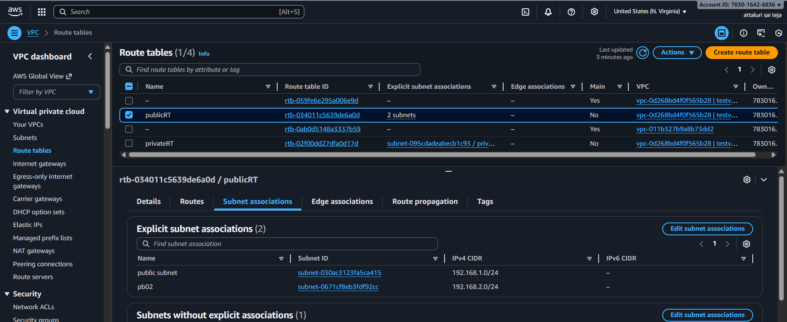
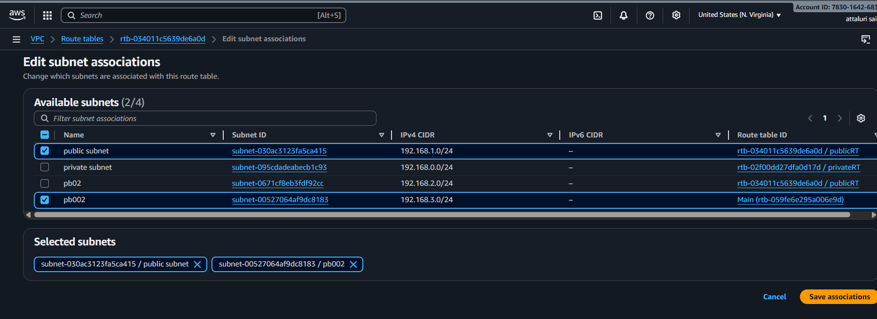
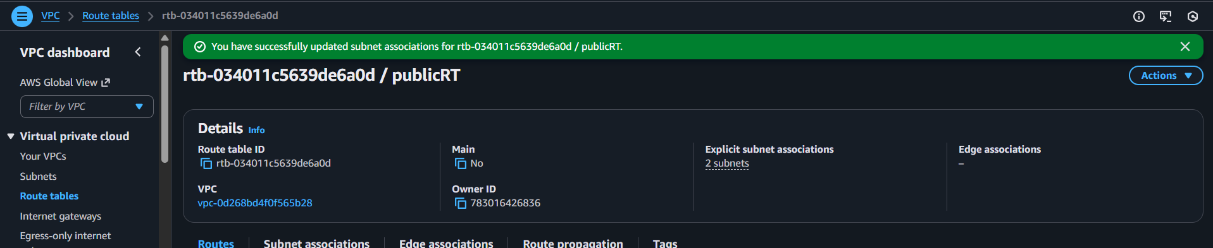

Step 3: Navigate to EC2 and select load balancer as service and continue
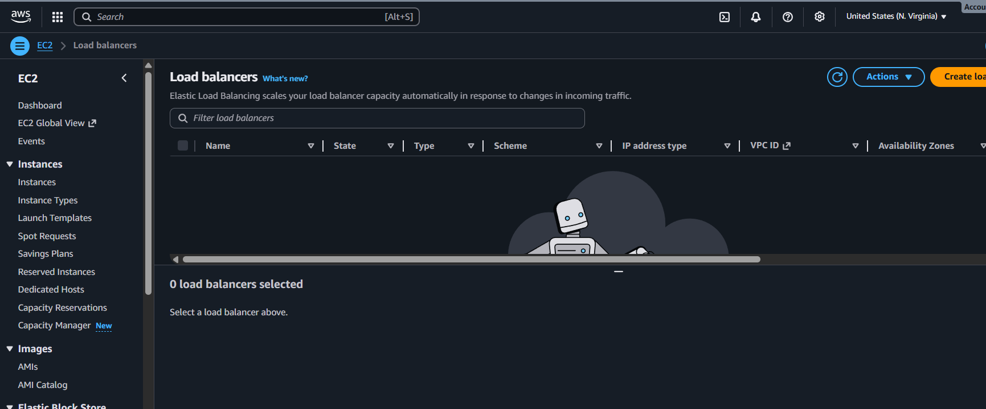
Step 4: Select Application Load balancer and continue by providing name and selecting vpc and subnets
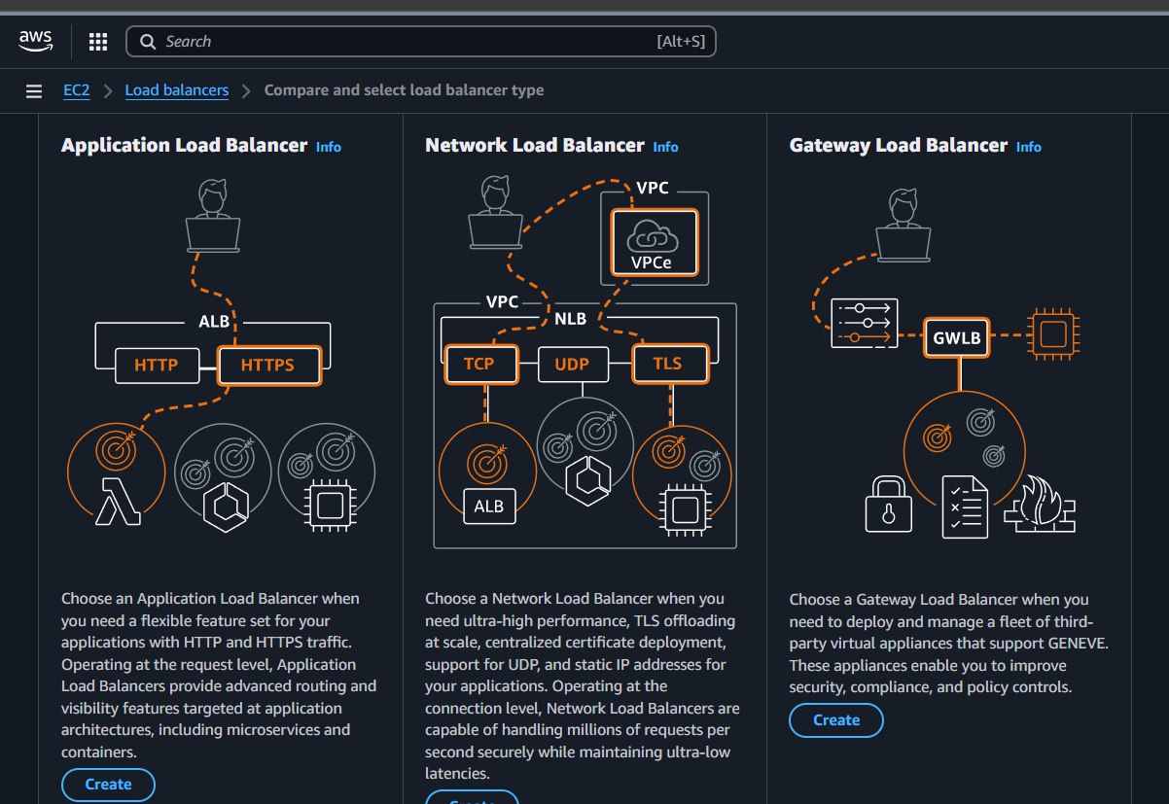
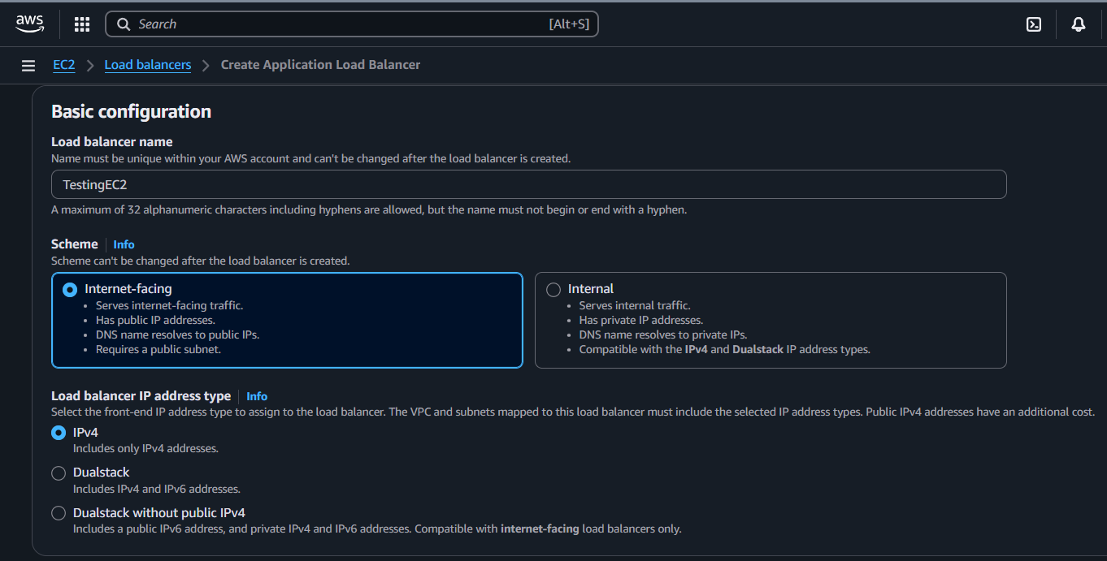
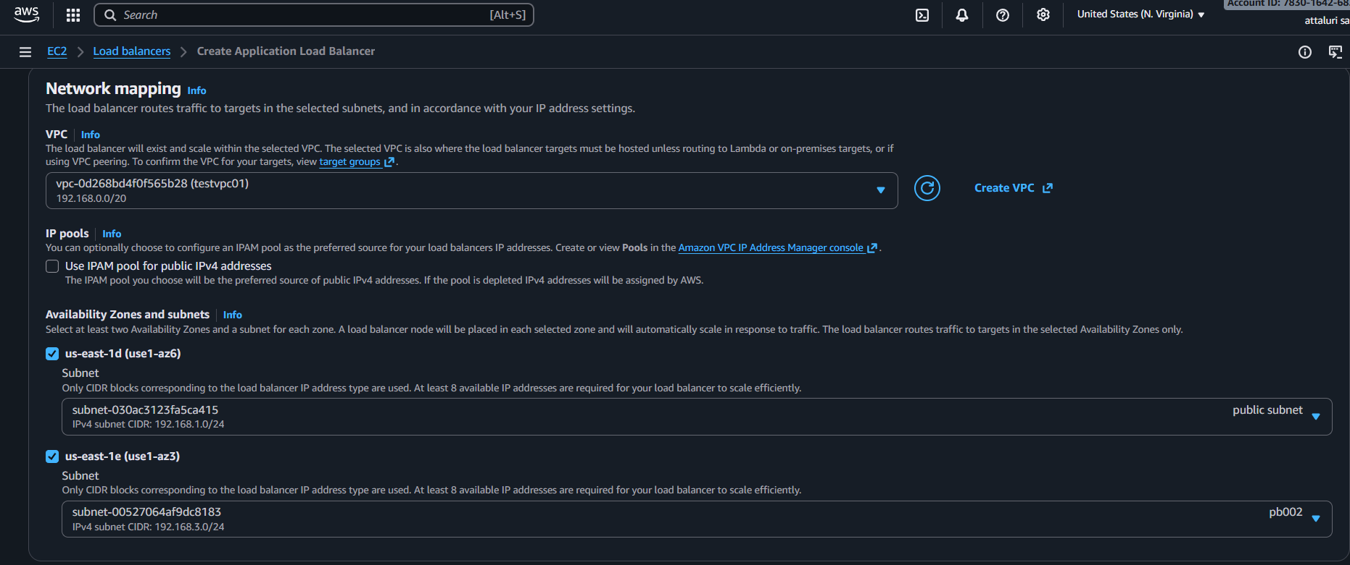
Step 5: Select the target group if earlier created or click on create to create new
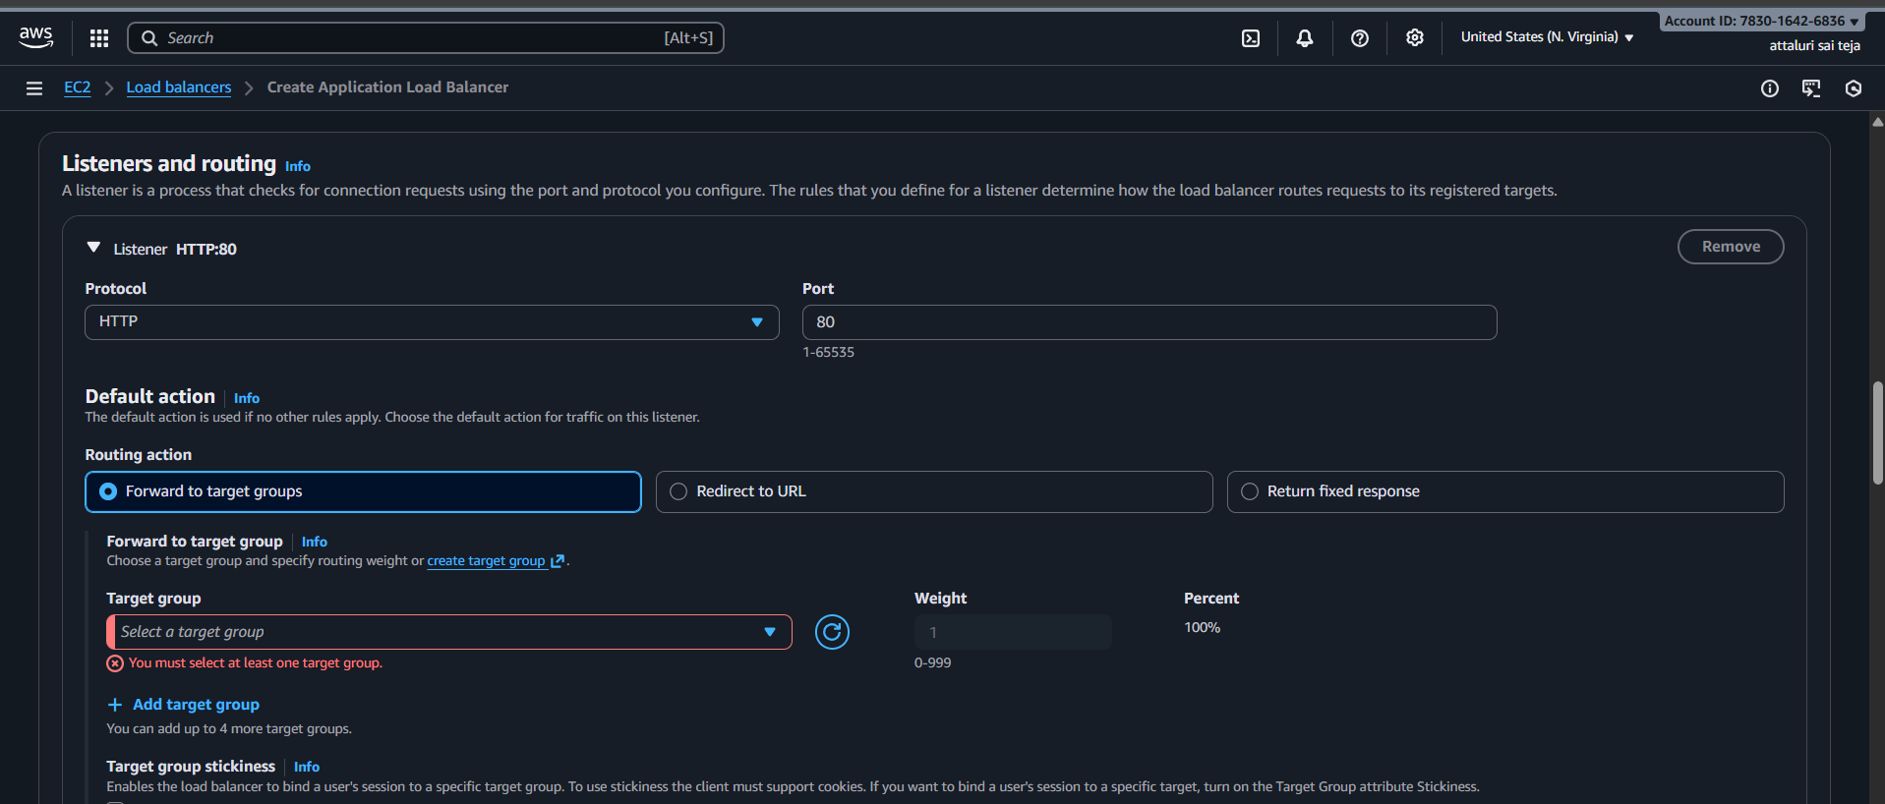

Step 6: In the target group select instances and provide a name and continue
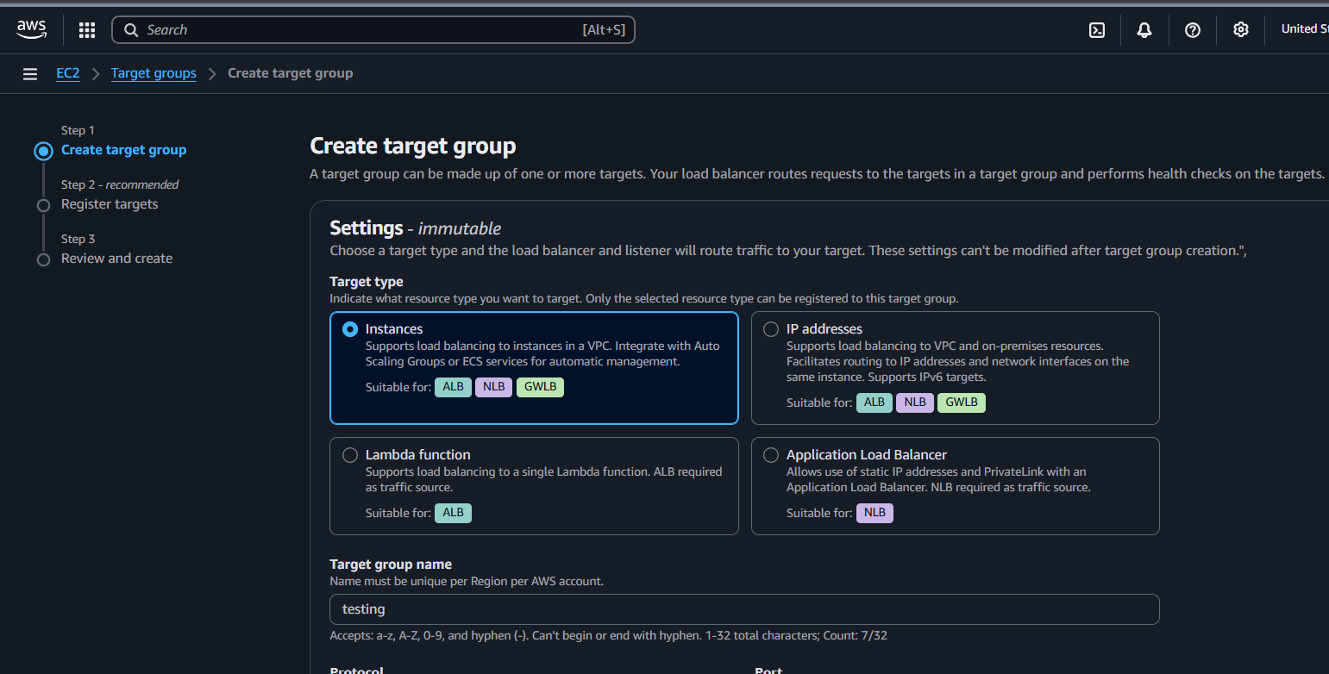
Select the VPC and and verify the port number as 80
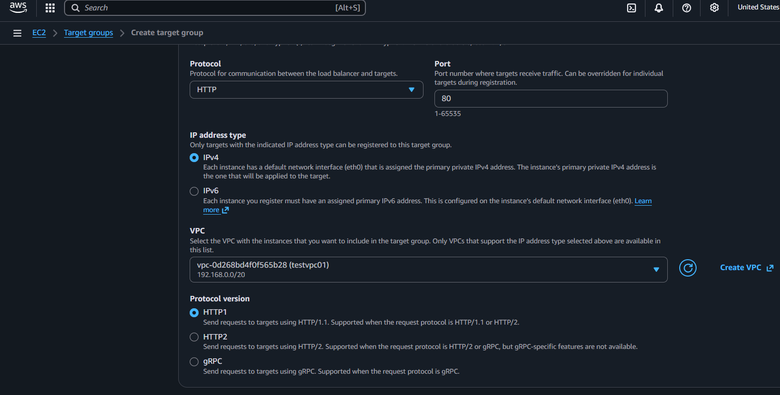

Step 7: Select the Running Instances and click on continue
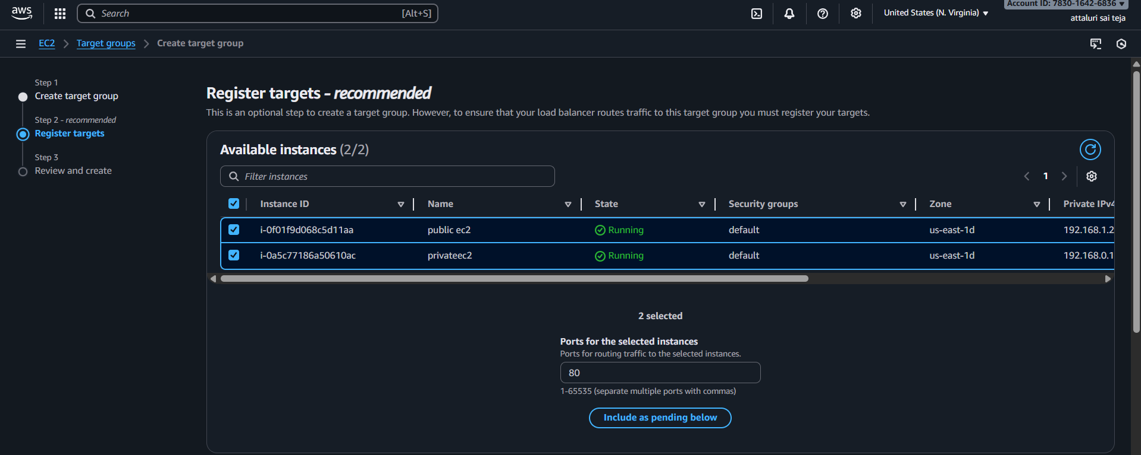
Then create the target groups
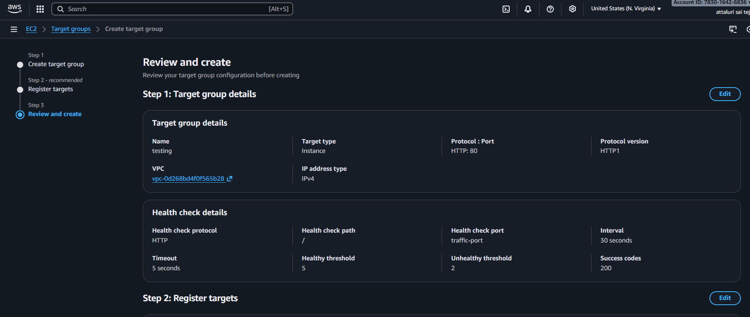
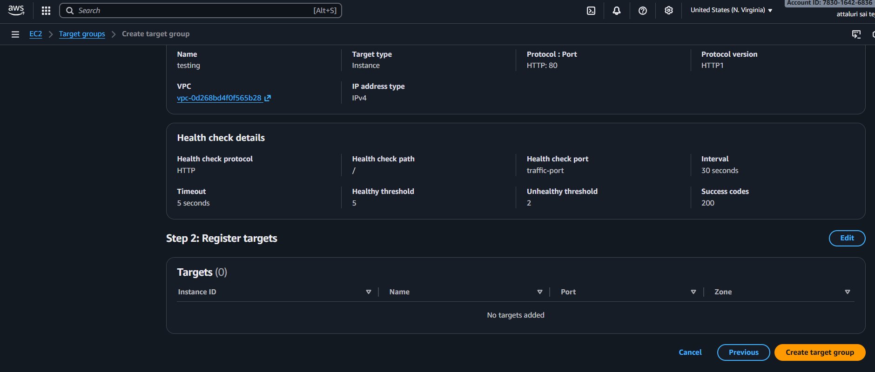

Target group has been created and check the health of instances
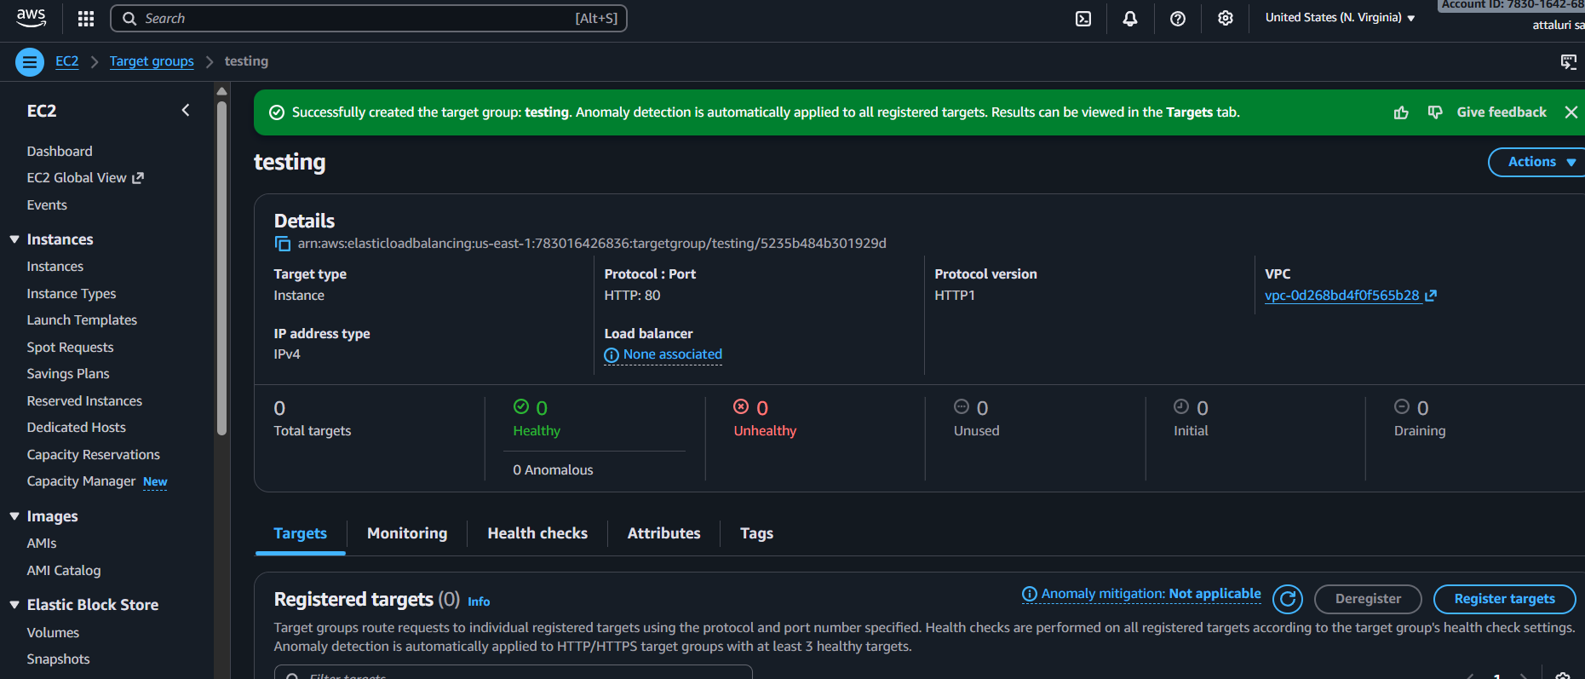
If any issues occur while creating target groups then click on INCLUDE AS PENDING BELOW and register the targets
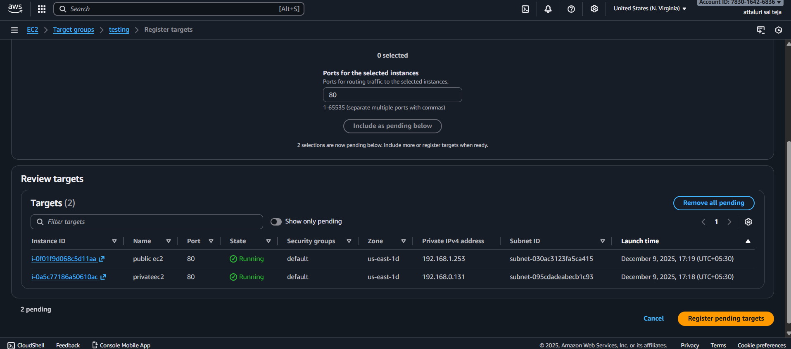
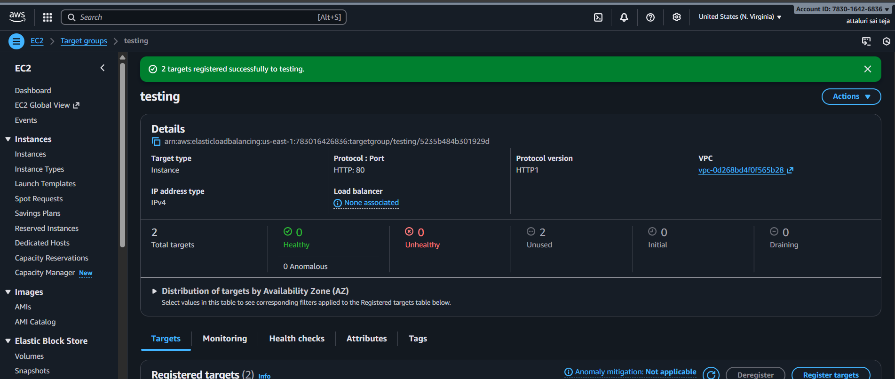
Step 8: Faced an error while checking the health
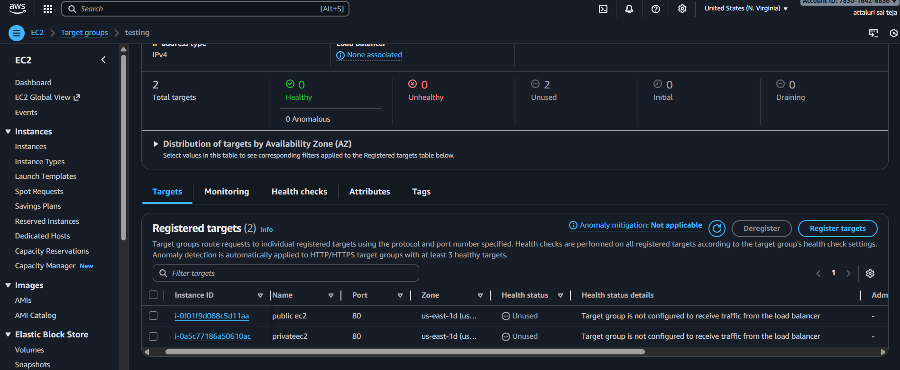
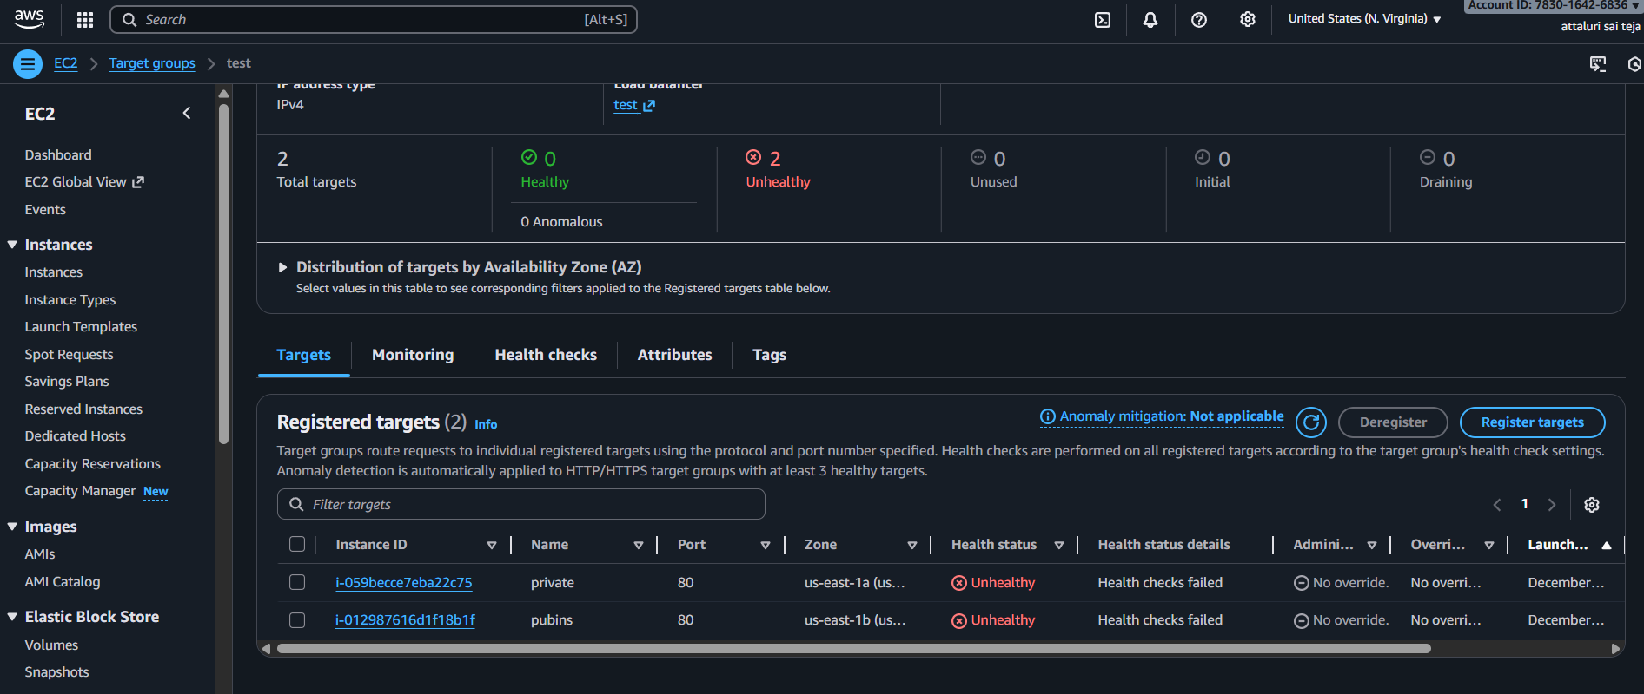
To overcome the issue I reverified the package,port number, route table,sg,subnet associations which I installed after that the checks were into healthy stage
Public ip Validation


Private ip validation
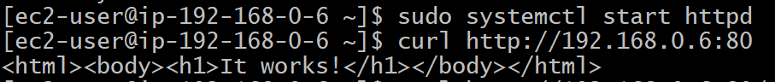
Back to Load balancer
Step 9: Select the Routing action as forward to target options and select the created target group and continue
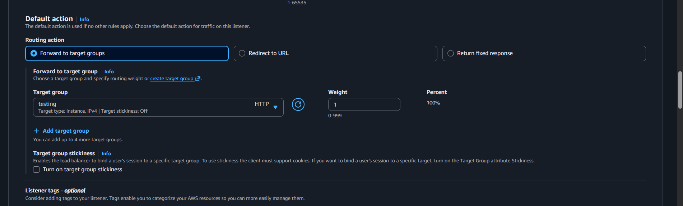
Click on create to continue
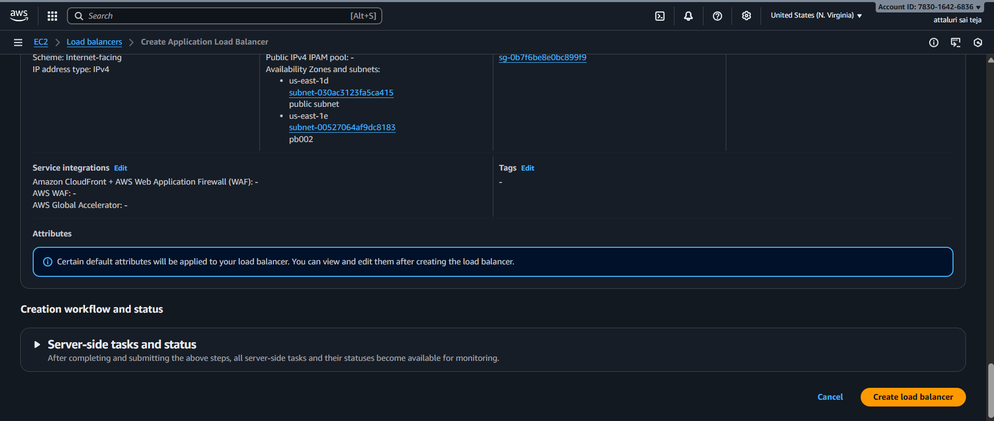

And if you see the status it is in provisioning stage wait for some time it will be Active

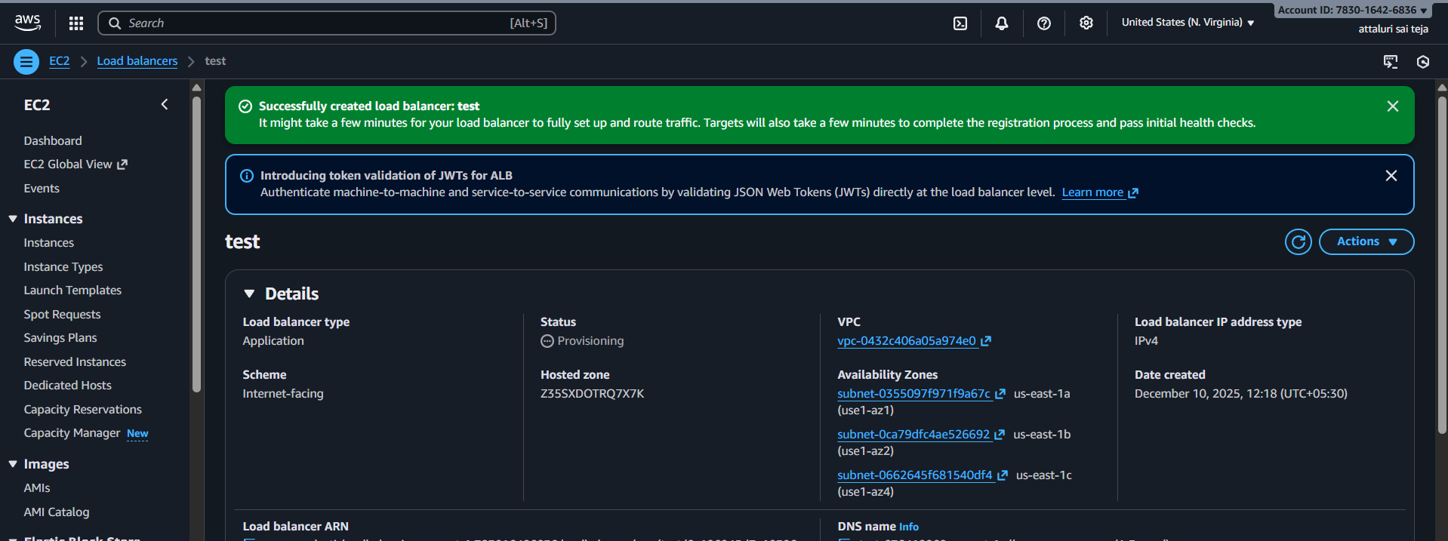
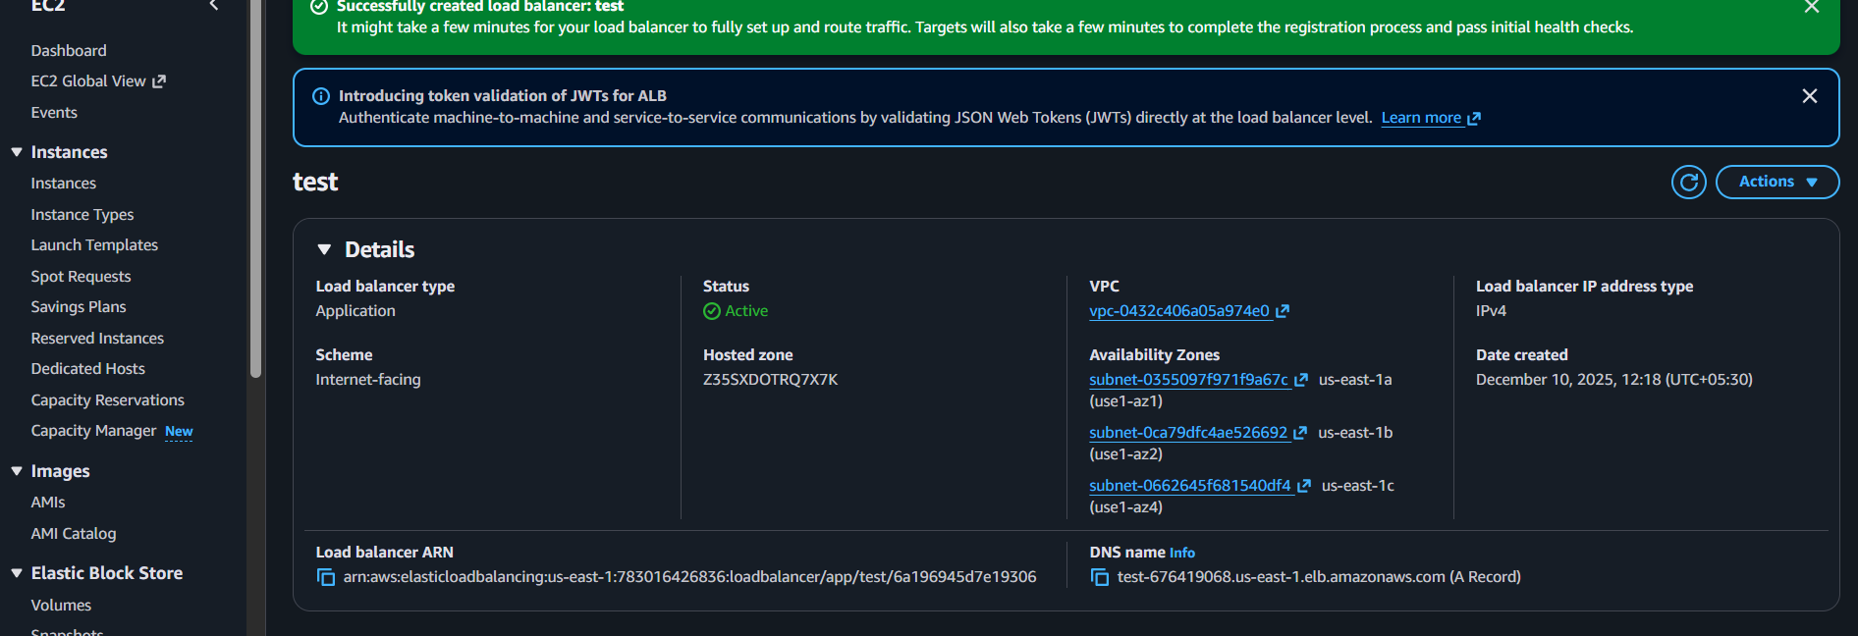
Step 10: Click on the DNS link and verify in Browser
If you refresh the web page then it will redirect to another
Private EC2 webpage
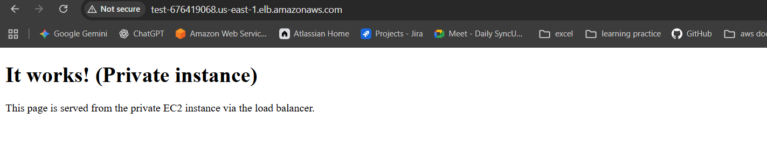
Public Ec2 webpage
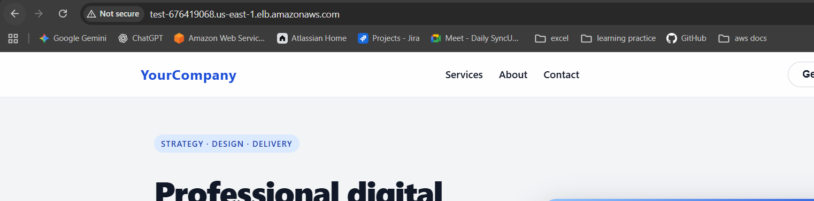

Issues Faced:
Target Group Showing Unhealthy (403/404 Errors)
During the load balancer configuration, one of the EC2 instances (private subnet) constantly showed Unhealthy in the Target Group status.
The Health Status Details indicated:
- HTTP 403: Forbidden
- HTTP 404: Not Found
Although the instance was reachable through the Load Balancer, the Apache web server denied the health check request, resulting in failed health checks.
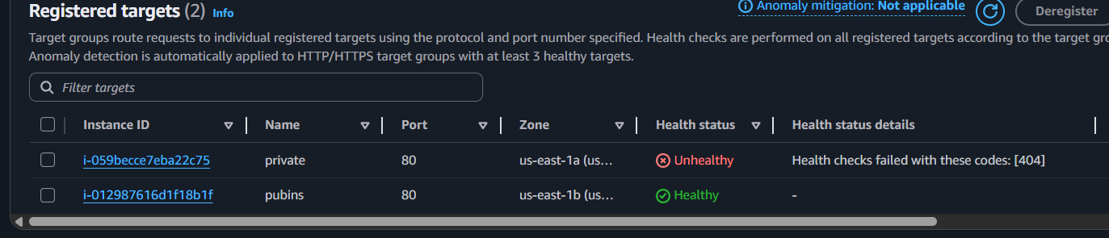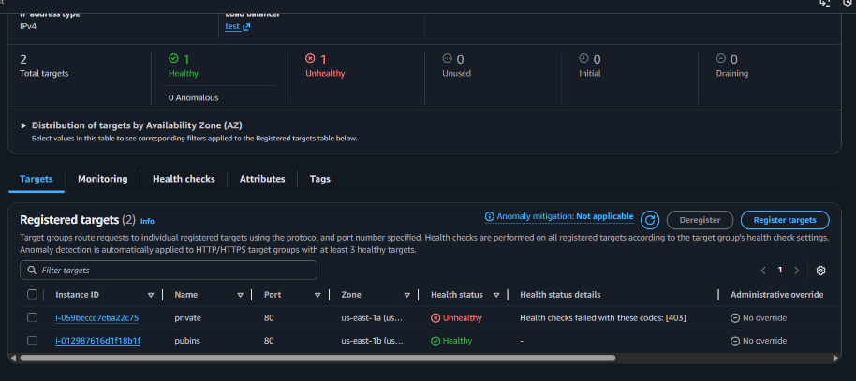
Root Causes Identified:
No valid index.html under /var/www/html, causing 404
Incorrect Apache <Directory> permissions, causing 403
ALB health check expected 200 OK but server returned errors
Conclusion
The issue was caused by missing website content and incorrect Apache directory access rules.
Once file structure, permissions, and Apache configuration were corrected, the health checks returned 200 OK, resolving the problem
Title:
Store application load balancer logs in S3.
Objective:
To enable and configure Application Load Balancer (ALB) access logging so that all incoming traffic logs are automatically stored in Amazon S3.
Prerequisites :
- Application Load Balancer
- S3
Step by Step Implementation:
Step 1: Navigate to S3 and select on create
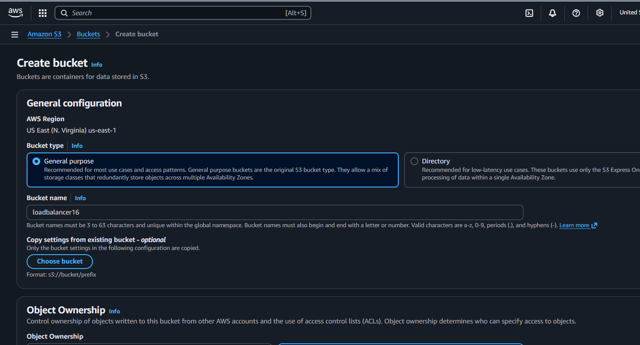

Step 2: Keep all the permissions default and continue with creation
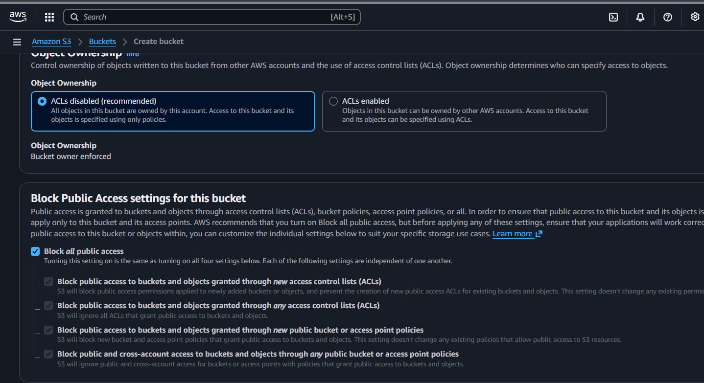
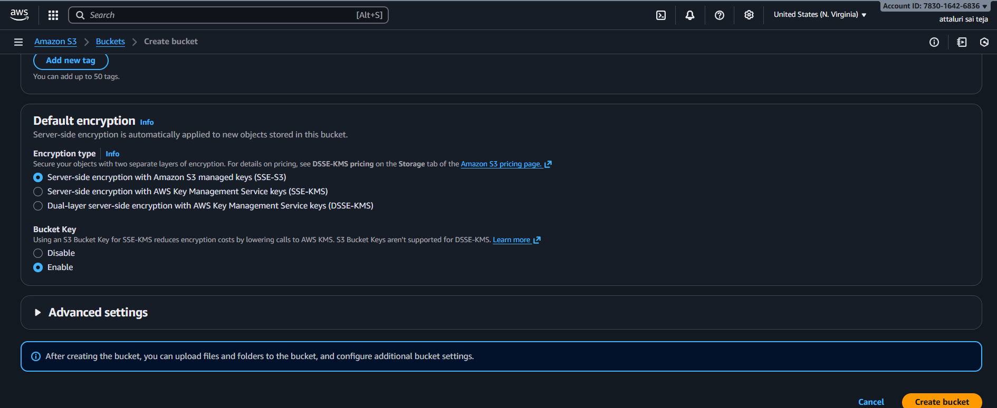
Successfully buckeyt has been created
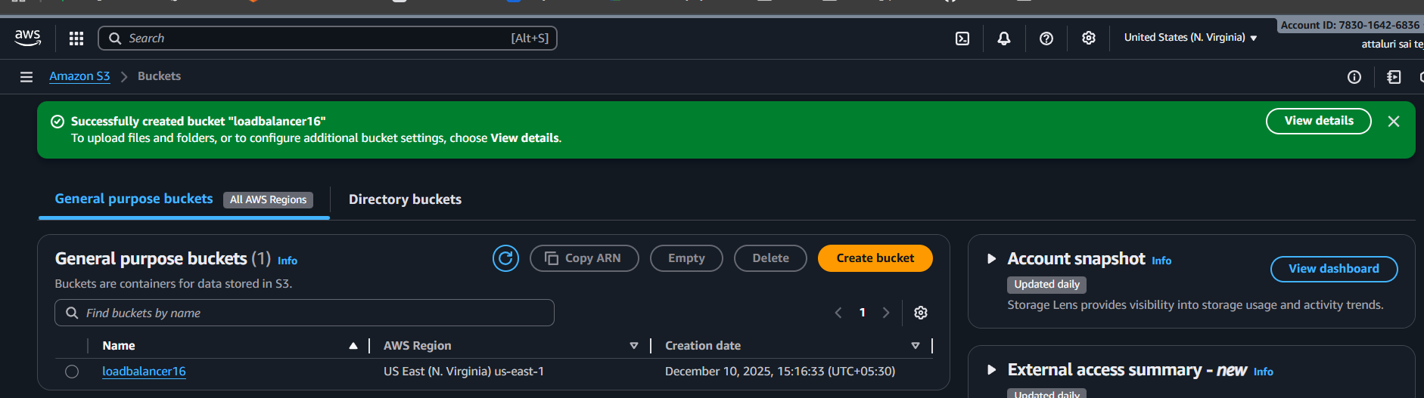

Navigate into the bucket and select permissions tab provide a json policy for storing the logs from alb to s3
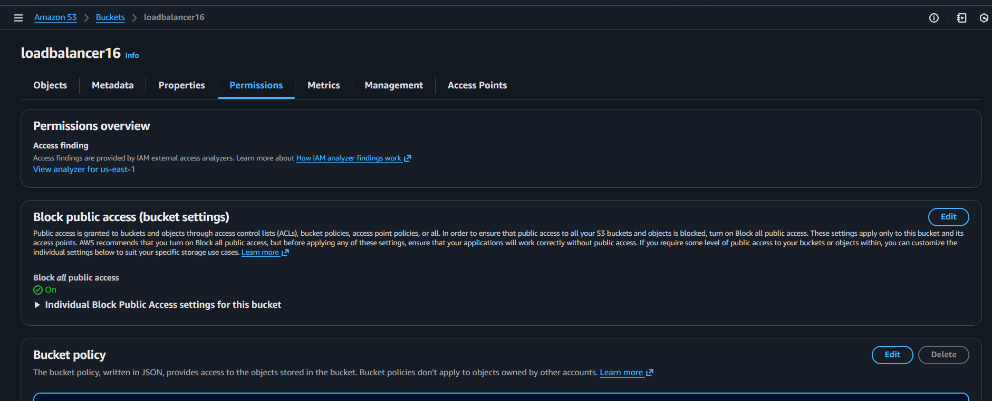
Here is the policy which I pasted.
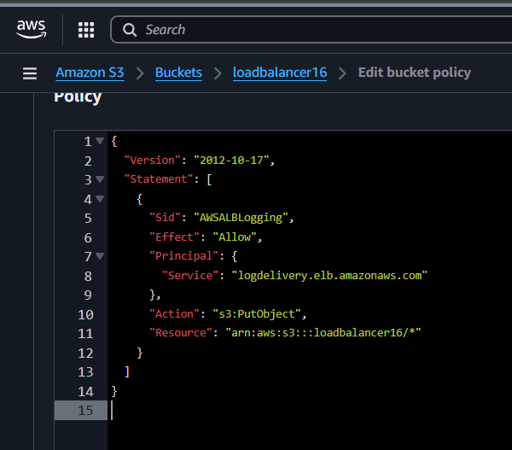

Step 3: Navigate to Load balancer in Ec2 and select attributes tab and proceed
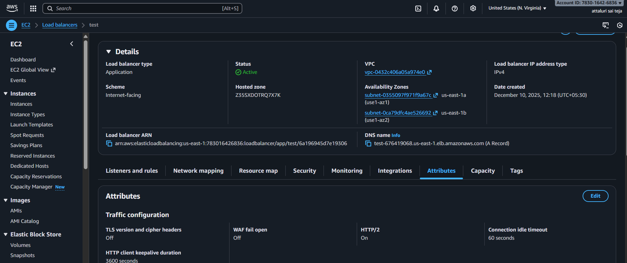
Step4: Scroll down the lists and enable the access logs and select the s3 bucket and continue
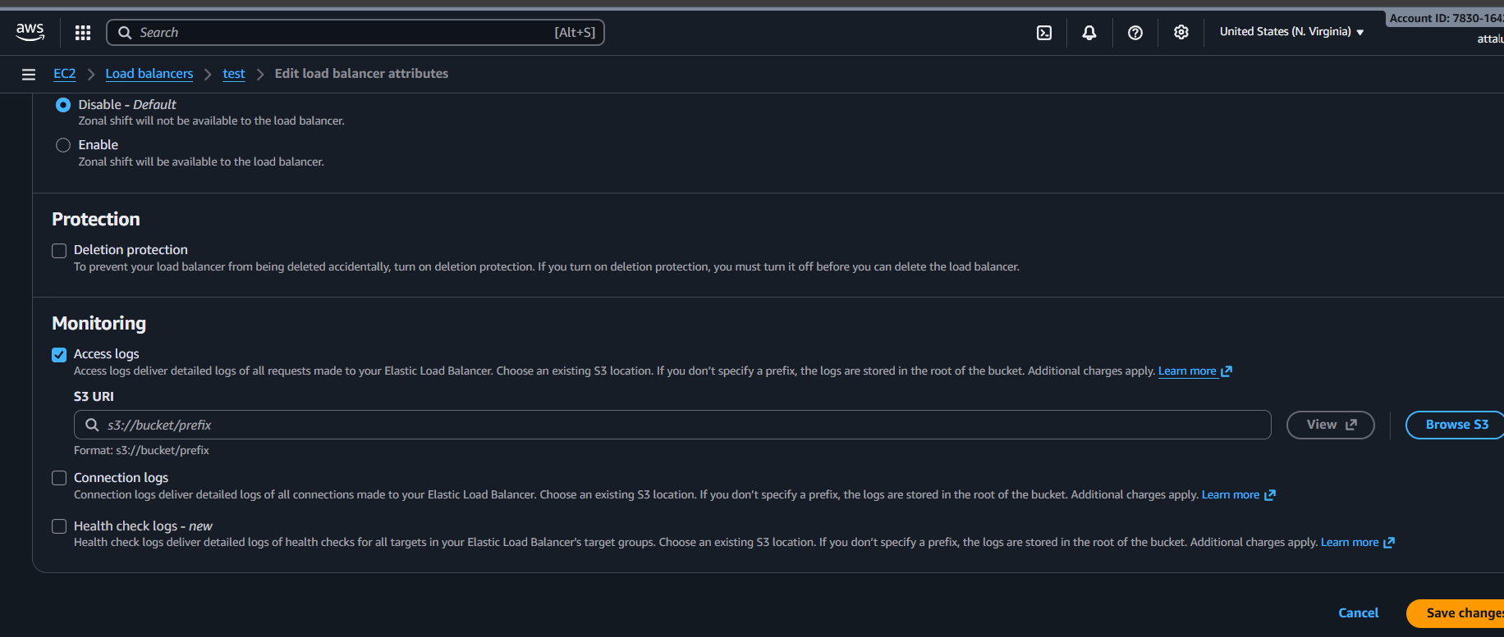
Browse the bucket or enter the bucket name and click on save changes
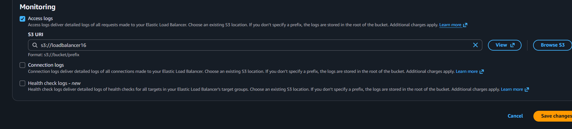

Faced an error while saving the attributes
The issue is in the POLICY which we attached in the bucket
Later changed the policy and continued with saving the changes
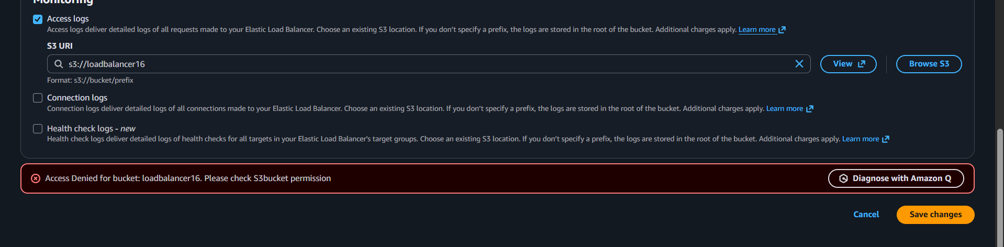
New script
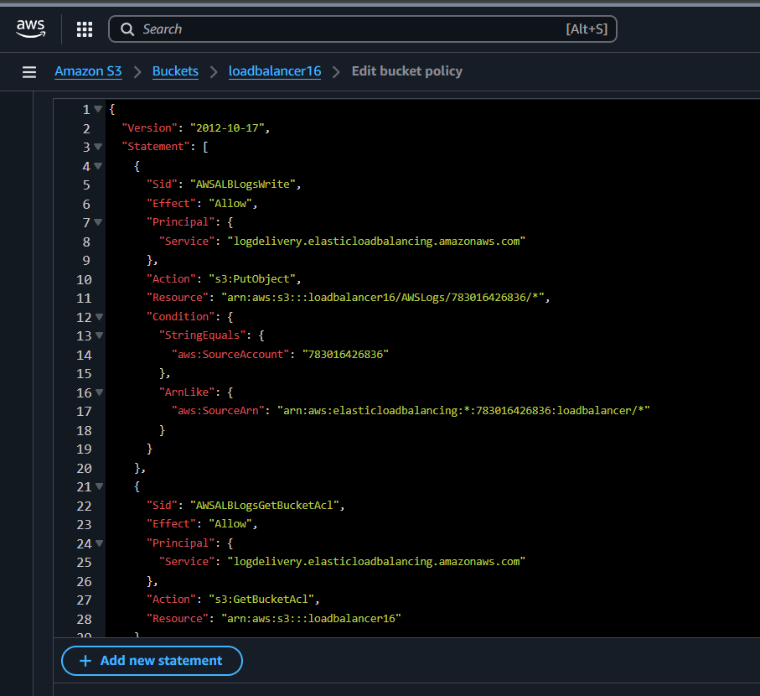

Also enable the ACLs for getting the logs
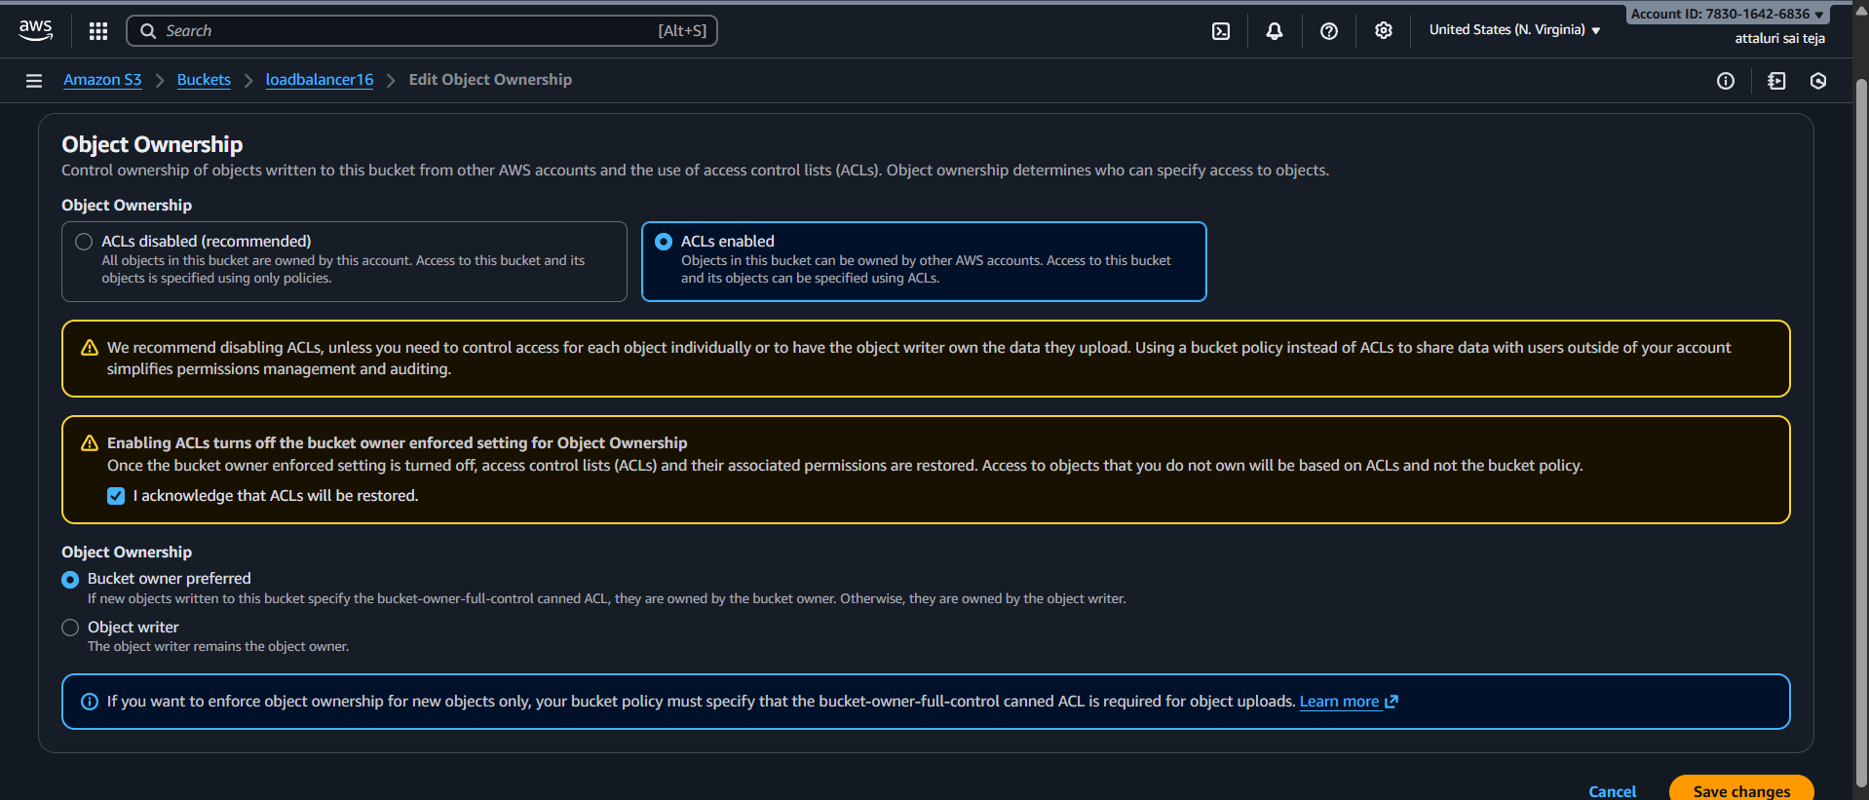
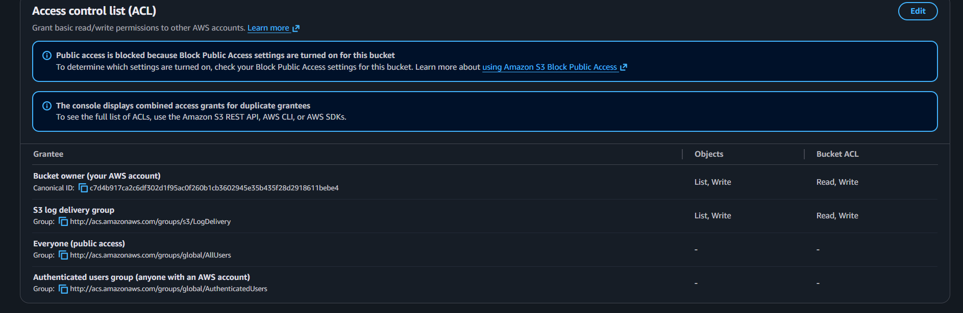
Successfully modified the load balancer attributes
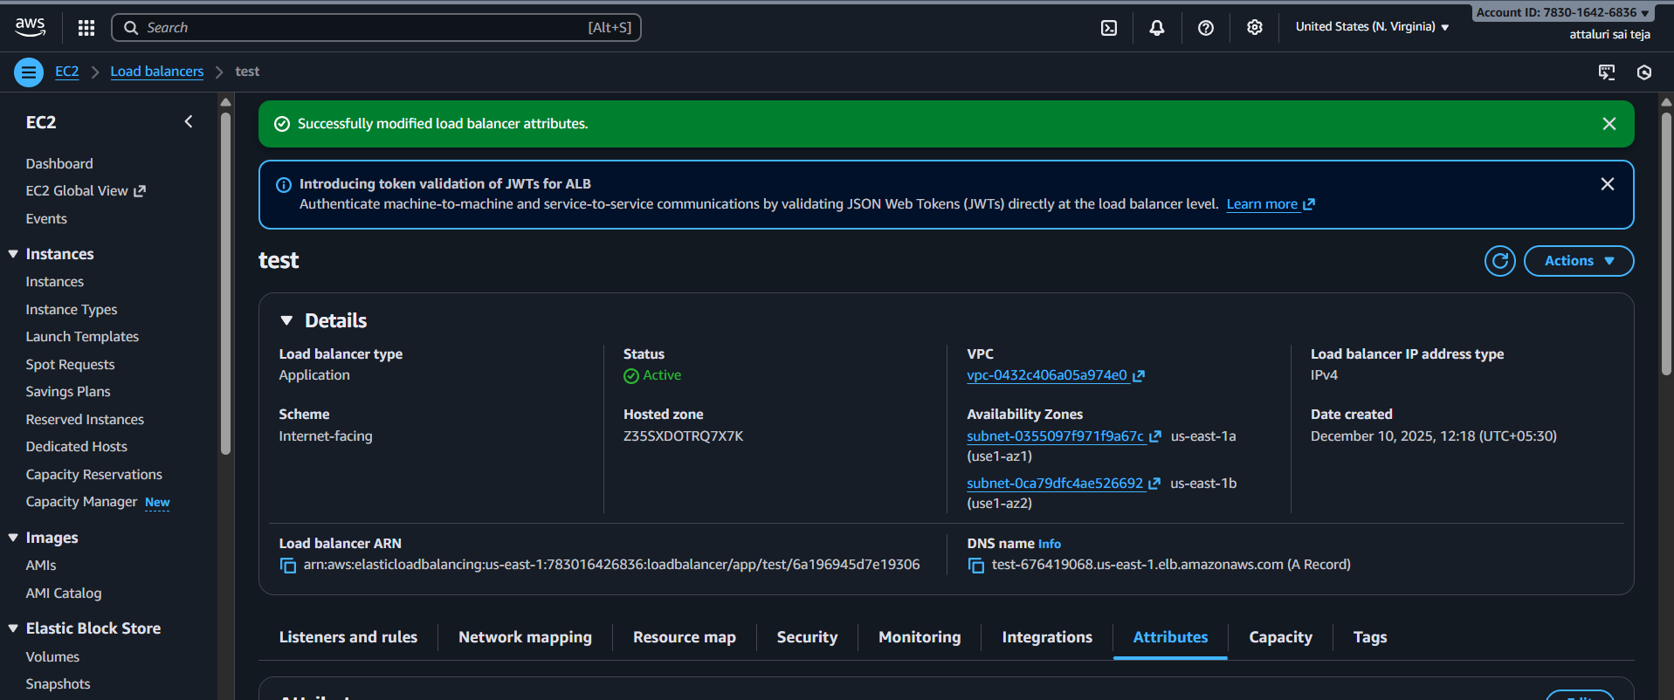

Generated Traffic between servers
Refresh many times by that the traffic could be generated

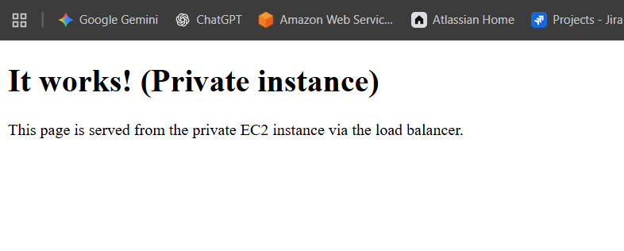
Step 5: Again navigate to s3 bucket and select elasticloadbalancing/ tab and proceed
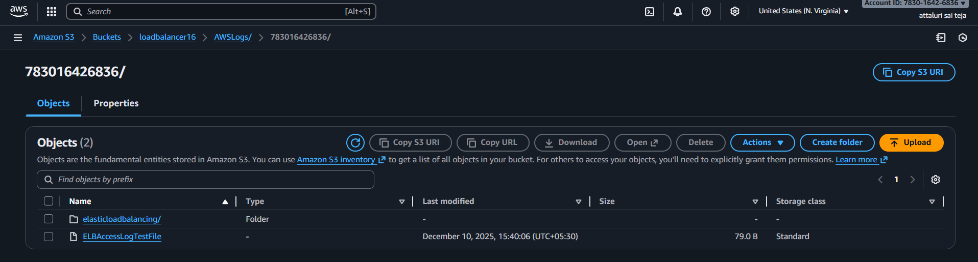

The logs were created and tried to display
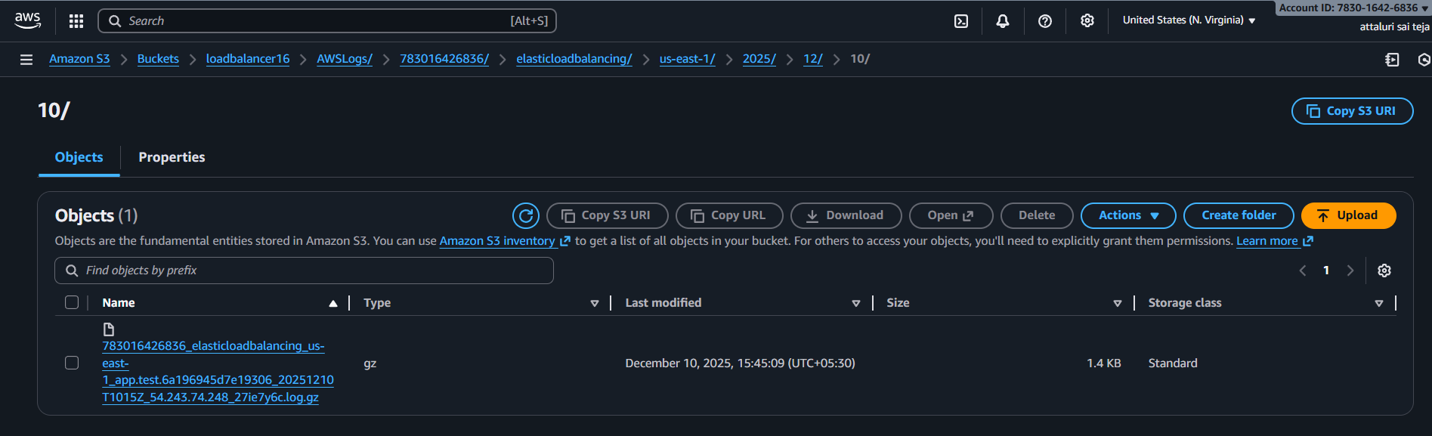
Again faced an error for the reason my bucket is in private access not for public so that the logs could not be displayed
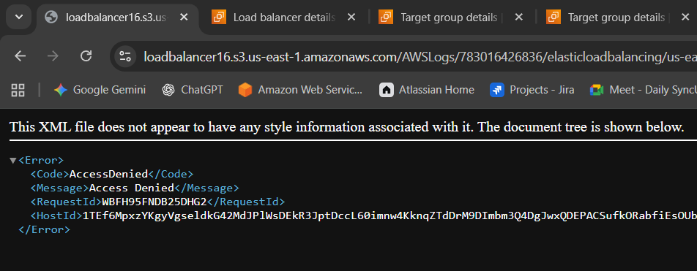
If you click on OPEN then a log file will be downloaded
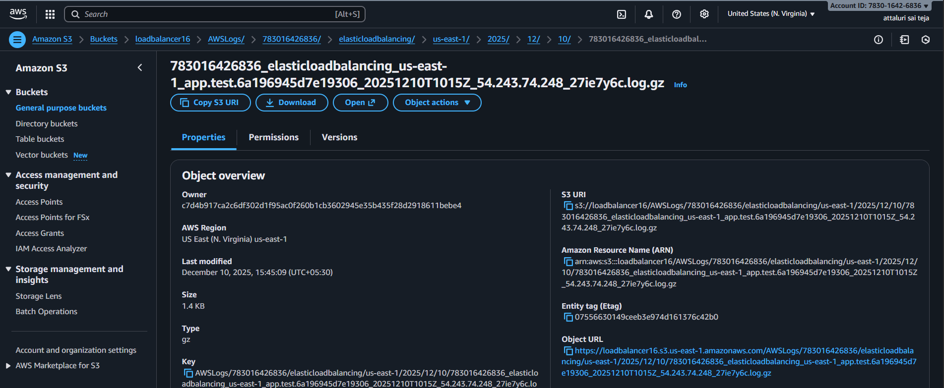

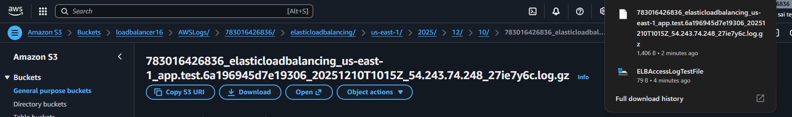
Conclusion:
This setup improves application observability, enhances operational monitoring, and ensures compliance with logging best practices.

Title:
Create monitoring dashboards to monitor CPU utilization and to monitor the Apache service.
Objective:
The objective of this task is to implement effective monitoring and observability for the EC2 instances by creating Amazon CloudWatch dashboards that track:
Prerequisites:
- EC2
- Cloud watch
- Apache package
- Bash script , cronjob
Step by Step Implementation
Step : Navigate to Cloud watch and create a dashboard
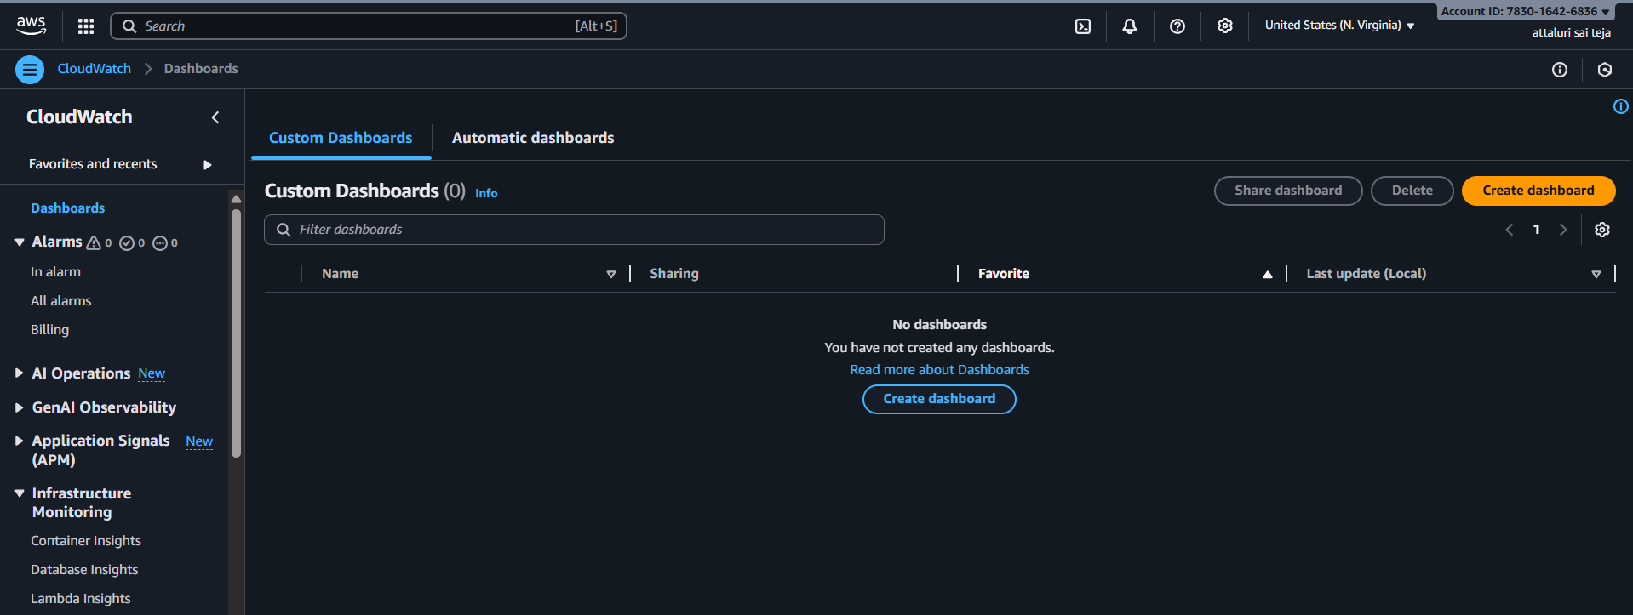
Step 2: Select the metrics as number and continue
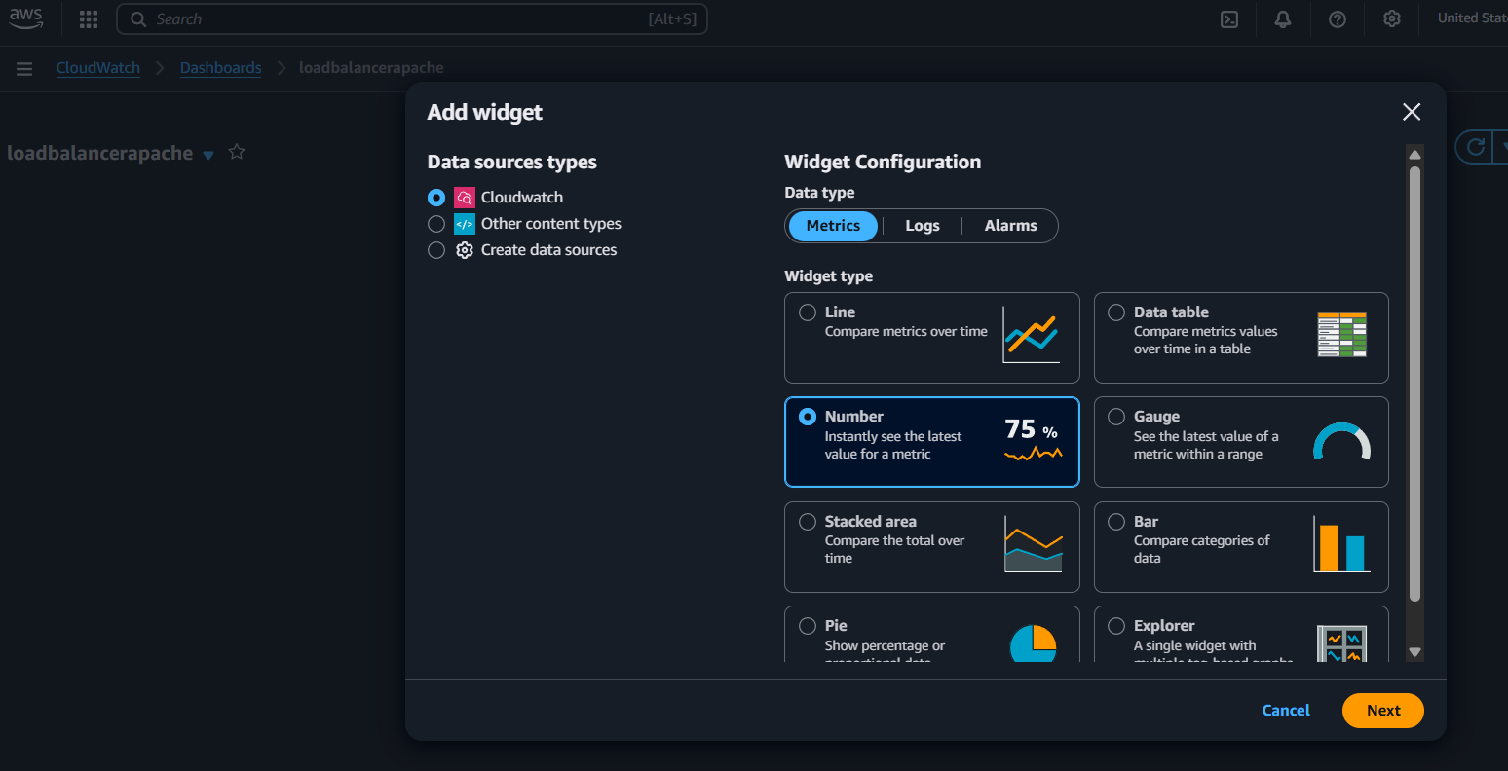
Step 3: Select with Custom Instance id and continue
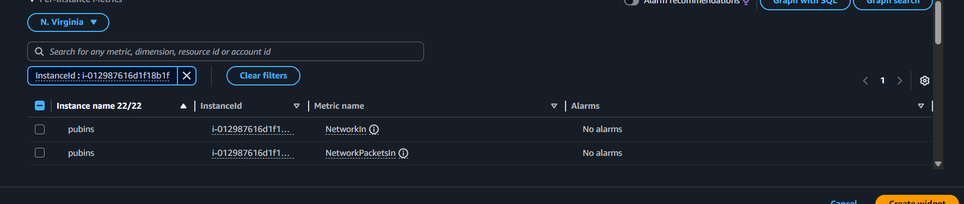
Step 4: Select the CPU Utilization and continue to add
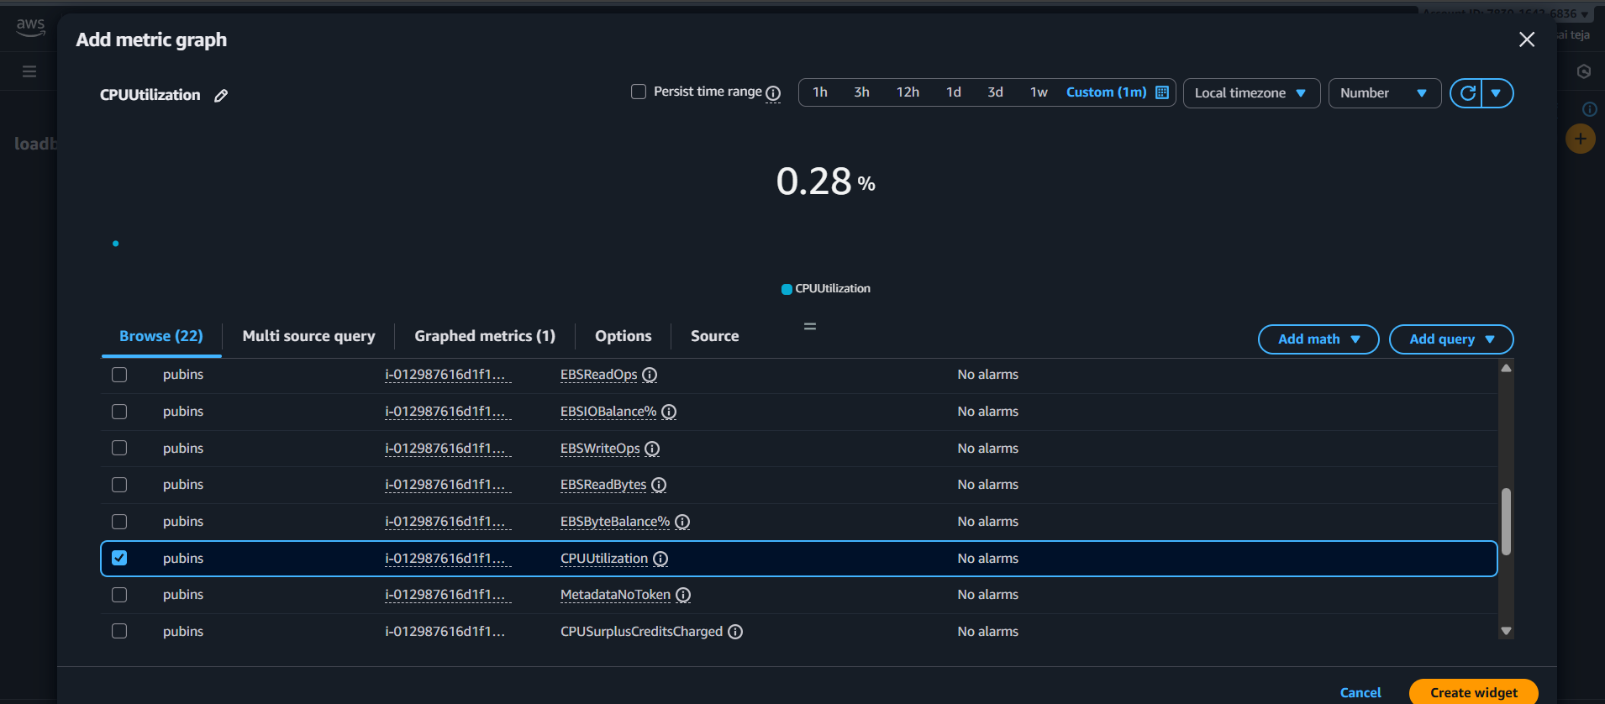
Step 5: Successfully Created a dashboard to monitor the cpu utilization
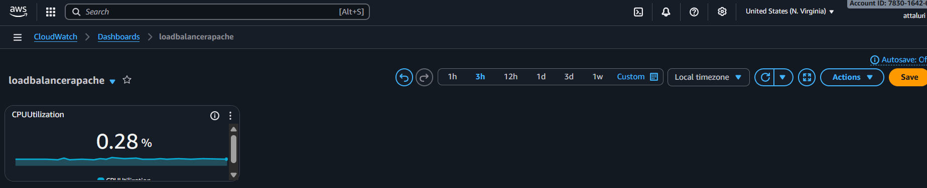

Step 6: Create a bash script to enable the monitoring of apache service
And provide the permissions and enable cronjobs
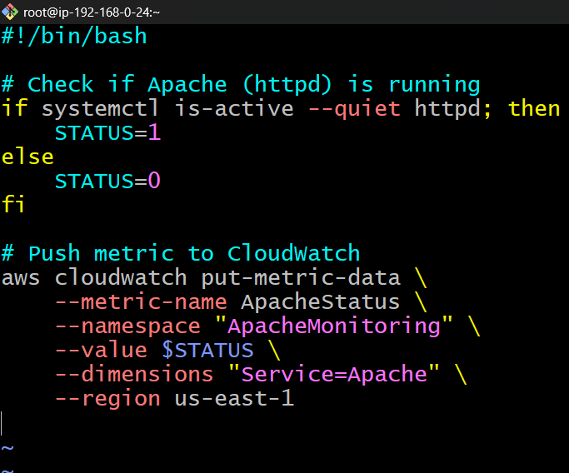
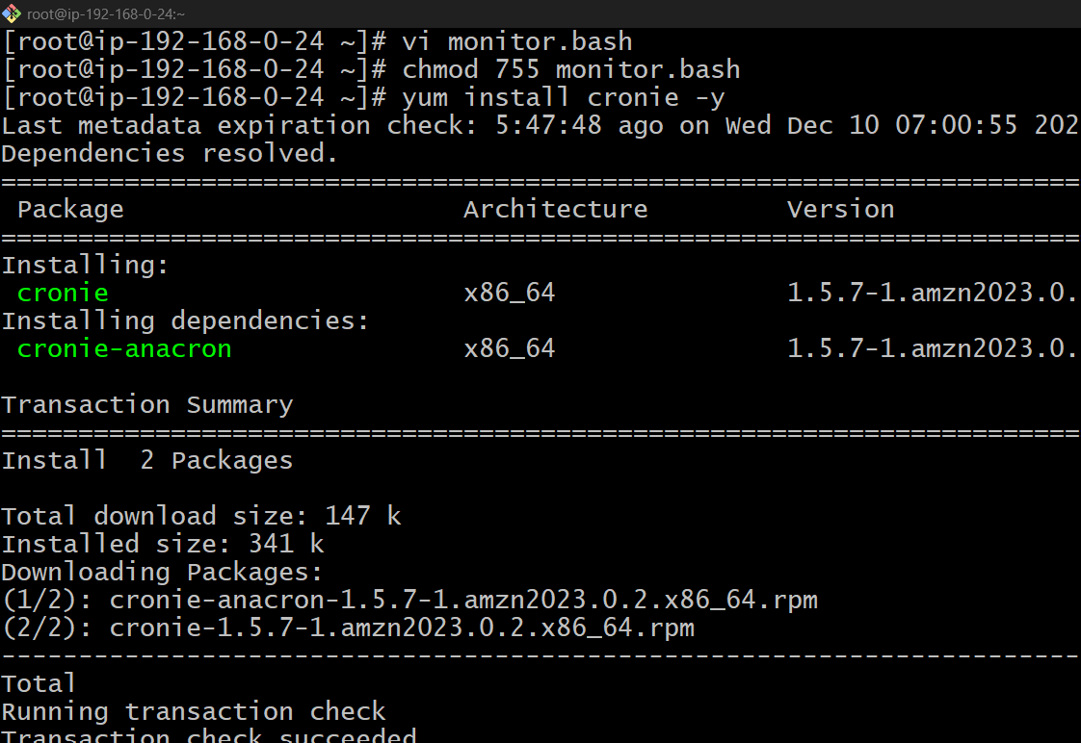
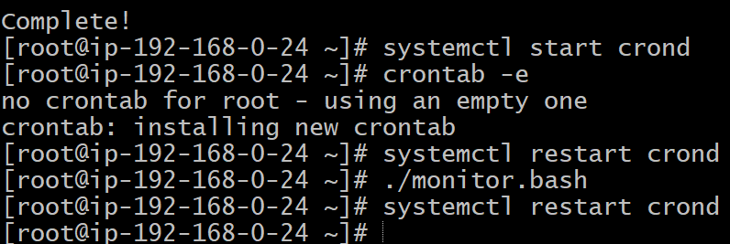
Step 7: Navigate to cloudwatch metrics and now we can see a apache in namespace
Click on it and add to dashboard
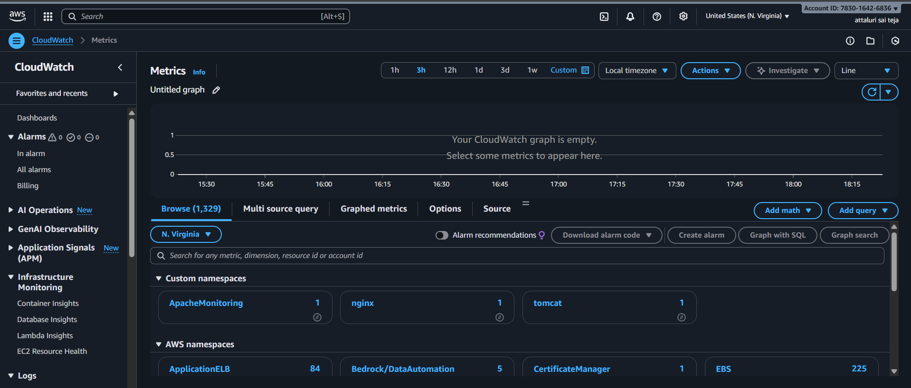

Step 8: Wait for some time and the data will be reflected
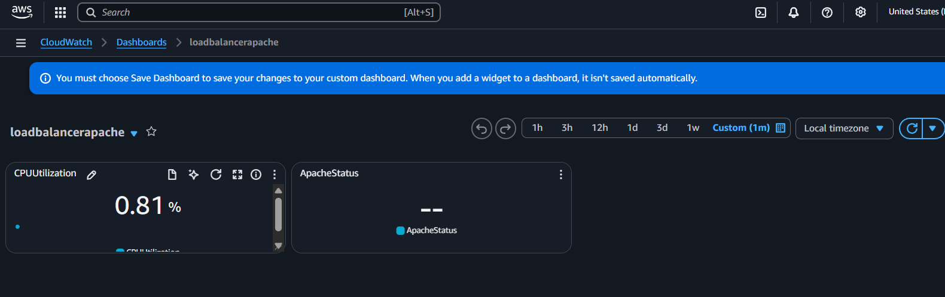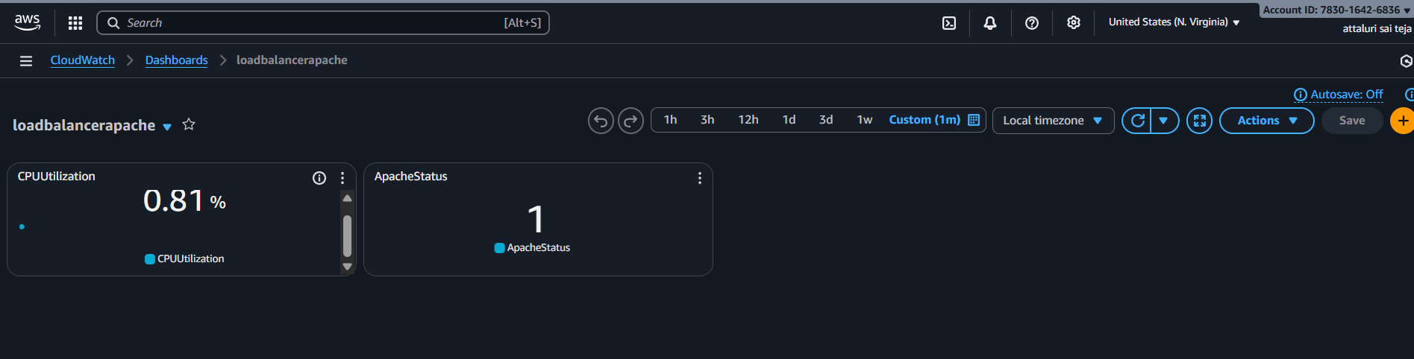
Conclusion:
CloudWatch monitoring was set up to track CPU usage and Apache service health, ensuring better visibility and quicker troubleshooting of the server.

Title:
- If CPU utilization is more than 70%, then it should trigger auto scaling and launch new instance.
Objective:
configure Auto Scaling on AWS so that whenever the CPU utilization of the running EC2 instance exceeds 70%, an additional instance is automatically launched. This ensures that the application can handle increased traffic smoothly, preventing performance degradation and maintaining high availability.
Prerequisites :
- Auto Scaling
- Ec2
- Launch template
- Load Balancer
- Target Groups
- VPC
Step by step Implementation
Step 1: Navigate to EC2 and select actions and click on image and template and click on create template
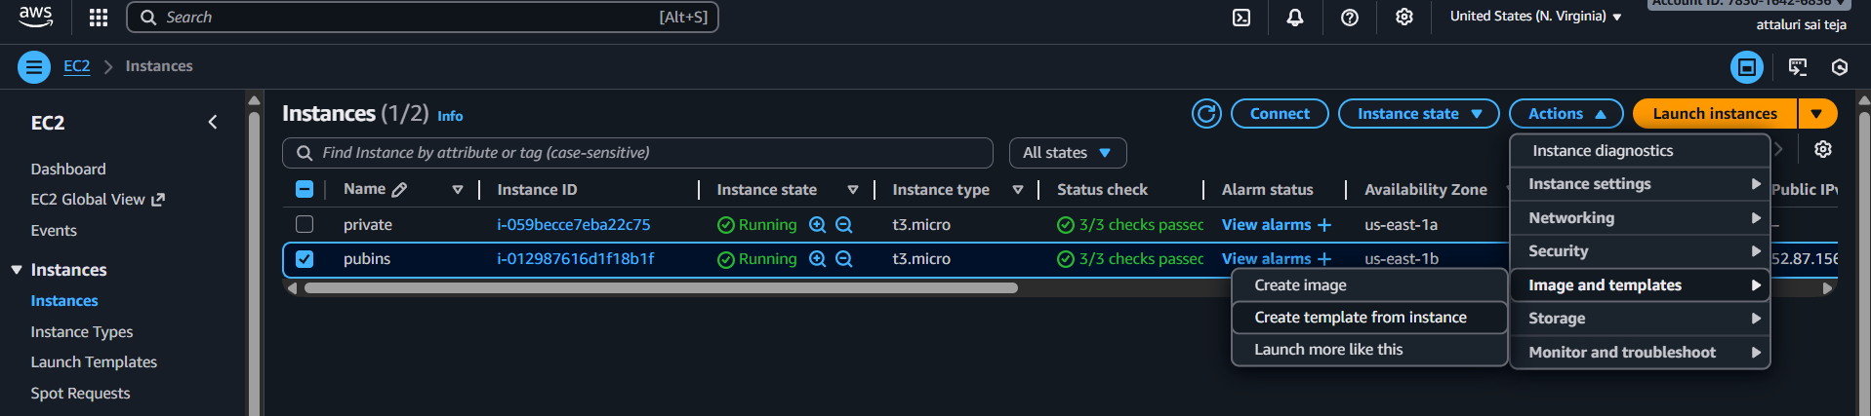
Step 2: Provide a name and continue
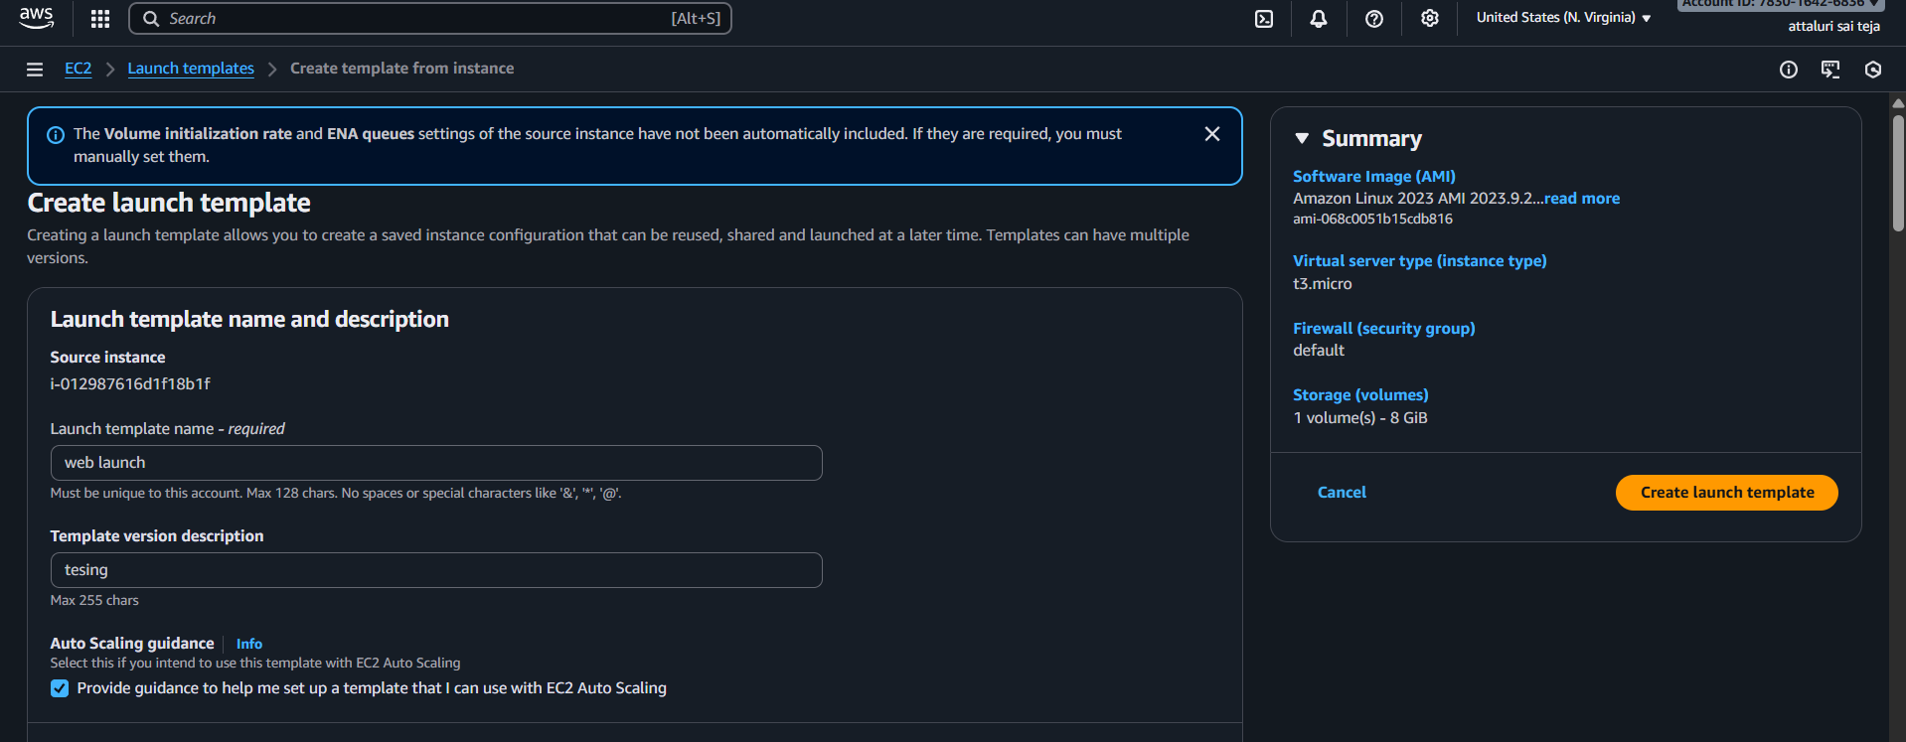
Step 3: Verify the default settings and continue
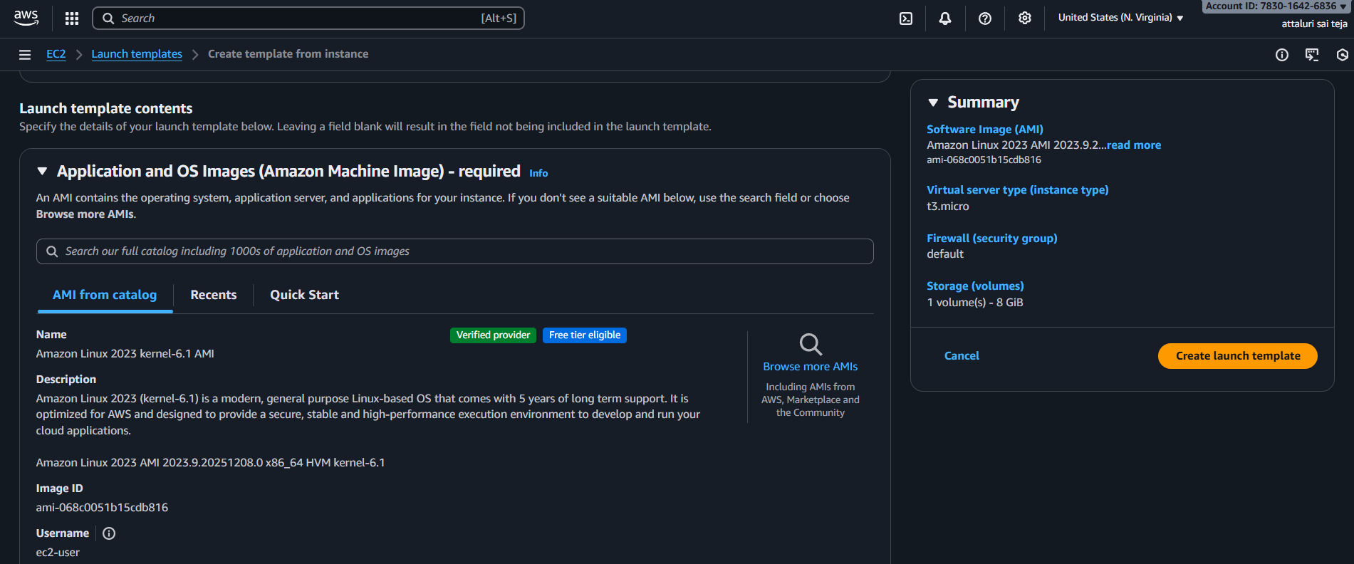
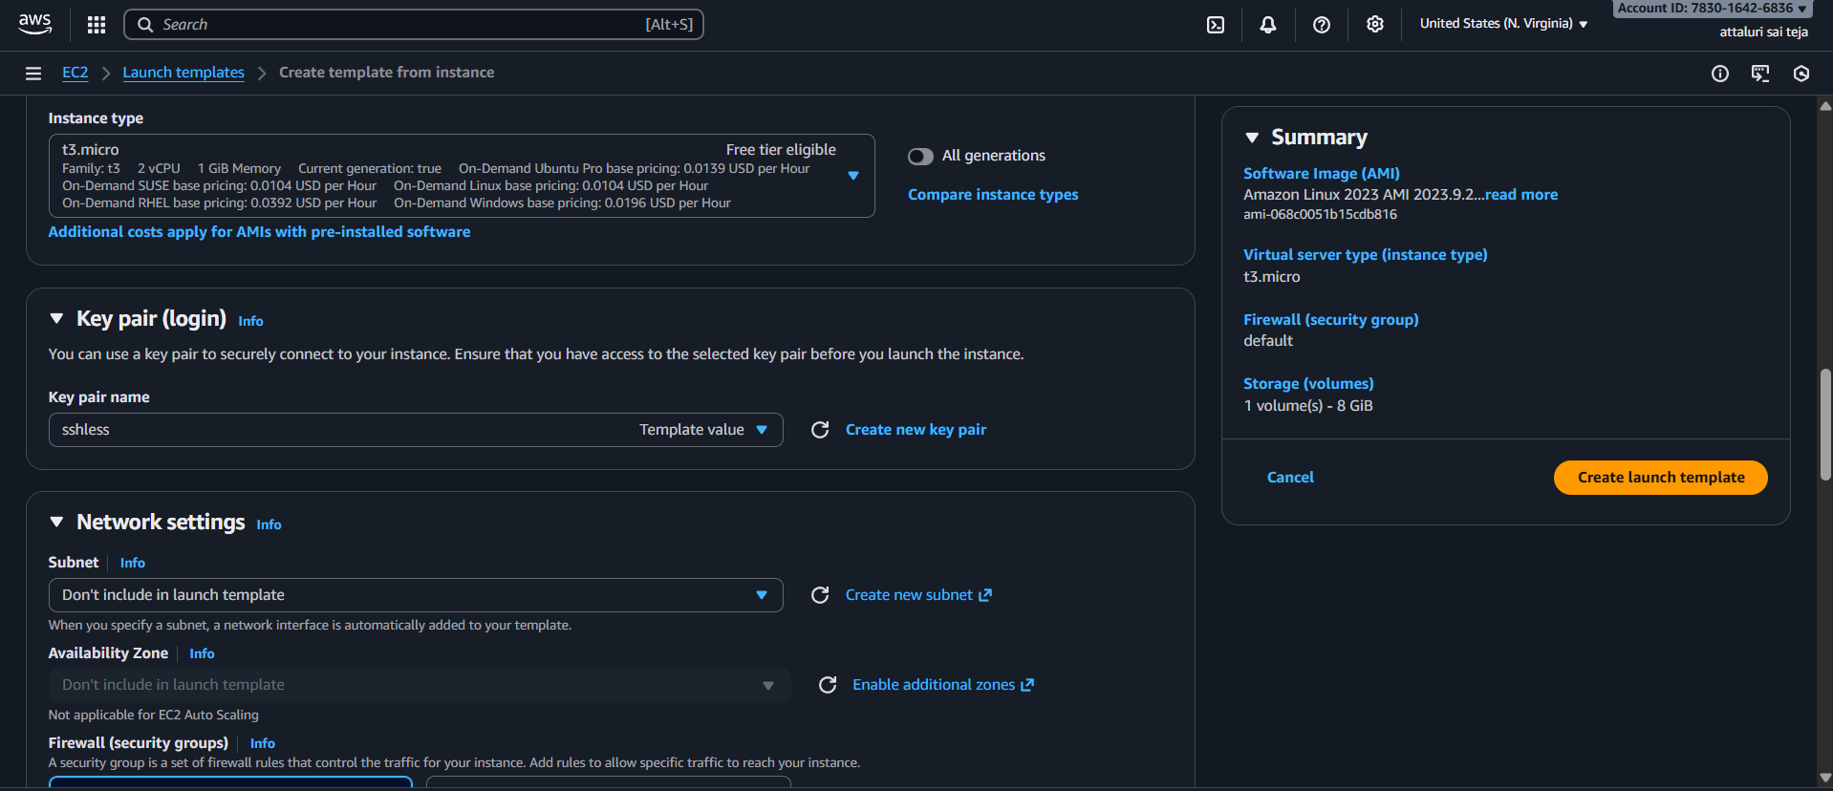
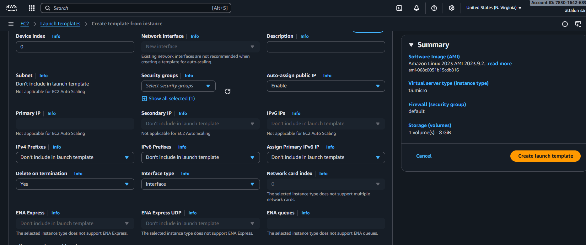
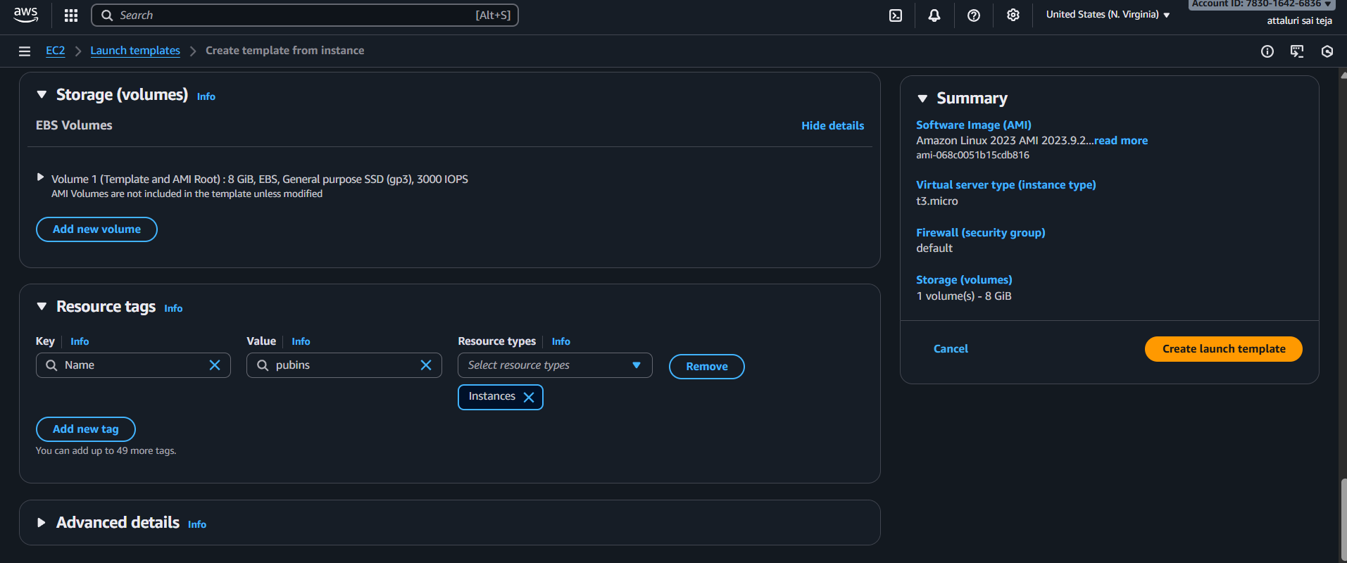
Enter the user data to install apache and continue
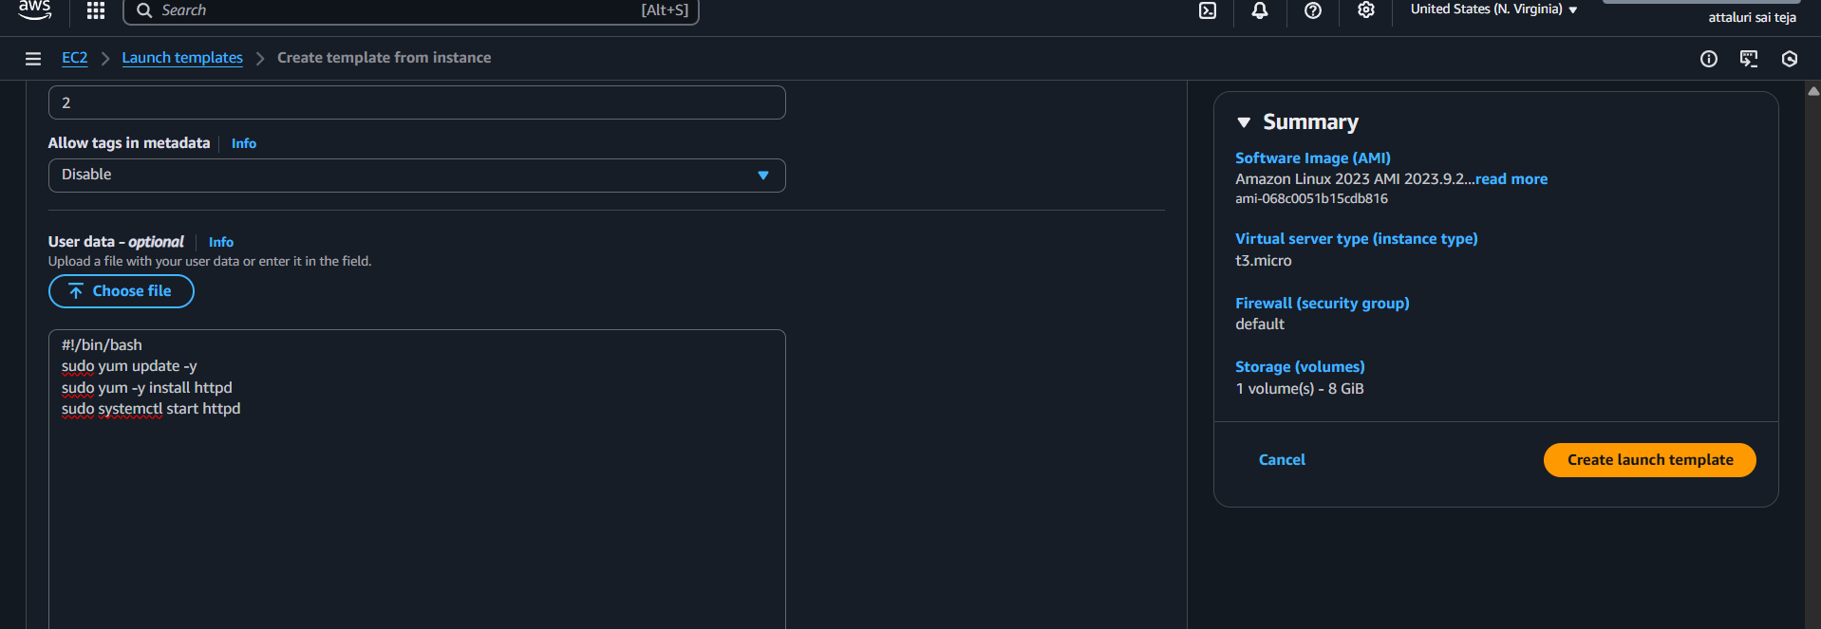
Successfully launched template
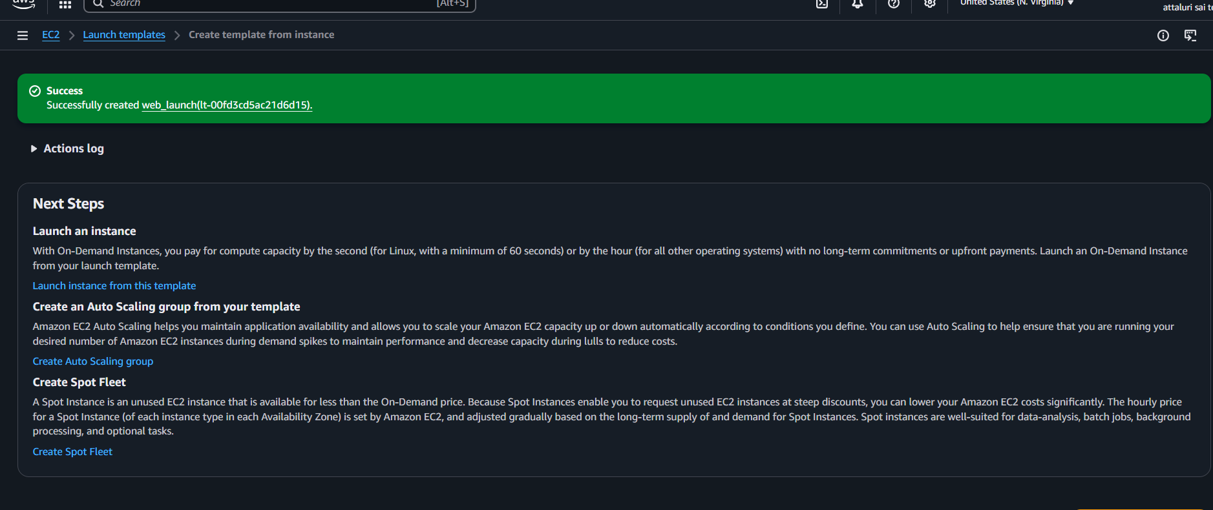

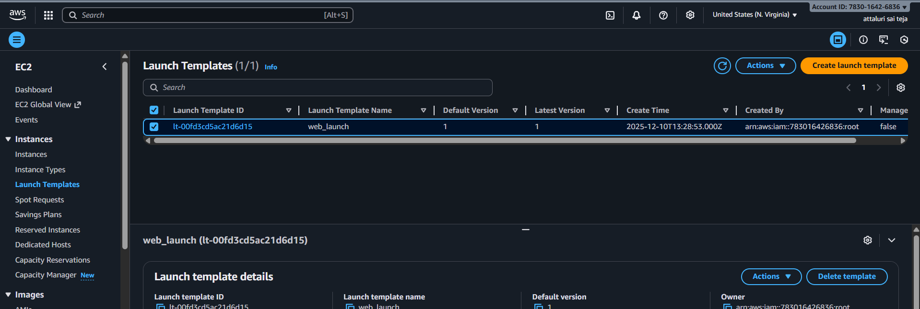
Step 4: Navigate to Auto scaling groups in EC2
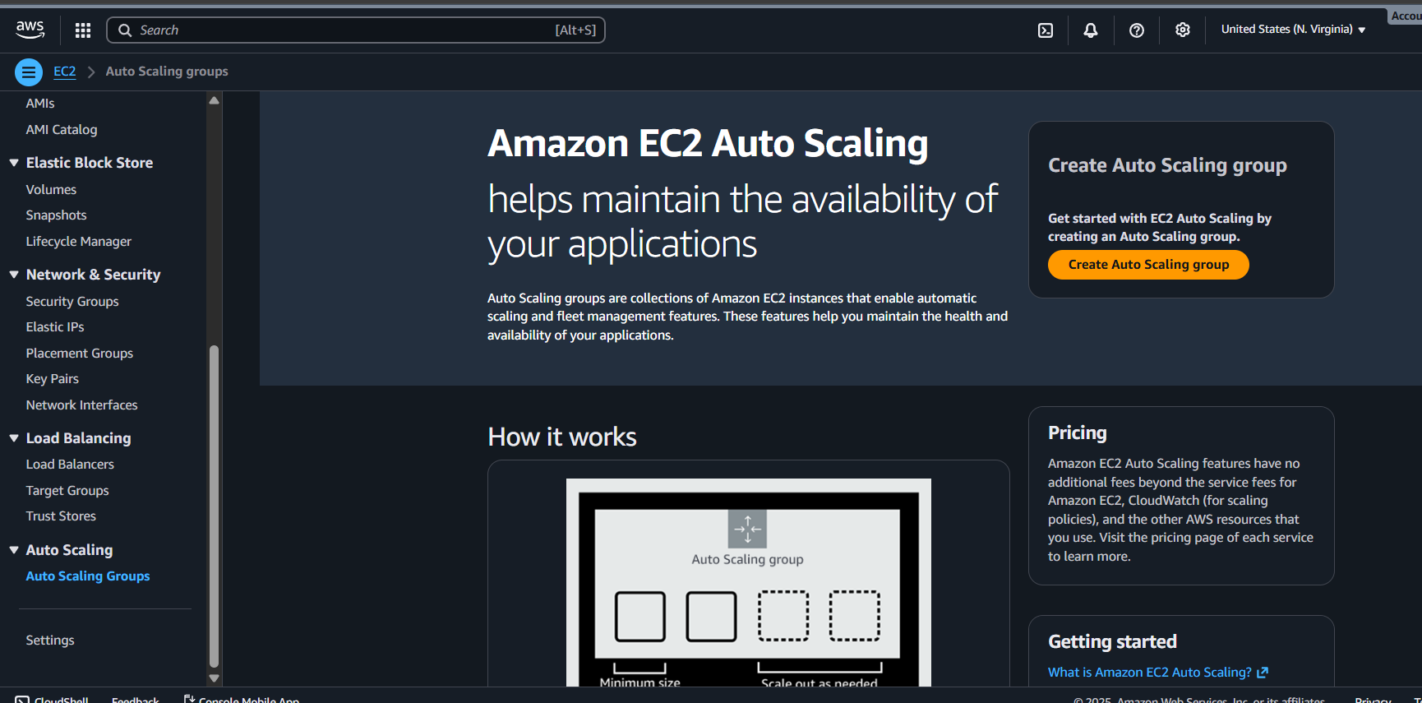
Provide a name and select the template and proceed
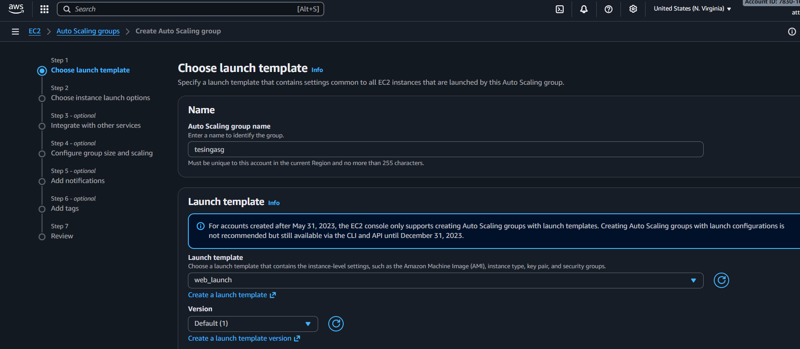
Verify the details and proceed
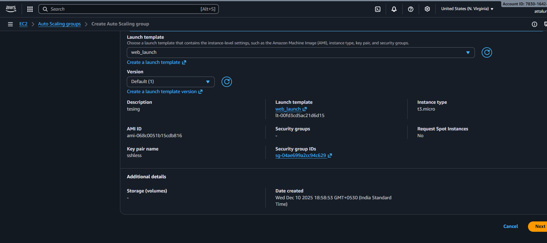
Select the VPC and provide multiple subnets and continue
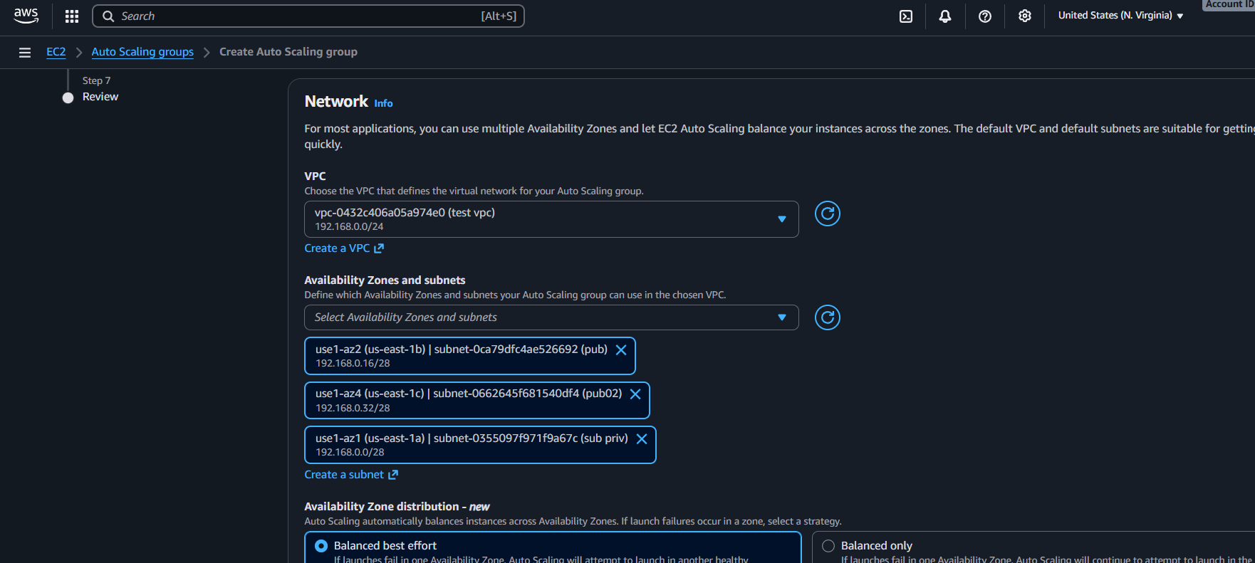

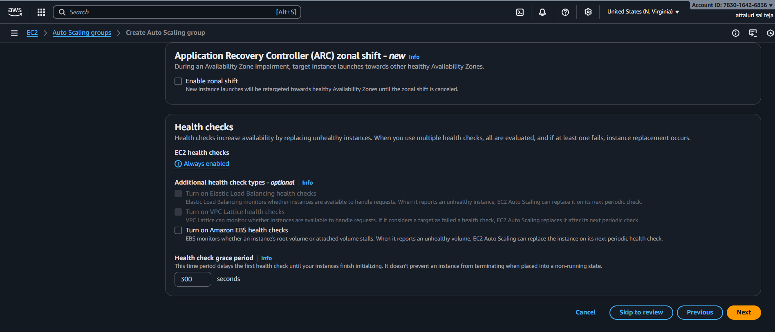
Select the Load balancer and continue by selecting target groups
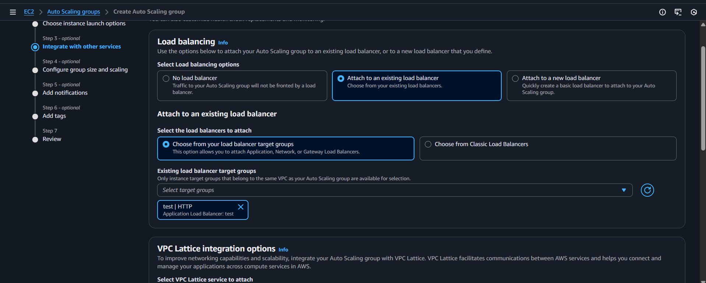
Select the size of EC2 and continue
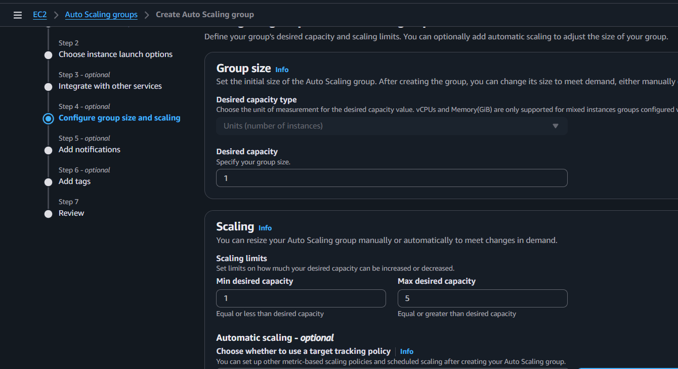
In my case I setup threshold value as 50%
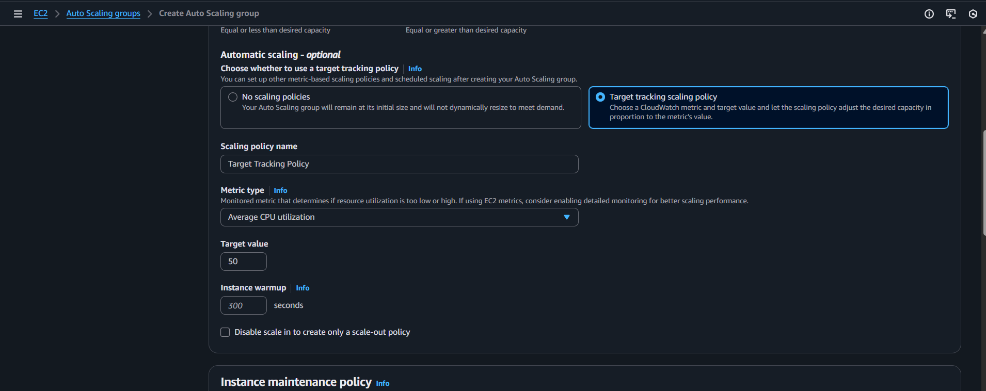
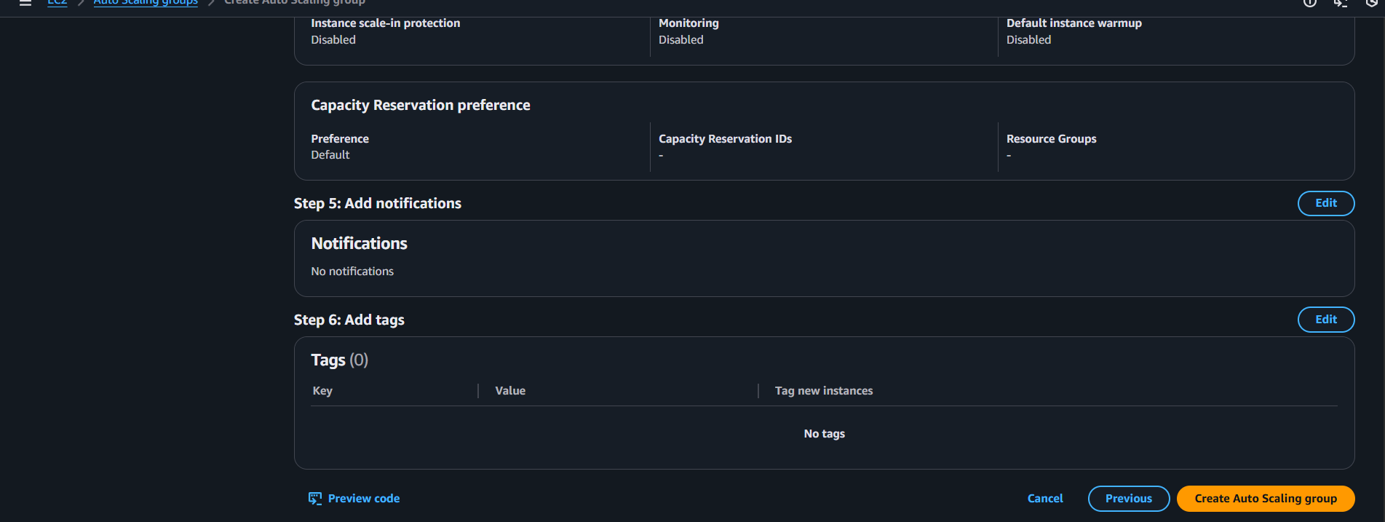
That’s the asg has been created
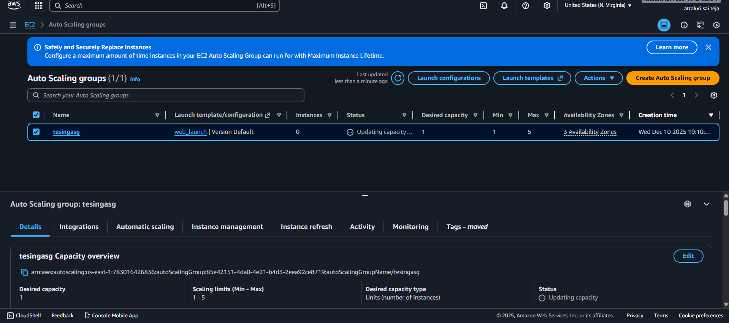

Enable the Autoscaling metric collections and visualize the metrics
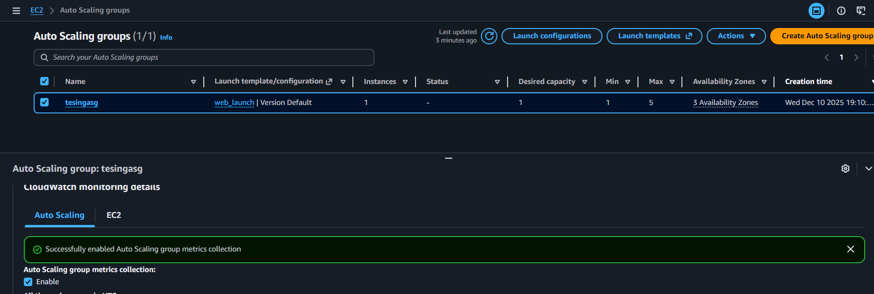
After some time the metrics will be visible
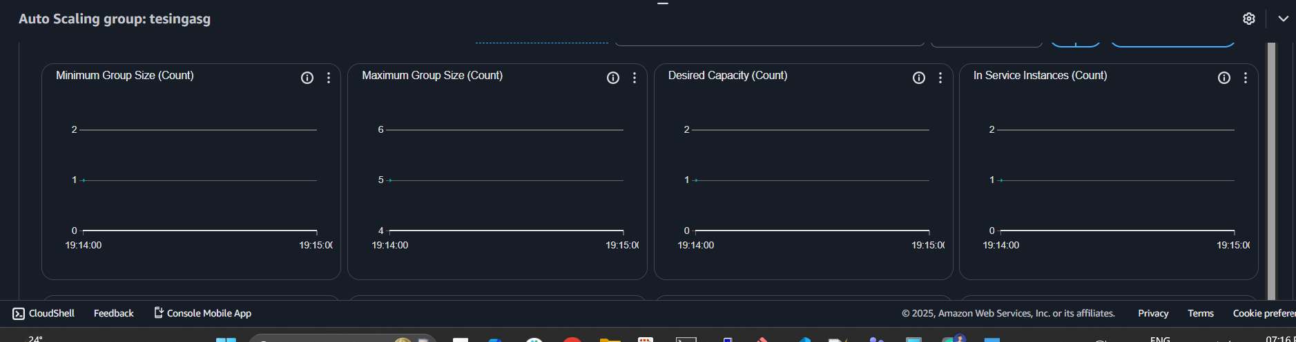
Provided a load on server
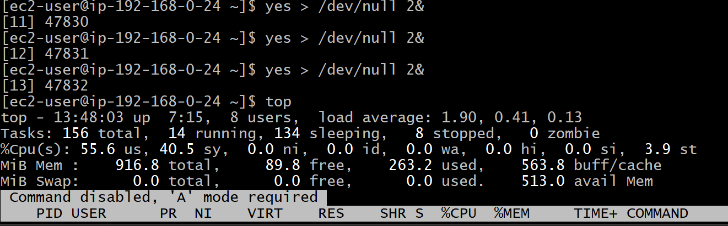

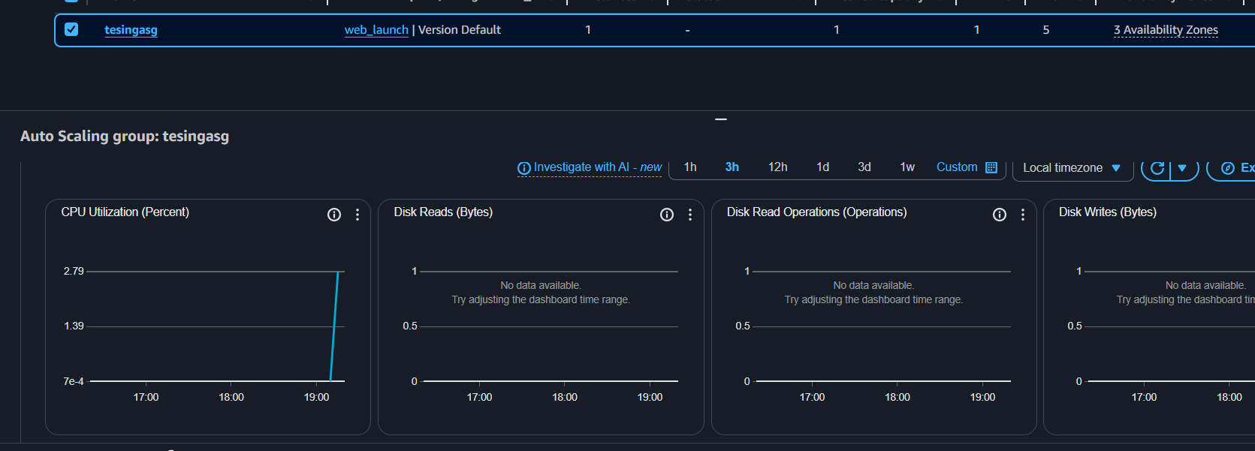
Earlier there was only two instances now a new instance has been created because the cpu utilization is 100%
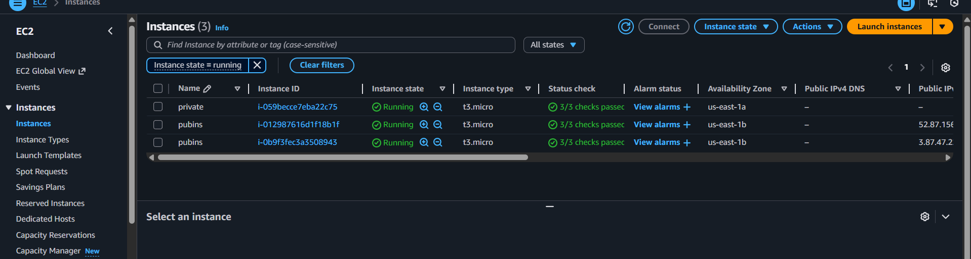
Validation Part:
Stopped the instances for validation
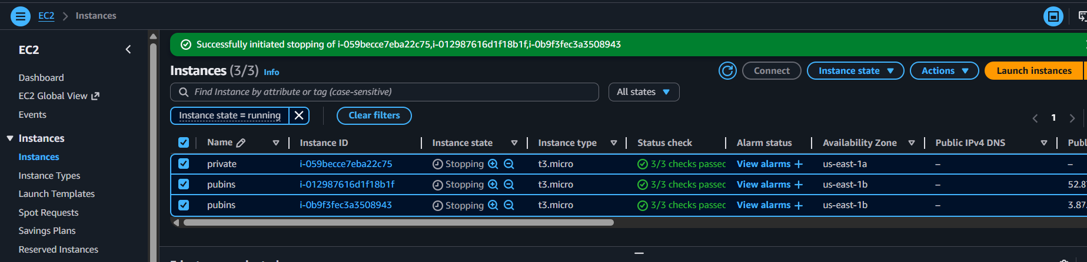
If you observe the new instance was launching as we set the limit
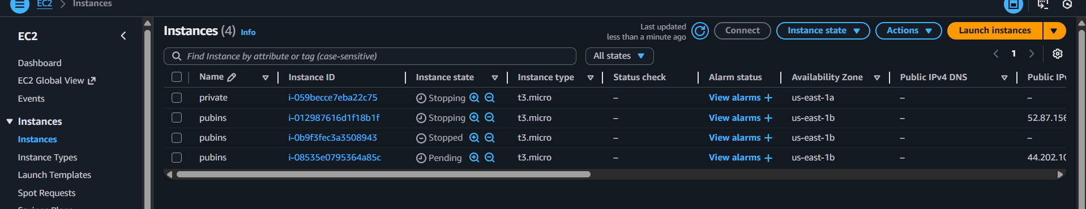
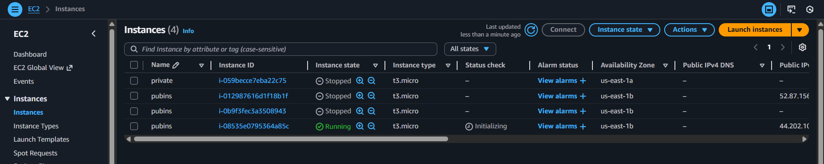
And verified on browser

Conclusion:
Auto Scaling was successfully implemented to monitor CPU utilization and automatically launch a new EC2 instance when usage rises above 70%. This setup improves scalability, maintains performance during peak loads, and ensures continuous availability of the application without manual intervention.

